JDT Core
JDT Core (org.eclipse.jdt.core) is the plug-in that defines the core Java elements and API. You should always list this plug-in as a prerequisite when you are developing Java specific features.
JDT Core packages give you access to the Java model objects and headless Java IDE infrastructure. The JDT Core packages include:
- org.eclipse.jdt.core - defines the classes that describe the Java model.
- org.eclipse.jdt.core.compiler - defines an API for the compiler infrastructure.
- org.eclipse.jdt.core.dom - supports Abstract Syntax Trees (AST) that can be used for examining the structure of a compilation unit down to the statement level.
- org.eclipse.jdt.core.dom.rewrite - supports rewriting of Abstract Syntax Trees (AST) that can be used for manipulating the structure of a compilation unit down to the statement level.
- org.eclipse.jdt.core.eval - supports the evaluation of code snippets in a scrapbook or inside the debugger.
- org.eclipse.jdt.core.formatter - supports the formatting of compilation units, types, statements, expressions, etc.
- org.eclipse.jdt.core.index - supports the generation of indexes that can be used by the JDT search engine.
- org.eclipse.jdt.core.jdom - supports a Java Document Object Model (DOM) that can be used for walking the structure of a Java compilation unit. All types within this package are deprecated.
- org.eclipse.jdt.core.search - supports searching the workspace's Java model for Java elements that match a particular description.
- org.eclipse.jdt.core.util - provides utility classes for manipulating .class files and Java model elements.
org.eclipse.jdt.core.jdom is deprecated since version 3.0. The manipulation of the structure of a compilation unit should be done using org.eclipse.jdt.core.dom instead.

Java model
The Java model is the set of classes that model the objects associated with creating, editing, and building a Java program. The Java model classes are defined in org.eclipse.jdt.core. These classes implement Java specific behavior for resources and further decompose Java resources into model elements.

Java elements
The package org.eclipse.jdt.core defines the classes that model the elements that compose a Java program. The JDT uses an in-memory object model to represent the structure of a Java program. This structure is derived from the project's class path. The model is hierarchical. Elements of a program can be decomposed into child elements.
Manipulating Java elements is similar to manipulating resource objects. When you work with a Java element, you are actually working with a handle to some underlying model object. You must use the exists() protocol to determine whether the element is actually present in the workspace.
The following table summarizes the different kinds of Java elements.
Element | Description
IJavaModel | Represents the root Java element, corresponding to the workspace. The parent of all projects with the Java nature. It also gives you access to the projects without the java nature.
IJavaProject | Represents a Java project in the workspace. (Child of IJavaModel)
IModuleDescription | Represents a Java module descriptor. (Child of IJavaProject)
IPackageFragmentRoot | Represents a set of package fragments, and maps the fragments to an underlying resource which is either a folder, JAR, or ZIP file. (Child of IJavaProject)
IPackageFragment | Represents the portion of the workspace that corresponds to an entire package, or a portion of the package. (Child of IPackageFragmentRoot )
ICompilationUnit | Represents a Java source (.java) file. (Child of IPackageFragment )
IPackageDeclaration | Represents a package declaration in a compilation unit. (Child of ICompilationUnit )
IImportContainer | Represents the collection of package import declarations in a compilation unit. (Child of ICompilationUnit )
IImportDeclaration | Represents a single package import declaration. (Child of IImportContainer )
IType | Represents either a source type inside a compilation unit, or a binary type inside a class file.
IField | Represents a field inside a type. (Child of IType )
IMethod | Represents a method or constructor inside a type. (Child of IType )
IInitializer | Represents a static or instance initializer inside a type. (Child of IType )
IClassFile | Represents a compiled (binary) type. (Child of IPackageFragment )
IModularClassFile | Represents the class file of a module description ("module-info.class"). (Child of IPackageFragment )
ITypeParameter | Represents a type parameter. (Not a child of any Java element, it is obtained using IType.getTypeParameter(String) or IMethod.getTypeParameter(String))
ILocalVariable | Represents a local variable in a method or an initializer. (Not a child of any Java element, it is obtained using ICodeAssist.codeSelect(int, int))
IAnnotation | Represents a Java 5 annotation. (Not a child of any Java element, it is obtained using IAnnotatable.getAnnotation(String) or IAnnotatable.getAnnotations())
IAnnotatable | Represents a type, a field, a method, a local variable, or a package declaration that can be annotated with one or several IAnnotations.
All Java elements support the IJavaElement interface.
Some of the elements are shown in the Packages view. These elements implement the IOpenable interface, since they must be opened before they can be navigated. The figure below shows how these elements are represented in the Packages view.

The Java elements that implement IOpenable are created primarily from information found in the underlying resource files. The same elements are represented generically in the resource navigator view.

Since 3.3, IOpenables that are the root of ITypes implement ITypeRoot . These are ICompilationUnit and IClassFile.
Other elements correspond to the items that make up a Java compilation unit. The figure below shows a Java compilation unit and a content outliner that displays the source elements in the compilation unit.

These elements implement the ISourceReference interface, since they can provide corresponding source code. (As these elements are selected in the content outliner, their corresponding source code is shown in the Java editor).

Java elements and their resources
Many of the Java elements correspond to generic resources in the workspace. When you want to create Java elements from a generic resource the class JavaCore is the best starting point. The following code snippet shows how to get Java elements from their corresponding resources.
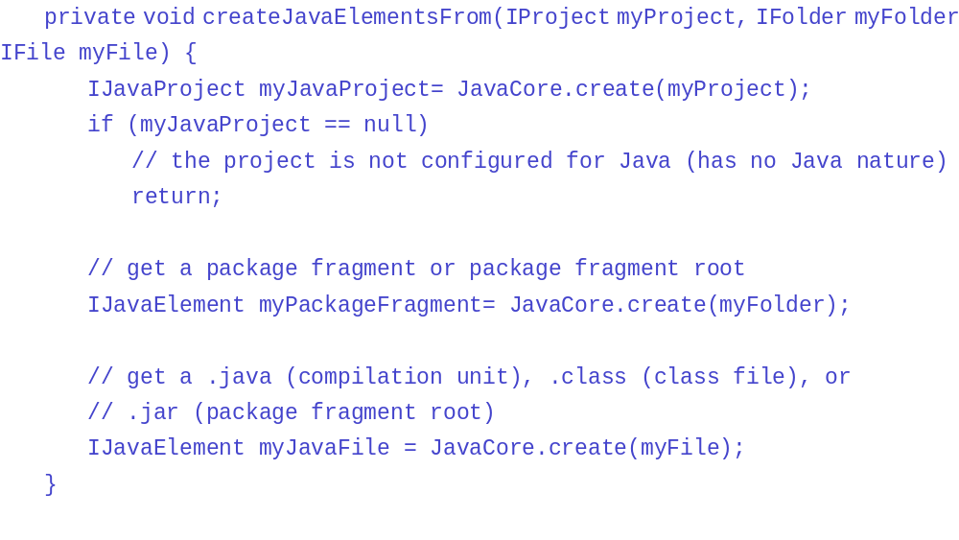
Once you have a Java element, you can use the JDT API to traverse and query the model. You may also query the non-Java resources contained in a Java element.
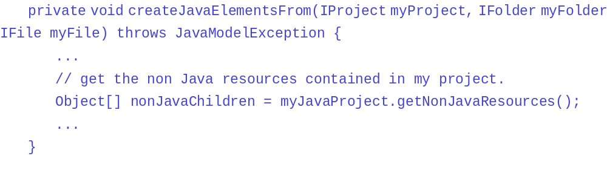

Java projects
When you create a Java project from a simple project, JavaCore will check to see if the project is configured with the Java nature. The JDT plug-in uses a project nature to designate a project as having Java behavior. This nature (org.eclipse.jdt.core.JavaCore#NATURE_ID ) is assigned to a project when the "New Java project" wizard creates a project. If the Java nature is not configured on a project,JavaCore will return null when asked to create the project.
JavaCore is also used to maintain the Java class path, including locations for finding source code and libraries, and locations for generating output binary (.class) files.
What are the unique characteristics of Java projects? They record their classpath in a ".classpath" file and add the Java incremental project builder to the project's build spec. Otherwise, they are just regular projects and can be configured with other natures (and other incremental builders) by plug-ins. Plug-ins that want to configure projects with Java behavior in addition to their own behavior typically use the NewJavaProjectWizardPage to assign the Java nature to the project in addition to their own custom natures or behavior.
IJavaModel can be considered the parent of all projects in the workspace that have the Java project nature (and therefore can be treated as an IJavaProject).

Manipulating Java code
Your plug-in can use the JDT API to create classes or interfaces, add methods to existing types, or alter the methods for types.
The simplest way to alter Java objects is to use the Java element API. More general techniques can be used to work with the raw source code for a Java element.

Code modification using Java elements

Generating a compilation unit
The easiest way to programmatically generate a compilation unit is to use IPackageFragment.createCompilationUnit. You specify the name and contents of the compilation unit. The compilation unit is created inside the package and the new ICompilationUnit is returned.
A compilation unit can be created generically by creating a file resource whose extension is ".java" in the appropriate folder that corresponds to the package directory. Using the generic resource API is a back door to the Java tooling, so the Java model is not updated until the generic resource change listeners are notified and the JDT listeners update the Java model with the new compilation unit.

Modifying a compilation unit
Most simple modifications of Java source can be done using the Java element API.
For example, you can query a type from a compilation unit. Once you have the IType, you can use protocols such as createField, createInitializer, createMethod, or createType to add source code members to the type. The source code and information about the location of the member is supplied in these methods.
The ISourceManipulation interface defines common source manipulations for Java elements. This includes methods for renaming, moving, copying, or deleting a type's member.

Working copies
Code can be modified by manipulating the compilation unit (and thus the underlying IFile is modified) or one can modify an in-memory copy of the compilation unit called a working copy.
A working copy is obtained from a compilation unit using the getWorkingCopy method. (Note that the compilation unit does not need to exist in the Java model in order for a working copy to be created.) Whoever creates such a working copy is responsible for discarding it when not needed any longer using the discardWorkingCopy method.
Working copies modify an in-memory buffer. The getWorkingCopy() method creates a default buffer, but clients can provide their own buffer implementation using the getWorkingCopy(WorkingCopyOwner, IProgressMonitor) method. Clients can manipulate the text of this buffer directly. If they do so, they must synchronize the working copy with the buffer from time to time using either the reconcile(int, boolean, WorkingCopyOwner, IProgressMonitor) method.
Finally a working copy can be saved to disk (replacing the original compilation unit) using the commitWorkingCopy method.
For example the following code snippet creates a working copy on a compilation unit using a custom working copy owner. The snippet modifies the buffer, reconciles the changes, commits the changes to disk and finally discards the working copy.
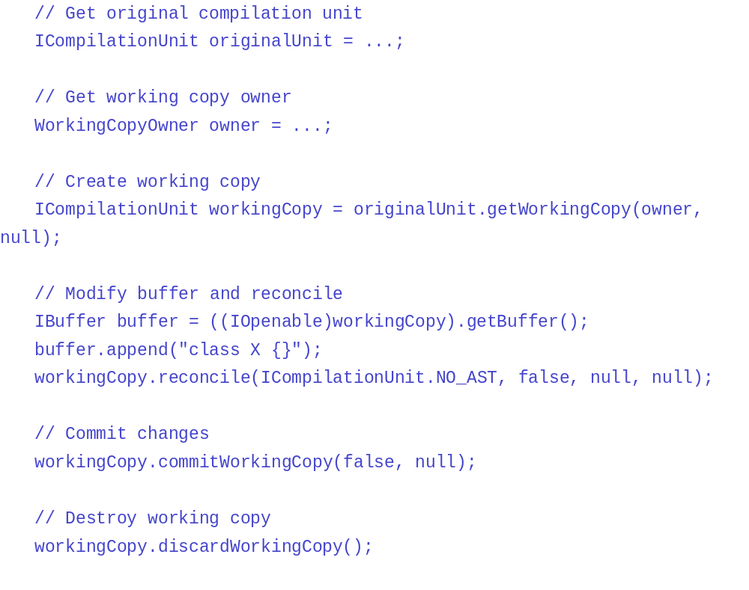
The compilation unit's buffer can also be modified using the ICompilationUnit.applyTextEdit method.
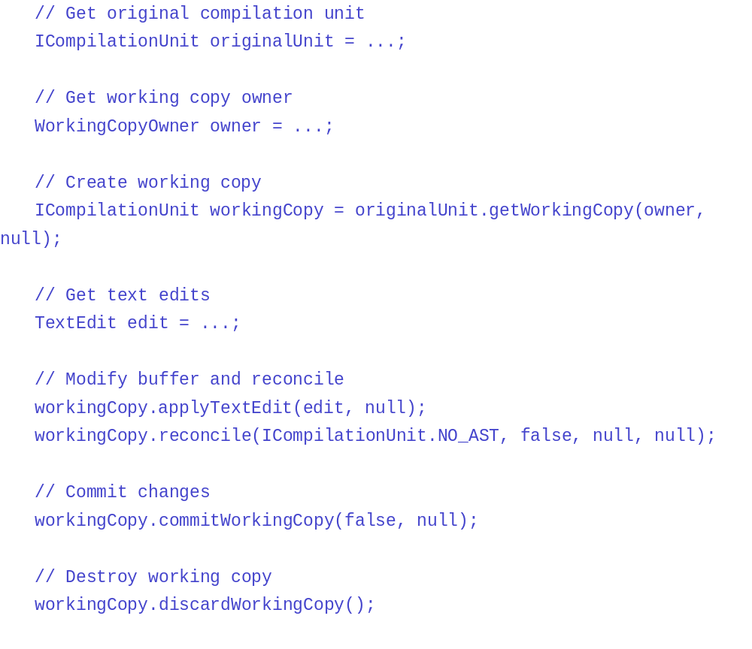Working copies can also be shared by several clients using a working copy owner. A working copy can be later retrieved using the findWorkingCopy method. A shared working copy is thus keyed on the original compilation unit and on a working copy owner.
The following shows how client 1 creates a shared working copy, client 2 retrieves this working copy, client 1 discards the working copy, and client 2 trying to retrieve the shared working copy notices it does not exist any longer:

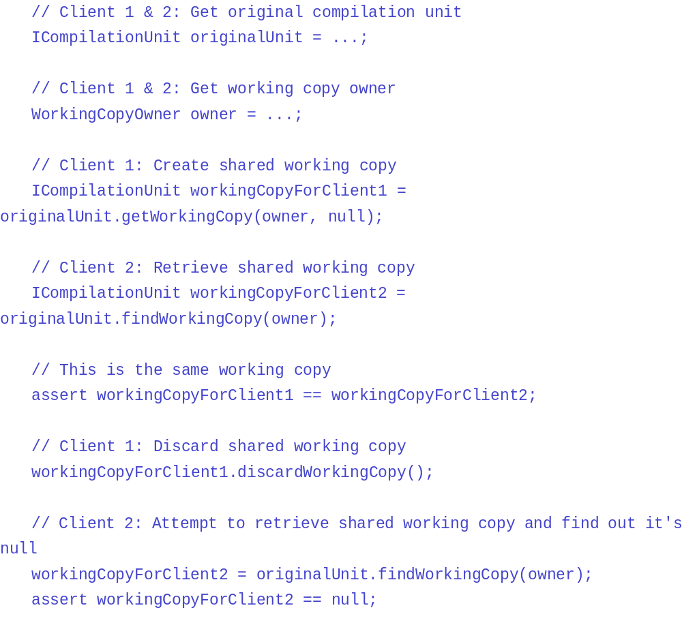

Code modification using the DOM/AST API
There are three ways to create a CompilationUnit. The first one is to use ASTParser. The second is to use ICompilationUnit#reconcile(...). The third is to start from scratch using the factory methods on AST (Abstract Syntax Tree).

Creating an AST from existing source code
An instance of ASTParser must be created with ASTParser.newParser(int).
The source code is given to the ASTParser with one of the following methods:
- setSource(char[]): to create the AST from source code
- setSource(IClassFile): to create the AST from a classfile
- setSource(ICompilationUnit): to create the AST from a compilation unit
Then the AST is created by calling createAST(IProgressMonitor).
The result is an AST with correct source positions for each node. The resolution of bindings has to be requested before the creation of the tree with setResolveBindings(boolean). Resolving the bindings is a costly operation and should be done only when necessary. As soon as the tree has been modified, all positions and bindings are lost.
Note that some bindings recovery can also be done during this resolution with setBindingsRecovery(boolean). Using this recovery, some bindings - typically missing types - will no longer be null, hence improving the resilience of any clients using the AST tree.

Creating an AST by reconciling a working copy
If a working copy is not consistent (has been modified) then an AST can be created by calling the method reconcile(int, boolean, WorkingCopyOwner, IProgressMonitor). To request AST creation, call the reconcile(...) method with AST.JLS3 as first parameter.
Its bindings are computed only if the problem requestor is active, or if the problem detection is forced. Resolving the bindings is a costly operation and should be done only when necessary. As soon as the tree has been modified, all positions and bindings are lost.
Note that some bindings recovery can also be done during this resolution with by using the method reconcile(int, int, WorkingCopyOwner, IProgressMonitor) with the flag ENABLE_BINDINGS_RECOVERY set on the second parameter. Using this recovery, some bindings - typically missing types - will no longer be null, hence improving the resilience of any clients using the AST tree.

From scratch
It is possible to create a CompilationUnit from scratch using the factory methods on AST. These method names start with new.... The following is an example that creates a HelloWorld class.
The first snippet is the generated output:
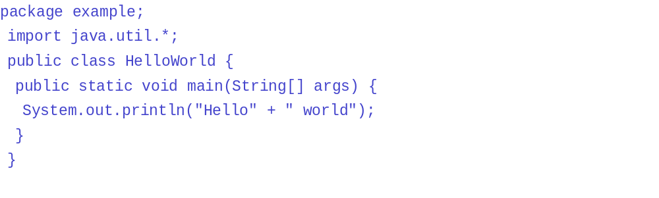The following snippet is the corresponding code that generates the output.
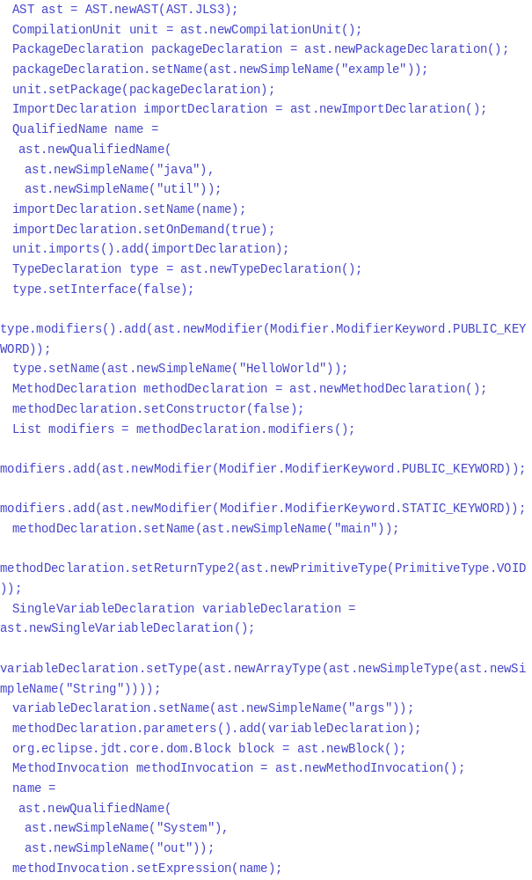

Retrieving extra positions
The DOM/AST node contains only a pair of positions (the starting position and the length of the node). This is not always sufficient. In order to retrieve intermediate positions, the IScanner API should be used. For example, we have an InstanceofExpression for which we want to know the positions of the instanceof operator. We could write the following method to achieve this:
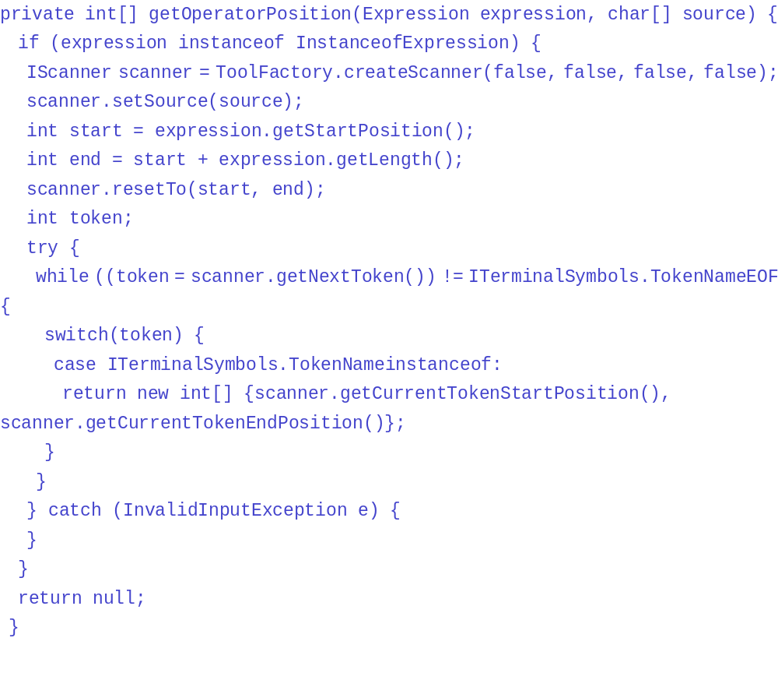
The IScanner is used to divide the input source into tokens. Each token has a specific value that is defined in the ITerminalSymbols interface. It is fairly simple to iterate and retrieve the right token. We also recommend that you use the scanner if you want to find the position of the super keyword in a SuperMethodInvocation.

Source code modifications
Some source code modifications are not provided via the Java element API. A more general way to edit source code (such as changing the source code for existing elements) is accomplished using the compilation unit's raw source code and the rewrite API of the DOM/AST.
To perform DOM/AST rewriting, there are two sets of API: the descriptive rewriting and the modifying rewriting.
The descriptive API does not modify the AST but use ASTRewrite API to generate the descriptions of modifications. The AST rewriter collects descriptions of modifications to nodes and translates these descriptions into text edits that can then be applied to the original source.
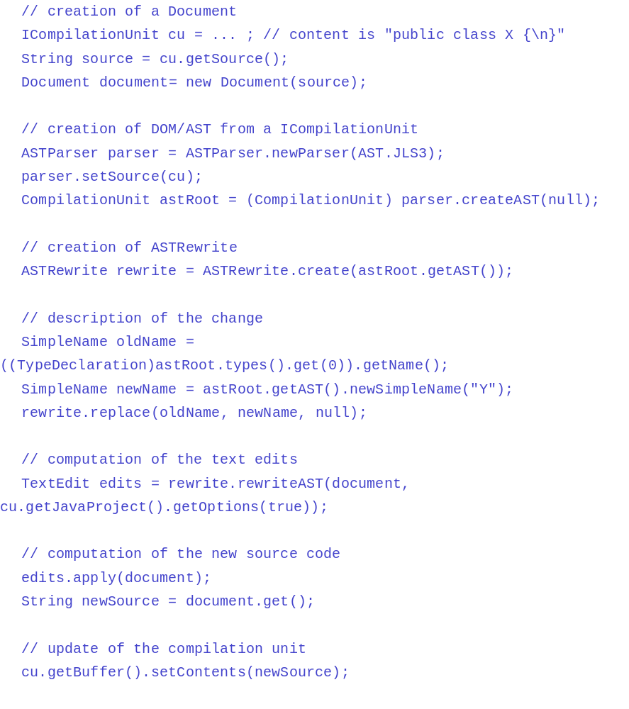

The modifying API allows to modify directly the AST:
- Request the recording of modifications (CompilationUnit.recordModifications()).
- Perform the modifications on the AST Nodes.
- And when the modifications are finished, generate text edits that can then be applied to the original source (CompilationUnit.rewrite(...)).
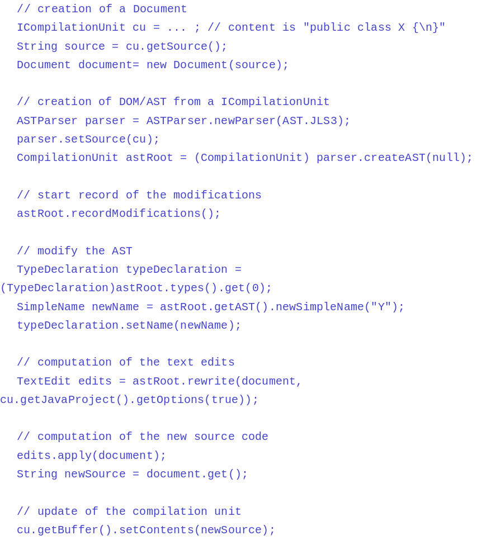

Responding to changes in Java elements
If your plug-in needs to know about changes to Java elements after the fact, you can register a Java IElementChangedListener with JavaCore.

You can be more specific and specify the type of events you're interested in using addElementChangedListener(IElementChangedListener, int).
For example, if you're only interested in listening for events during a reconcile operation:

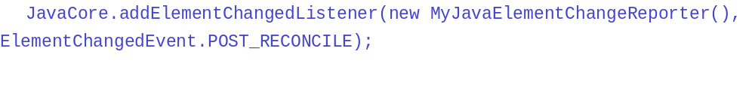There are two kinds of events that are supported by JavaCore:
- POST_CHANGE: Listeners of this event kind will get notified during the corresponding POST_CHANGE resource change notification.
- POST_RECONCILE: Listeners of this event kind will get notified at the end of a reconcile operation on a working copy (see ICompilationUnit.reconcile(int, boolean, WorkingCopyOwner, IProgressMonitor)).
Java element change listeners are similar conceptually to resource change listeners (described in tracking resource changes). The following snippet implements a Java element change reporter that prints the element deltas to the system console.
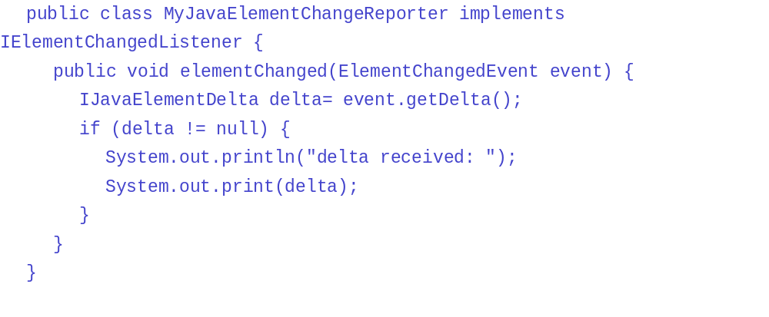
The IJavaElementDelta includes the element that was changed and flags describing the kind of change that occurred. Most of the time the delta tree is rooted at the Java Model level. Clients must then navigate this delta using getAffectedChildren to find out what projects have changed.
The following example method traverses a delta and prints the elements that have been added, removed and changed:
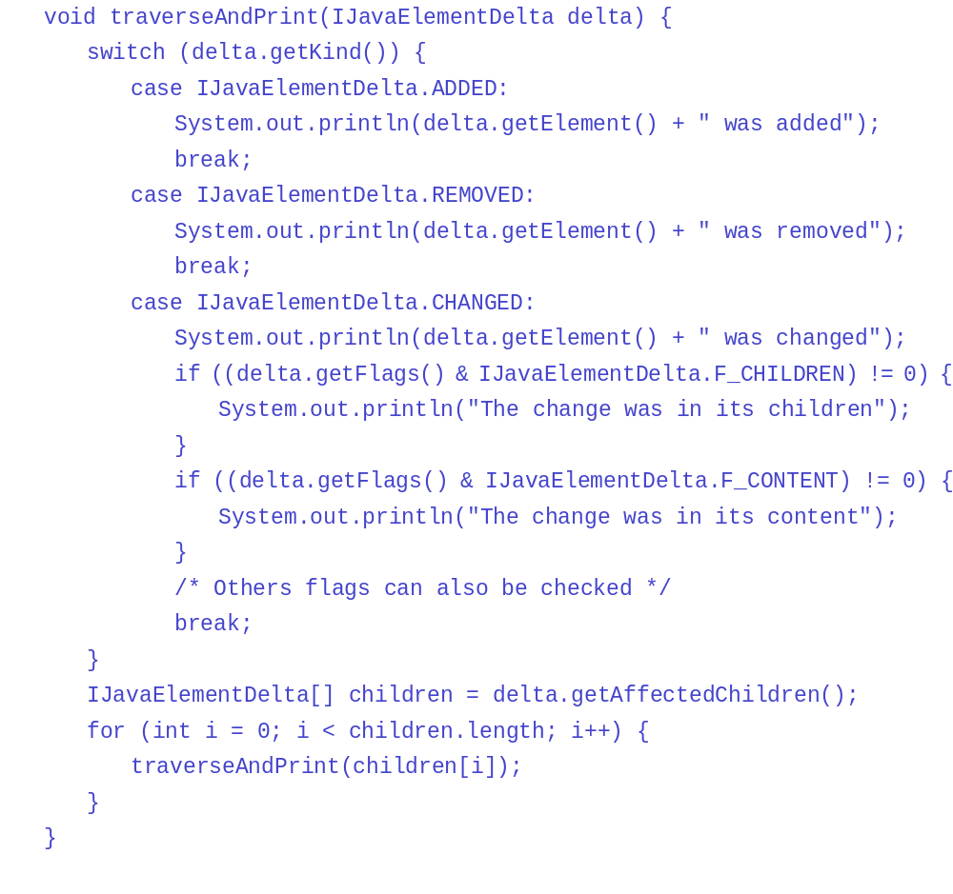
Since IAnnotations are not children of any Java element, annotation deltas are obtained using getAnnotationDeltas().
Several kinds of operations can trigger a Java element change notification. Here are some examples:
- Creating a resource, e.g. IPackageFragment.createCompilationUnit (the delta indicates the addition of the compilation unit)
- Modifying a resource, e.g. ICompilationUnit.createType (the delta indicates that the compilation unit has changed and that a type was added as a child of this compilation unit)
- Modifying a project's classpath, e.g. IJavaProject.setRawClasspath (the delta indicates that package fragment roots have been added to the classpath, removed from the classpath, or reordered on the classpath)
- Modifying a classpath variable value, e.g. JavaCore.setClasspathVariable (the delta also indicates that package fragment roots have been affected)
- Reconciling a working copy with its buffer, e.g. ICompilationUnit.reconcile
- Modifying an IFile that ends with ".java" and that is on the project's classpath, e.g. using IFile.setContents (the delta indicates that a compilation unit was changed, but no finer-grained information is provided as this was not done through a Java Model operation)
Similar to IResourceDelta the Java element deltas can be batched using an IWorkspaceRunnable. The deltas resulting from several Java Model operations that are run inside a IWorkspaceRunnable are merged and reported at once.
JavaCoreprovides a run method for batching Java element changes.
For example, the following code fragment will trigger 2 Java element change events:

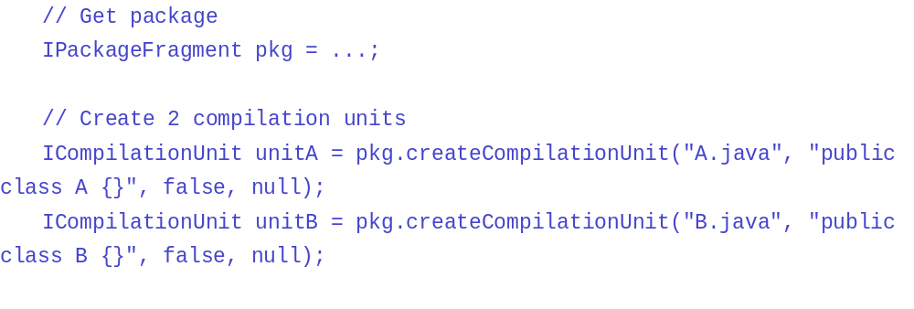Whereas the following code fragment will trigger 1 Java element change event:

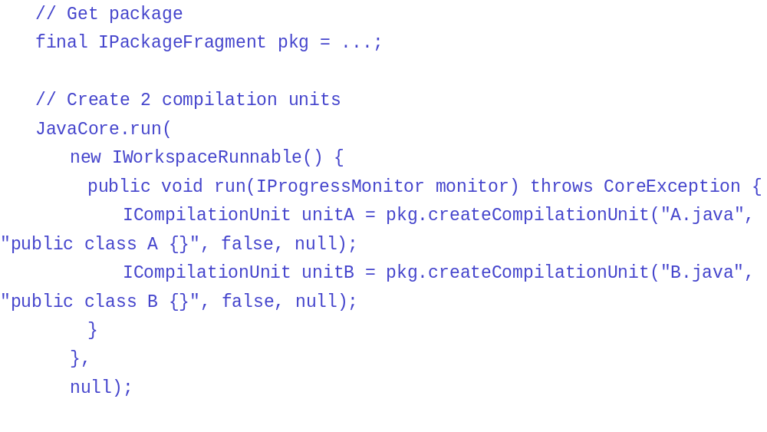

Setting the Java build path
This section describes how to set the Java build path. The build path is the classpath that is used for building a Java project (IJavaProject).
A classpath is simply an array of classpath entries (IClasspathEntry) that describe the types that are available. The types can appear in source or binary form and the ordering of the entries on the path defines the lookup order for resolving types during a build.
The Java build path is reflected in the structure of a Java project element. You can query a project for its package fragment roots (IPackageFragmentRoot). Each classpath entry maps to one or more package fragment roots, each of which further contains a set of package fragments.
This discussion of the build path does not involve the Java runtime path, which can be defined separately from the build path. (See Running Java code for a discussion of the runtime classpath.)

Changing the build path
You can programmatically change a project's build path using setRawClasspath on the corresponding project's Java element. The following code sets the classpath for a project resource:

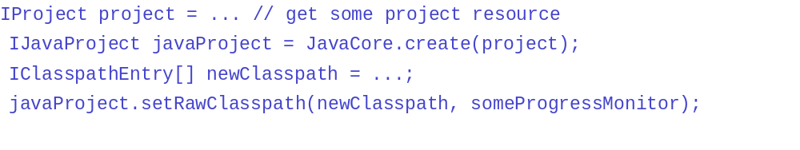
(Note: The use of the term "raw" classpath is used to emphasize the fact that any variables used to describe entry locations have not been resolved.)
The Java build path is persisted into a file named '.classpath' in the project's file structure. The purpose of this file is to provide a way to share Java build path settings with others through some source code repository. In particular, this file should not be manually edited, since it may get corrupted.

Classpath entries
Classpath entries can be defined using factory methods defined on JavaCore. Classpath entries can reference any of the following:
- a source folder - a folder containing source compilation units organized under their corresponding package directory structure. Source folders are used to better structure source files in large projects, and may only be referenced within the containing project. The corresponding factory method is newSourceEntry. Inside a given source folder, each compilation unit is expected to be nested in the appropriate folder structure according to its package statement. For example, compilation unit 'X.java' in package 'p1' must be located inside sub-folder 'p1' of a source folder. It is possible to use multiple source folders, as long as they don't overlap. A source folder may be assigned its own output location which determines where generated class files should be placed. If none is specified, then class files will be placed in the containing project's output location (see IJavaProject.setOutputLocation).
The following is an example classpath entry that denotes the source folder 'src' of project 'MyProject':

- a binary library - either a class file folder (contained inside or outside the workspace) or a class file archive file (contained inside or outside the workspace). Archive libraries can have attached source archives, which are extracted when asking a class file element for its source (getSource). The factory method for libraries is newLibraryEntry.
The following is an example classpath entry that denotes the class file folder 'lib' of 'MyProject':

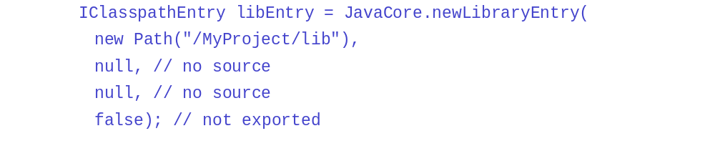
The following classpath entry has a source attachment:

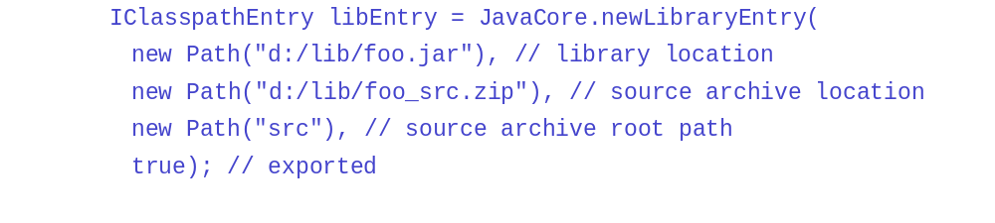
The source archive root path describes the location of the root within the source archive. If set to null, the root of the archive will be inferred dynamically.

- a prerequisite project - another Java project. A prerequisite project always contributes its source folders to dependent projects. It can also optionally contribute any of its classpath entries which are tagged as exported (see factory methods supporting the extra boolean argument 'isExported'). This means that in addition to contributing its source to its dependents, a project will also export all classpath entries tagged as such. This allows prerequisite projects to better hide their own structure changes. For example, a given project may choose to switch from using a source folder to exporting a library. This can be done without requiring its dependent projects to change their classpath. The factory method for a project prerequisite is newProjectEntry.
The following classpath entry denotes a prerequisite project 'MyFramework'.


- an indirect reference to a project or library, using some classpath variable - The location of projects or libraries can be dynamically resolved relative to a classpath variable, which is specified as the first segment of the entry path. The remainder of the entry path is then appended to the resolved variable path. The factory method for a classpath variable is newVariableEntry. Classpath variables are global to the workspace, and can be manipulated through JavaCore methods getClasspathVariable and setClasspathVariable.
It is possible to register an automatic classpath variable initializer which is invoked through the extension point org.eclipse.jdt.core.classpathVariableInitializer when the workspace is started.
The following classpath entry denotes a library whose location is kept in the variable 'HOME'. The source attachment is defined using the variables 'SRC_HOME' and 'SRC_ROOT' :

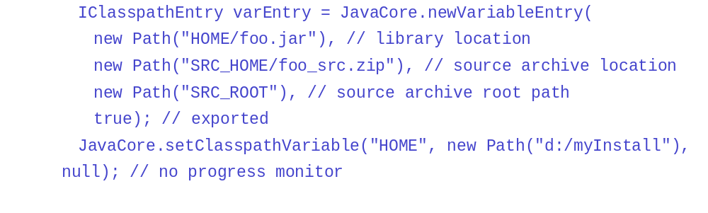
- entry denoting a classpath container - an indirect reference to a structured set of project or libraries. Classpath containers are used to refer to a set of classpath entries that describe a complex library structure. Like classpath variables, classpath containers (IClasspathContainer) are dynamically resolved. Classpath containers may be used by different projects, causing their path entries to resolve to distinct values per project. They also provide meta information about the library that they represent (name, kind, description of library.) The factory method for a classpath variable is newContainerEntry. Classpath containers can be manipulated through JavaCore methods getClasspathContainer and setClasspathContainer.
It is possible to register an automatic classpath container initializer which is lazily invoked through the extension point org.eclipse.jdt.core.classpathContainerInitializer when the container needs to be bound.
The following classpath entry denotes a system class library container:

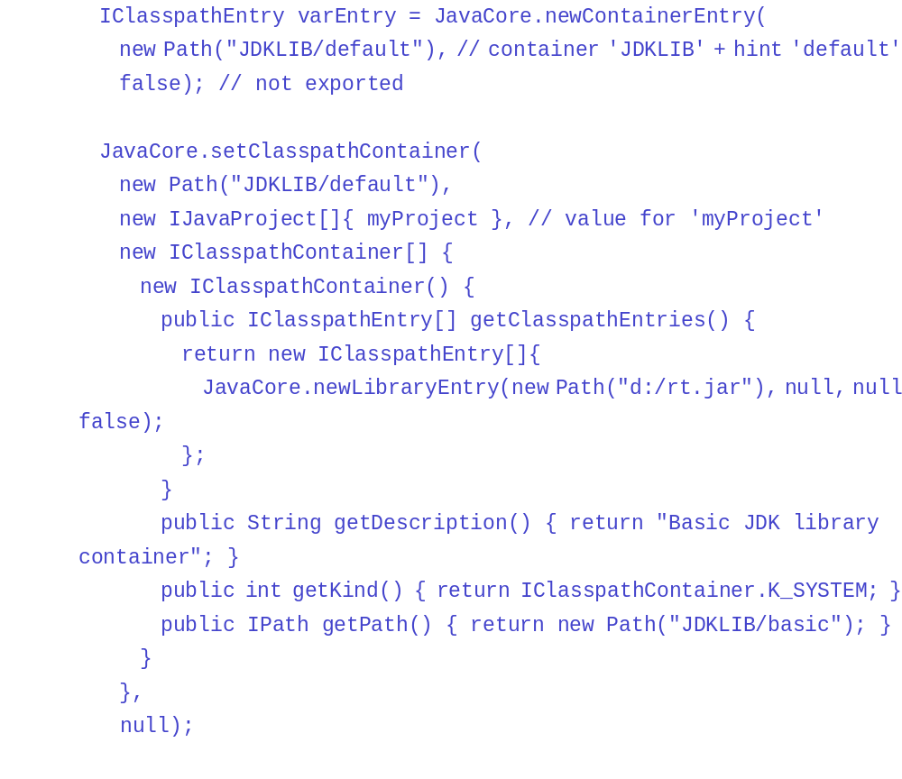

Exclusion patterns
A classpath source entry may be assigned an exclusion pattern, which prevents certain resources in a source folder from being visible on the classpath. Using a pattern allows specified portions of the resource tree to be filtered out. Each exclusion pattern path is relative to the classpath entry and uses a pattern mechanism similar to Ant. Exclusion patterns can be used to specify nested source folders as long as the outer pattern excludes the inner pattern.
See getExclusionPatterns for more detail on exclusion patterns.
The Java project API isOnClasspath checks both inclusion and exclusion patterns before determining whether a particular resource is on the classpath.
Remarks:
- Exclusion patterns have higher precedence than inclusion patterns; in other words, exclusion patterns can remove files from the ones that are to be included, not the other way around.
- A nested source folder excluded from build path can be set as an output location. The following is an example classpath entry that denotes the source folder 'src' of project 'MyProject' with an excluded nested source folder used as an output location:
- 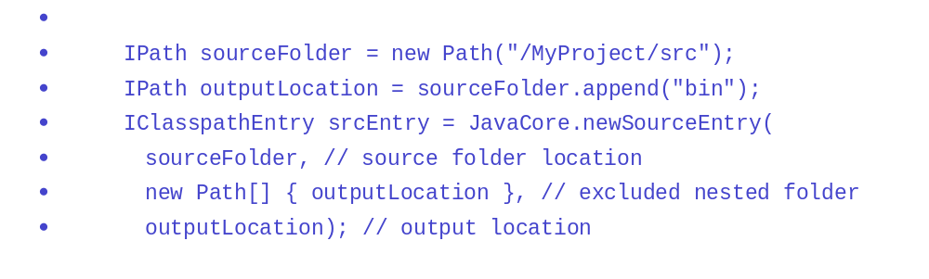

Inclusion patterns
A classpath source entry may also be assigned an inclusion pattern, which explicitly defines resources to be visible on the classpath. When no inclusion patterns are specified, the source entry includes all relevant files in the resource tree rooted at this source entry's path. Specifying one or more inclusion patterns means that only the specified portions of the resource tree are to be included. Each path specified must be a relative path, and will be interpreted relative to this source entry's path. File patterns are case-sensitive. A file matched by one or more of these patterns is included in the corresponding package fragment root unless it is excluded by one or more of this entry's exclusion patterns.
See getExclusionPatterns for a discussion of the syntax and semantics of path patterns. The absence of any inclusion patterns is semantically equivalent to the explicit inclusion pattern **.
The Java project API isOnClasspath checks both inclusion and exclusion patterns before determining whether a particular resource is on the classpath.
Examples:
- The inclusion pattern src/** by itself includes all files under a root folder named src.
- The inclusion patterns src/** and tests/** includes all files under the root folders named src and tests.
- The inclusion pattern src/** together with the exclusion pattern src/**/Foo.java includes all files under a root folder named src except for ones named Foo.java.

Classpath resolution
Since classpath variables and containers allow you to define dynamically bound classpath entries, the classpath API distinguishes between a raw and a resolved classpath. The raw classpath is the one originally set on the Java project using setRawClasspath, and can be further queried by asking the project for getRawClasspath. The resolved classpath can be queried using getResolvedClasspath. This operation triggers initialization of any variables and containers necessary to resolve the classpath. Many Java Model operations implicitly cause the Java build path to be resolved. For example, computing a project's package fragment roots requires the build path to be resolved.

Compiling Java code
See the Java development user guide for using the batch compiler and using the ant javac adapter.
The JDT plug-ins include an incremental and batch Java compiler for building Java .class files from source code. There is no direct API provided by the compiler. It is installed as a builder on Java projects. Compilation is triggered using standard platform build mechanisms.
The platform build mechanism is described in detail in Incremental project builders.

Compiling code
You can programmatically compile the Java source files in a project using the build API.
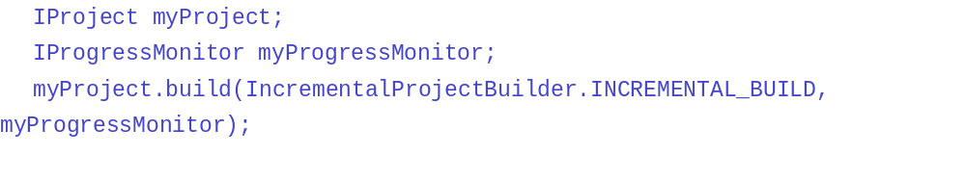
For a Java project, this invokes the Java incremental project builder (along with any other incremental project builders that have been added to the project's build spec). The generated .class files are written to the designated output folder. Additional resource files are also copied to the output folder.
In the case of a full batch build, all the .class files in the output folder may be 'scrubbed' to ensure that no stale files are found. This is controlled using a JDT Core Builder Option (CORE_JAVA_BUILD_CLEAN_OUTPUT_FOLDER). The default for this option is to clean output folders. Unless this option is reset, you must ensure that you place all .class files for which you do not have corresponding source files in a separate class file folder on the classpath instead of the output folder.
The incremental and batch builders can be configured with other options that control which resources are copied to the output folder. The following sample shows how to set up a resource filter so that files ending with '.ignore' and folders named 'META-INF', are not copied to the output folder:
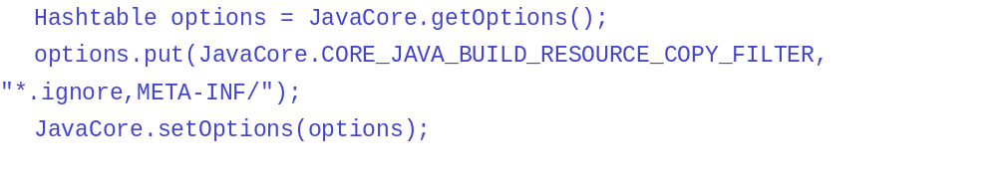
Filenames are filtered out if they match one of the supplied patterns. Entire folders are filtered out if their name matches one of the supplied folder names which end in a path separator.
The incremental and batch builders can also be configured to only generate a single error when the .classpath file has errors. This option is set by default and eliminates numerous errors. See JDT Core Builder Options for a complete list of builder-related options and their defaults.
The compiler can also be configured using JavaCore options. For example, you can define the severity that should be used for different kinds of problems that are found during compilation. See JDT Core Compiler Options for a complete list of compiler-related options and their defaults.
When programmatically configuring options for the builder or compiler, you should specify the scope of the option. For example, setting up a resource filter may apply to a particular project only:

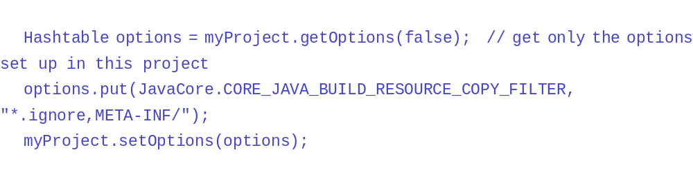

Problem determination
JDT Core defines a specialized marker (marker type "org.eclipse.jdt.core.problem ") to denote compilation problems. To programmatically discover problems detected by the compiler, the standard platform marker protocol should be used. See Resource Markers for an overview of using markers.
The following snippet finds all Java problem markers in a compilation unit.

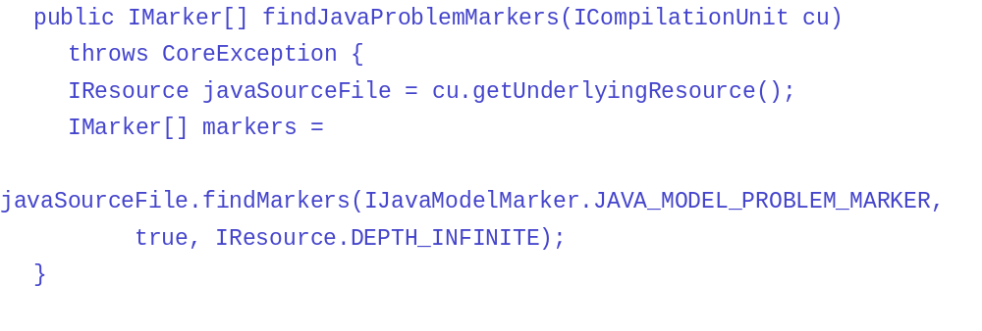
Java problem markers are maintained by the Java project builder and are removed automatically as problems are resolved and the Java source is recompiled.
The problem id value is set to one of the constants defined in IProblem . The problem's id is reliable, but the message is localized and therefore can be changed according to the default locale. The constants defined in IProblem are self-descriptive.
An implementation of IProblemRequestor should be defined to collect the problems discovered during a Java operation. Working copies can be reconciled with problem detection if a IProblemRequestorhas been supplied for the working copy creation. To achieve this, you can use the reconcile method. Here is an example:
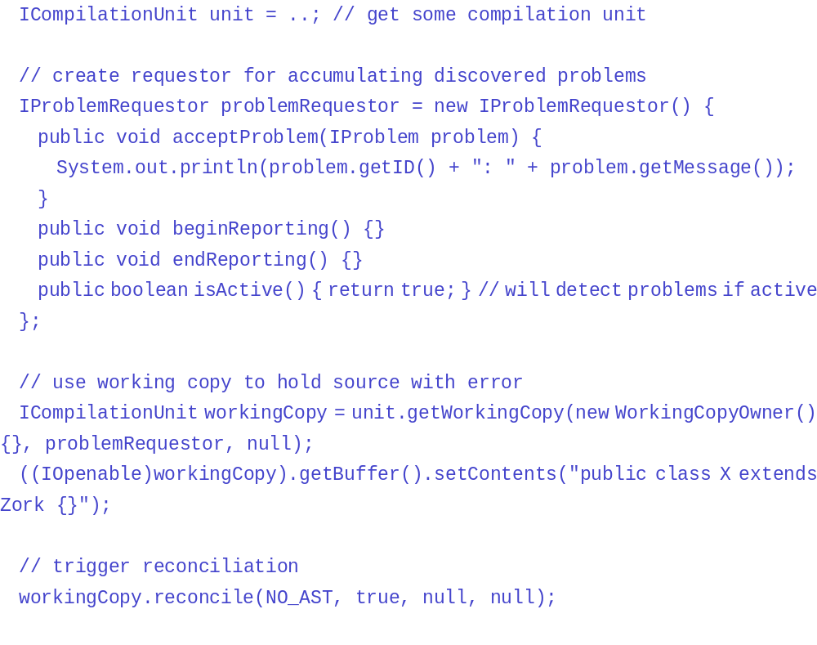
You can add an action on the reported problems in the acceptProblem(IProblem) method. In this example, the reported problem will be that Zork cannot be resolved or is not a valid superclass and its id is IProblem.SuperclassNotFound.

Using the Java search engine
Your plug-in can use the JDT API to search Java projects in the workspace for Java elements, such as method references, field declarations, implementors of an interface, etc.
The entry point for Java search is the SearchEngine class. You can search for particular patterns inside a Java element and scope the search to specific elements. Search patterns can be created using createPattern. A pattern is scoped using createJavaSearchScope. Once a pattern and scope are defined, the search method is used to collect the results.
Search results are reported to a SearchRequestor which you must extend in order to access the results.

Preparing for search
A search operation will use both a pattern for describing the nature of the search, and a scope for restraining the range of investigation.

Creating a Java search pattern
A search pattern defines how search results are found. You can either create a search pattern from a Java element (see createPatternPattern(IJavaElement element, int limitTo)) or from a string (see createPattern(String, int, int, int).) The last method supports wildcards (i.e. '*') and can be used to widen the search results.
For example, creating a search pattern for searching for references to a given method is done as follows:
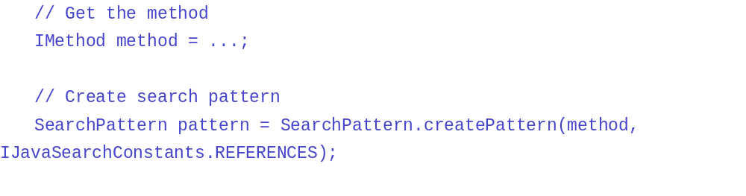
Or creating a search pattern for searching for declarations of all types starting with "Obj":
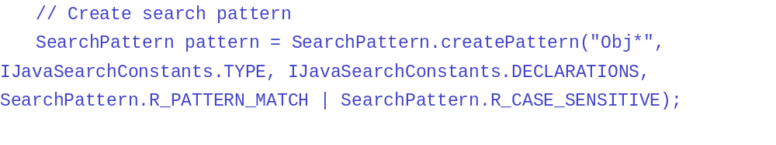
The following search patterns are supported:
- Package declarations
- Type declarations
- Field declarations
- Method (and constructor) declarations
- Package references
- Type references
- Interface implementors
- Field references
- Field write accesses
- Module declarations
- Module references
- Field read accesses
- Method (and constructor) references
- Combinations of the above patterns using the OR pattern (see createOrPattern)
Note that these patterns are created using the following possible rules:
- R_EXACT_MATCH
- R_PREFIX_MATCH
- R_PATTERN_MATCH
- R_REGEXP_MATCH
- R_CAMELCASE_MATCH
- R_CAMELCASE_SAME_PART_COUNT_MATCH
which may be also combined with one of the following flags:
- R_CASE_SENSITIVE
- R_ERASURE_MATCH
- R_EQUIVALENT_MATCH
For example,

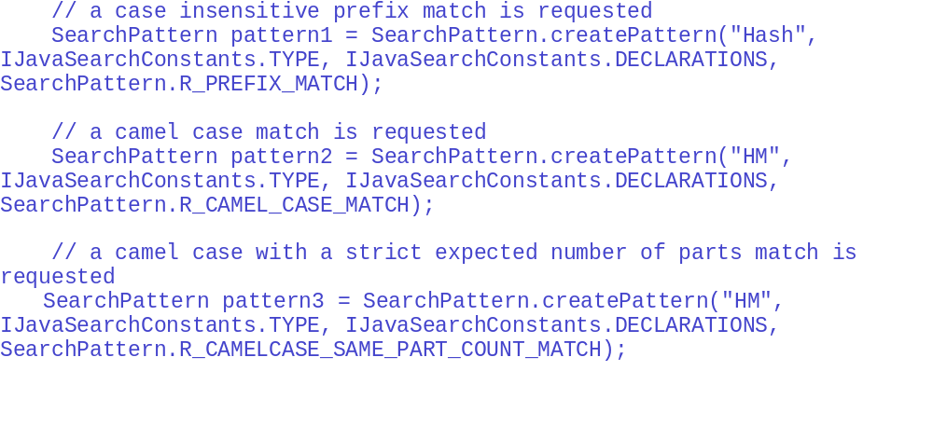
Note that using the patterns created above reduce the number of possible results among others:
- pattern1: Hashtable, HashMap, HashMapEntry, etc.
- pattern2: HashMap, HashMapEntry, etc.
- pattern3: HashMapEntry, etc.

Using fine grain flags in a Java search pattern
Some references patterns can be refined by adding one or several fine grain flags to the limitTo parameter.
For example, only the type references used in a cast expression will match the pattern created as follows:
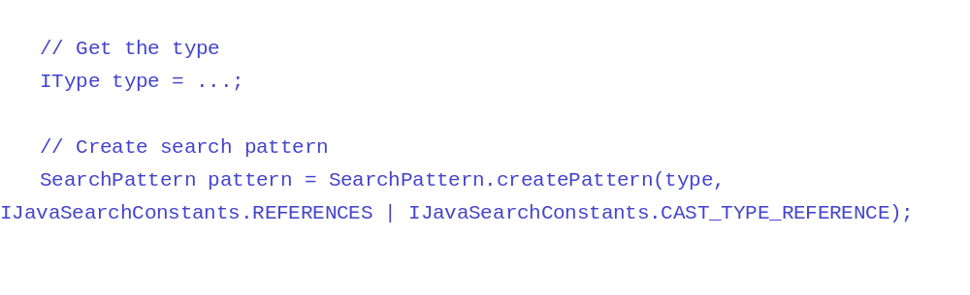
Note that the fine grain flags can be combined together but only for the same kind of search (e.g. only a combination of flags for type references will be meaningful if the searchFor parameter is set to TYPE).
Flags for type references:
- FIELD_DECLARATION_TYPE_REFERENCE: type references used as the type of a field declaration.
- LOCAL_VARIABLE_DECLARATION_TYPE_REFERENCE: type references used as the type of a local variable declaration.
- PARAMETER_DECLARATION_TYPE_REFERENCE: type references used as the type of a method parameter.
- SUPERTYPE_TYPE_REFERENCE: type references used as a super type or as a super interface.
- THROWS_CLAUSE_TYPE_REFERENCE: type references used in a throws clause.
- CAST_TYPE_REFERENCE: type references used in a cast expression.
- CATCH_TYPE_REFERENCE: type references used in a catch header.
- CLASS_INSTANCE_CREATION_TYPE_REFERENCE: type references used in class instance creation.
- RETURN_TYPE_REFERENCE: type references used as a method return type.
- IMPORT_DECLARATION_TYPE_REFERENCE: type references used in an import declaration.
- ANNOTATION_TYPE_REFERENCE: type references used as an annotation.
- TYPE_ARGUMENT_TYPE_REFERENCE: type references used as a type argument in a parameterized type or a parameterized method.
- TYPE_VARIABLE_BOUND_TYPE_REFERENCE: type references used as a type variable bound.
- WILDCARD_BOUND_TYPE_REFERENCE: type references used as a wildcard bound.
- INSTANCEOF_TYPE_REFERENCE: type references used in an instance of condition.
Flags for field or method references:
- SUPER_REFERENCE: super field accesses or super method invocations (e.g. using the super qualifier).
- QUALIFIED_REFERENCE: qualified field accesses or qualified method invocations.
- THIS_REFERENCE: primary field accesses or primary method invocations (e.g. using the this qualifier).
- IMPLICIT_THIS_REFERENCE: field accesses or method invocations without any qualification.

Creating a Java search scope
If you are interested in search results in a given project or even in a given package, or if you know that search results can only be found in the hierarchy of a given type, you can create the appropriate search scope using createJavaSearchScope(IJavaElement[]) or createHierarchyScope(IType).
For example, creating a search scope on a given package is done as follows:
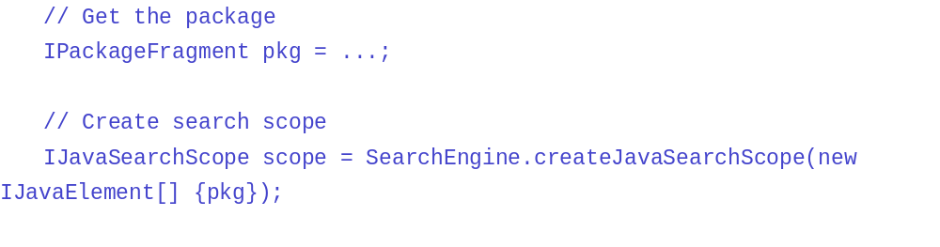
Or creating a search scope on the hierarchy of a given type is:
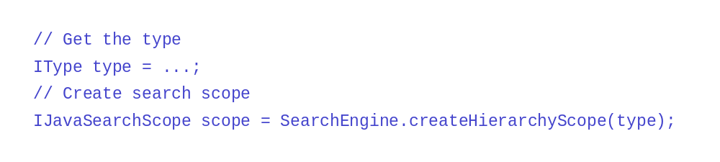Finally, you can create a search scope comprising the entire workspace using createWorkspaceScope:
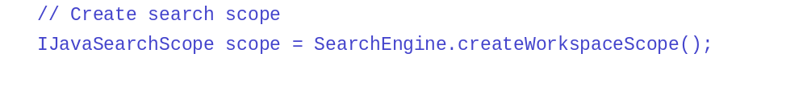

Searching
Once you have created a search pattern and a search scope, and you have extended SearchRequestor, you can start a search query as follows:
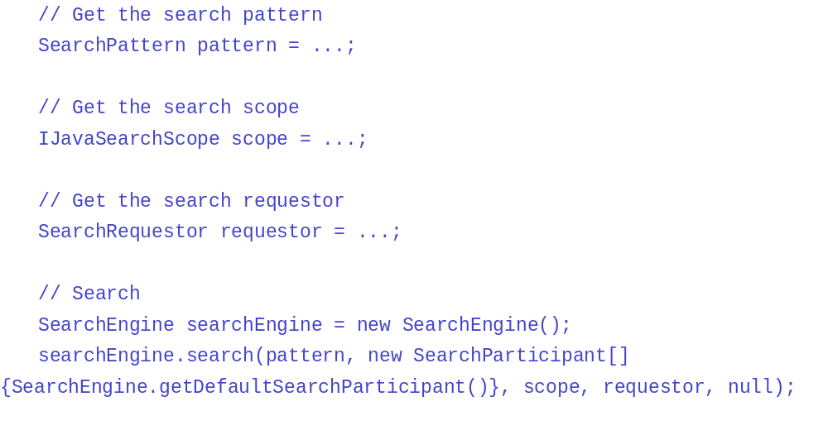
A notification that the search starts is sent to your search requestor using the beginReporting method. Then, each search result is reported using the acceptSearchMatch method. Finally endReportingindicates that the search has ended.

Collecting search results
Search results are reported using the acceptSearchMatch(SearchMatch) method. Paragraphs below highlight some features of SearchMatch.

Resources and Java elements
A search result can correspond to a Java element (e.g. a type declaration) or it can be contained in a Java element (e.g. a reference to a type inside a method). The search engine always tries to find the innermost Java element that corresponds to or that contains the search result. For example, searching for references to a method could find such a reference in an initializer. The initializer that contains this method reference is the element of the search match.
The search engine also tries to find the resource that contains the Java element. If the Java element is contained in a compilation unit or a class file, the resource is the corresponding IFile. If the Java element is contained in a .jar file, the returned resource is that .jar file if it is in the workspace, null otherwise.

Source positions
Source positions getOffset and getLength are given relative to the compilation unit that contains the search result. If the search result is contained in a .jar file, the source positions are relative to the attached source. They are (-1, -1) if there is no source attached to the .jar file.

Accurate versus inaccurate search results
In most cases search results are accurate, meaning that the search engine was able to determine that the given match is what was asked for. However in some cases the search engine is unable to do so, in such cases the match is inaccurate. Some possible reasons why a match could be inaccurate are:
- The classpath on the project that contains the result is not properly set. For example, it refers to a project that is not accessible, a jar on the classpath requires another jar that is not on the classpath, etc.
- The user code would not compile. For example, it refers to a class that is not yet defined.

Indexes for the Java search
The JDT search creates indexes for all the sources and the dependent JARs. As a JAR gets added onto the classpath, it is indexed. This operation could take some time depending upon the size of the JAR. To improve the performance, one can pre-build the index and specify the index file for a JAR when it gets added onto the classpath. This is only supported for JARs.

Generating the index
An index can be pre-generated in the following ways:
- An API JavaIndexer#generateIndexForJar.
- A command line application JavaIndexer
- An Ant task eclipse.buildJarIndex

Specifying the index
The index can be specified as a classpath attribute of the library that is getting added. The index file has to be in a valid URL form. If the index file is not found, JDT generates an index file and uses it for searches.

Performing code assist on Java code
The JDT API allows other plug-ins to perform code assist or code select on some Java elements. Elements that allow this manipulation should implement ICodeAssist.
There are two kinds of manipulation:
- Code completion - compute the completion of a Java token.
- Code selection - answer the Java element indicated by the selected text of a given offset and length.
In the Java model there are two elements that implement this interface: IClassFile and ICompilationUnit. Code completion and code selection only answer results for a class file if it has attached source.

Code completion

Performing a code completion
One way to programmatically perform code completion is to invoke ICodeAssist.codeComplete. You specify the offset in the compilation unit after which the code completion is desired. You must also supply an instance of CompletionRequestor to accept the possible completions.
The method in CompletionRequestor.accept(CompletionProposal) accepts all kinds of proposals for code completion. The methods of CompletionProposal give information that describes the proposed element (its name, declaring type, etc.), its proposed position for insertion in the compilation unit, and its relevance.
A completion requestor can accept many different kinds of completions. This kind is given by CompletionProposal.getKind.
Some of the possible completion kinds are (The complete list of possible completion kinds can be seen on CompletionProposal):
- annotation attribute - ANNOTATION_ATTRIBUTE_REF
- anonymous type - ANONYMOUS_CLASS_DECLARATION
- type reference - TYPE_REF
- field reference- FIELD_REF
- keyword - KEYWORD
- label reference - LABEL_REF
- local variable reference - LOCAL_VARIABLE_REF
- method reference - METHOD_REF
- method declaration - METHOD_DECLARATION
- package import or reference - PACKAGE_REF
- variable name - VARIABLE_DECLARATION
The completion requestor must also be able to accept compilation errors.

Completion relevance
Because there may be many different possible completions, the notion of relevance is used to compare the relevance of a suggested completion to other proposals. Relevance is represented by a positive integer. The value has no implicit meaning except to be used relative to the value for other proposals. The relevance of a code completion candidate can be affected by the expected type of the expression, as it relates to the types in the surrounding code, such as variable types, cast types, return types, etc. The presence of an expected prefix or suffix in a completion also affects its relevance.

Completion context
An instance of CompletionRequestor can also accept a completion context. This context is given by the method CompletionRequestor.acceptContext(CompletionContext) and does not depend on a specific completion proposal. The methods of CompletionContext give information that describe the general context like the offset of completion, the completed token, the completed token kind (name or string literal) and its position.
A CompletionContext can also give some information about elements (IJavaElement) which are related to the completion location. These elements are based on the content of the completed compilation unit's buffer and are not the result of the last reconcile operation.
Some of these methods are:
- getEnclosingElement() - This method returns the innermost enclosing element which contains the completion location
- getVisibleElements(String) - This method returns the elements which are visible from the completion location and which can be assigned to the given type

Code completion options
The JDT Core plug-in defines options that control the behavior of code completion. These options can be changed by other plug-ins.
- Activate Visibility Sensitive Completion
When this option is active, code completion will not answer elements that are not visible in the current context. (For example, it will not answer private methods of a super class.)
- Automatic Qualification of Implicit Members
When this option is active, completion automatically qualifies completion on implicit field references and message expressions.
Additional options allow you to specify prefixes and suffixes for the proposed completion names for fields, static fields, local variables, and method arguments.
See JDT Core Code Assist Options for more information about the code assist options and their defaults.

Code selection

Performing a code selection
Code selection is used to find the Java element represented by a range of text (typically the selected text) in a compilation unit. To programmatically perform code selection, you must invoke ICodeAssist.codeSelect. You must supply the starting index location of the selection and its length. The result is an array of Java elements. Most of the time there is only one element in the array, but if the selection is ambiguous then all the possible elements are returned.
In the following example, code select is invoked for a compilation unit.
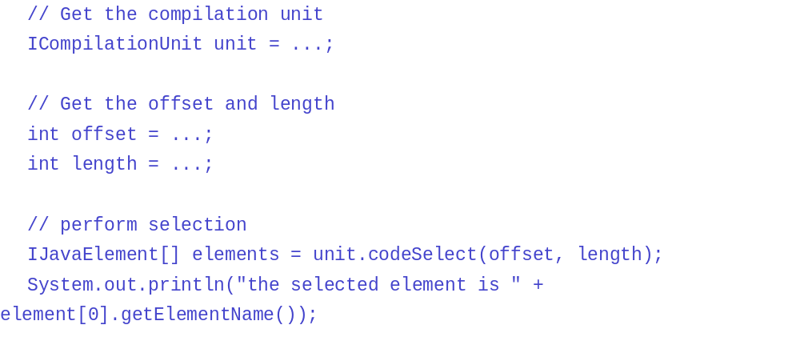

Selection at cursor location
When the selection length is specified as 0, a selection will be computed by finding the complete token that encloses the specified offset. Consider the following example method:
public void fooMethod(Object) {
}
If you specify an offset after the first character of fooMethod, and you specify a length of 0, then the selection will be computed to include the entire token fooMethod. If instead, you specify a length of 5, the selection will considered as ooMet.

jDT Core options
JDT Core options control the behavior of core features such as the Java compiler, code formatter, code assist, and other core behaviors. The APIs for accessing the options are defined in JavaCore. Options can be accessed as a group as follows:
- JavaCore.getDefaultOptions() - Answers the default value of the options.
- JavaCore.getOptions() - Answers the current values of the options.
- JavaCore.setOptions(Hashtable newOptions) - Replaces the options values by new values.
Options can also be accessed individually by a string name.
- JavaCore.getOption(String optionName) - Answers the value of a specific option.
Options that can configure the severity of a problem can also be found.
- JavaCore.getOptionForConfigurableSeverity(int problemID) - Answers the option to use to configure the severity of the problem identified by problemID.
Options are stored as a hash table of all known configurable options with their values. Helper constants have been defined on JavaCore for each option ID and its possible constant values.
The following code fragment restores the value of all core options to their defaults except for one (COMPILER_PB_DEPRECATION), which is set specifically.
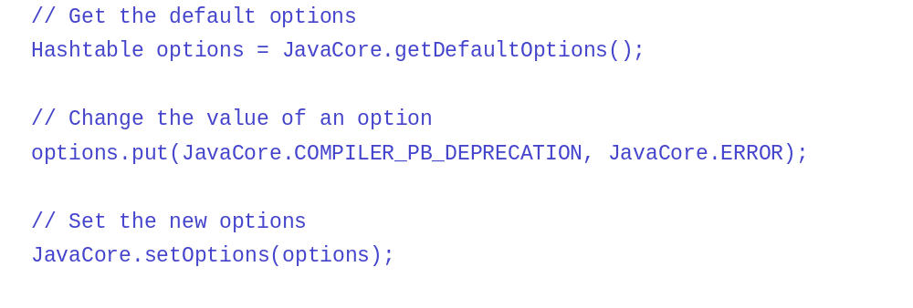
The following code fragment keeps the value of the current options and modifies only one (COMPILER_PB_DEPRECATION):

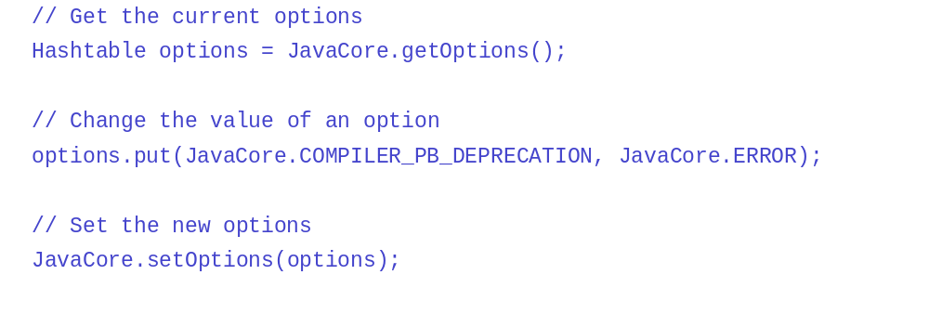

Project specific options
The values of options can be overridden per project using protocol in IJavaProject.
The following code fragment retrieves the value of an option (COMPILER_PB_DEPRECATION) for a specific project in two different ways. The boolean parameter controls whether only the project-specific options should be returned in a query or whether the project's option values should be merged with the values in JavaCore.

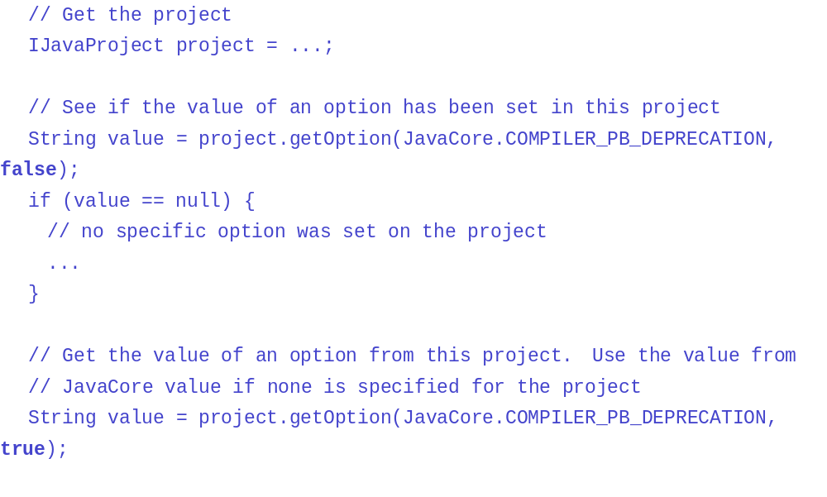

JDT Core options descriptions
The following tables describe the available JDT Core options. The option id is shown in parentheses and the default value is shown in bold italics.

Options categories
- Compiler options
- Builder options
- JavaCore options
- Formatter options
- CodeAssist options

Compiler options
Description | Values
Annotation Based Null Analysis (COMPILER_ANNOTATION_NULL_ANALYSIS)
This option controls whether the compiler will use null annotations for improved analysis of (potential) null references.  When enabled, the compiler will interpret the annotation types defined using COMPILER_NONNULL_ANNOTATION_NAME and COMPILER_NULLABLE_ANNOTATION_NAME as specifying whether or not a given type includes the value null.  The effect of these analyses is further controlled by the options COMPILER_PB_NULL_SPECIFICATION_VIOLATION,COMPILER_PB_NULL_ANNOTATION_INFERENCE_CONFLICT, COMPILER_PB_NULL_UNCHECKED_CONVERSION,COMPILER_PB_REDUNDANT_NULL_ANNOTATION, COMPILER_PB_MISSING_NONNULL_BY_DEFAULT_ANNOTATION,COMPILER_PB_SYNTACTIC_NULL_ANALYSIS_FOR_FIELDS, COMPILER_PB_NONNULL_PARAMETER_ANNOTATION_DROPPED, and COMPILER_INHERIT_NULL_ANNOTATIONS. | ENABLED
 | DISABLED
Inline JSR Bytecode Instruction (COMPILER_CODEGEN_INLINE_JSR_BYTECODE)
When enabled in conjunction with a Java target platform lesser than or equal to "1.4", the compiler will no longer generate JSR instructions, but rather inline corresponding subroutine code sequences (mostly corresponding to try finally blocks). The generated code will thus get bigger, but will load faster on virtual machines since the verification process is then much simpler. This mode is adding support for the Java Specification Request 202 to pre-"1.5" Java target platforms.  For a Java target platform greater than or equal to "1.5", the inlining of the JSR bytecode instruction is mandatory and this option is ignored. | ENABLED
 | DISABLED
Generating Method Parameters Attribute (COMPILER_CODEGEN_METHOD_PARAMETERS_ATTR)
When generated, this attribute will enable information about the formal parameters of a method (such as their names) to be accessed from reflection libraries, annotation processing, code weaving, and in the debugger, from platform target level 1.8 and later. | GENERATE
 | DO_NOT_GENERATE
Setting Target Java Platform (COMPILER_CODEGEN_TARGET_PLATFORM)
For binary compatibility reason, .class files are tagged with VM versions that are defined for each level of the reference specification. The target Java platform specifies the minimum runtime level required to execute the generated class files.  The compliance, source and target levels must satisfy a set of constraints summarized in a compatibility table below. | VERSION_1_1
 | VERSION_1_2
 | VERSION_1_3
 | VERSION_1_4
 | VERSION_1_5
 | VERSION_1_6
 | VERSION_1_7
 | VERSION_1_8
 | VERSION_CLDC_1_1
Preserving Unused Local Variables (COMPILER_CODEGEN_UNUSED_LOCAL)
Unless requested to preserve unused local variables (i.e. never read), the compiler will optimize them out, potentially altering debugging. | PRESERVE
 | OPTIMIZE_OUT
Setting Compliance Level (COMPILER_COMPLIANCE)
Select the compliance level for the compiler, which will then behave according to the said level of the reference specification.  The compliance, source and target levels must satisfy a set of constraints summarized in a compatibility table below. | VERSION_1_3
 | VERSION_1_4
 | VERSION_1_5
 | VERSION_1_6
 | VERSION_1_7
 | VERSION_1_8
 | VERSION_9
Javadoc Comment Support (COMPILER_DOC_COMMENT_SUPPORT)
When this support is disabled, the compiler will ignore all javadoc problems options settings and will not report any javadoc problem. It will also not find any reference in javadoc comment and DOM AST Javadoc node will be only a flat text instead of having structured tag elements. | ENABLED
 | DISABLED
Inheritance of Null Annotations (COMPILER_INHERIT_NULL_ANNOTATIONS)
When enabled, the compiler will check for each method without any explicit null annotations (see COMPILER_ANNOTATION_NULL_ANALYSIS): If it overrides a method which has null annotations, it will treat the current method as if it had the same annotations as the overridden method.  Annotation inheritance will use the effective nullness of the overridden method after transitively applying inheritance and after applying any default nullness (see COMPILER_NONNULL_BY_DEFAULT_ANNOTATION_NAME) at the site of the overridden method.  If different implicit null annotations (from a nonnull default and/or overridden methods) are applicable to the same type in a method signature, this is flagged as an error and an explicit null annotation must be used to disambiguate. | ENABLED
 | DISABLED
Generating Line Number Debug Attribute (COMPILER_LINE_NUMBER_ATTR)
When generated, this attribute will enable source code highlighting in the debugger (.class file is then bigger). | GENERATE
 | DO_NOT_GENERATE
Generating Local Variable Debug Attribute (COMPILER_LOCAL_VARIABLE_ATTR)
When generated, this attribute will enable local variable names to be displayed in the debugger, only in places where variables are definitely assigned (.class file is then bigger). | GENERATE
 | DO_NOT_GENERATE
Name of Annotation Type for Non-Null Types (COMPILER_NONNULL_ANNOTATION_NAME)
This option defines a fully qualified Java type name that the compiler may use to perform special null analysis.  If the annotation specified by this option is applied to a type in a method signature or variable declaration, this will be interpreted as a specification that null is not a legal value in that position. Currently supported positions are: method parameters, method return type and local variables.  For values declared with this annotation, the compiler will never trigger a null reference diagnostic (as controlled by COMPILER_PB_POTENTIAL_NULL_REFERENCE and COMPILER_PB_NULL_REFERENCE), because the assumption is made that null will never occur at runtime in these positions.  The compiler may furthermore check adherence to the null specification as further controlled by COMPILER_PB_NULL_SPECIFICATION_VIOLATION, COMPILER_PB_NULL_ANNOTATION_INFERENCE_CONFLICT andCOMPILER_PB_NULL_UNCHECKED_CONVERSION.  This option only has an effect if the option COMPILER_ANNOTATION_NULL_ANALYSIS is enabled. | The qualified name of a Java annotation type  Default is: org.eclipse.jdt.annotation.NonNull
Names of Secondary Annotation Types for Non-Null Types (COMPILER_NONNULL_ANNOTATION_SECONDARY_NAMES)
This option defines a comma-separated list of fully qualified Java type names that the compiler may use to perform special null analysis.  The annotation types identified by the names in this list are interpreted in the same way as the annotation identified by {@link #COMPILER_NONNULL_ANNOTATION_NAME}. The intention is to support libraries using different sets of null annotations, in addition to those used by the current project. Secondary null annotations should not be used in the project's own source code.  JDT will never actively use any secondary annotation names from this list, i.e., inferred null annotations and content assist proposals mentioning null annotations are always rendered using the primary name from COMPILER_NONNULL_ANNOTATION_NAME.  This option only has an effect if the option COMPILER_ANNOTATION_NULL_ANALYSIS is enabled. | The qualified name of a Java annotation type  Default is: ""
Name of Annotation Type for Nullable Types (COMPILER_NULLABLE_ANNOTATION_NAME)
This option defines a fully qualified Java type name that the compiler may use to perform special null analysis.  If the annotation specified by this option is applied to a type in a method signature or variable declaration, this will be interpreted as a specification that null is a legal value in that position. Currently supported positions are: method parameters, method return type and local variables.  If a value whose type is annotated with this annotation is dereferenced without checking for null, the compiler will trigger a diagnostic as further controlled by COMPILER_PB_POTENTIAL_NULL_REFERENCE.  The compiler may furthermore check adherence to the null specification as further controlled by COMPILER_PB_NULL_SPECIFICATION_VIOLATION, COMPILER_PB_NULL_ANNOTATION_INFERENCE_CONFLICT andCOMPILER_PB_NULL_UNCHECKED_CONVERSION.  This option only has an effect if the option COMPILER_ANNOTATION_NULL_ANALYSIS is enabled. | The qualified name of a Java annotation type  Default is: org.eclipse.jdt.annotation.Nullable
Names of Secondary Annotation Types for Nullable Types (COMPILER_NULLABLE_ANNOTATION_SECONDARY_NAMES)
This option defines a comma-separated list of fully qualified Java type names that the compiler may use to perform special null analysis.  The annotation types identified by the names in this list are interpreted in the same way as the annotation identified by COMPILER_NULLABLE_ANNOTATION_NAME. The intention is to support libraries using different sets of null annotations, in addition to those used by the current project. Secondary null annotations should not be used in the project's own source code.  JDT will never actively use any secondary annotation names from this list, i.e., inferred null annotations and content assist proposals mentioning null annotations are always rendered using the primary name from COMPILER_NULLABLE_ANNOTATION_NAME.  This option only has an effect if the option COMPILER_ANNOTATION_NULL_ANALYSIS is enabled. | The qualified name of a Java annotation type  Default is: ""
Name of Annotation Type to specify a nullness default for unannotated types. (COMPILER_NONNULL_BY_DEFAULT_ANNOTATION_NAME)
This option defines a fully qualified Java type name that the compiler may use to perform special null analysis.  If the annotation is applied without an argument, all unannotated types in method signatures within the annotated element will be treated as if they were specified with the non-null annotation (see COMPILER_NONNULL_ANNOTATION_NAME).  If the annotation is applied with the constant false as its argument, all corresponding defaults specified using this annotation at outer scopes will be canceled for the annotated element.  This option only has an effect if the option COMPILER_ANNOTATION_NULL_ANALYSIS is enabled. | The qualified name of a Java annotatin type  Default is: org.eclipse.jdt.annotation.NonNullByDefault
Names of Secondary Annotation Types to specify a nullness default for unannotated types (COMPILER_NONNULL_BY_DEFAULT_ANNOTATION_SECONDARY_NAMES)
This option defines a comma-separated list of fully qualified Java type names that the compiler may use to perform special null analysis.  The annotation types identified by the names in this list are interpreted in the same way as the annotation identified by COMPILER_NONNULL_BY_DEFAULT_ANNOTATION_NAME. The intention is to support libraries using different sets of null annotations, in addition to those used by the current project. Secondary null annotations should not be used in the project's own source code.  This option only has an effect if the option COMPILER_ANNOTATION_NULL_ANALYSIS is enabled. | The qualified name of a Java annotatin type  Default is: ""
Reporting Use of Annotation Type as Super Interface (COMPILER_PB_ANNOTATION_SUPER_INTERFACE)
When enabled, the compiler will issue an error or a warning whenever an annotation type is used as a super-interface. Though legal, this is discouraged. | ERROR
 | WARNING
 | INFO
 | IGNORE
Reporting Usage of 'assert' Identifier (COMPILER_PB_ASSERT_IDENTIFIER)
When enabled, the compiler will issue an error or a warning whenever 'assert' is used as an identifier (reserved keyword in 1.4) | ERROR
 | WARNING
 | INFO
 | IGNORE
Reporting Boxing/Unboxing Conversion (COMPILER_PB_AUTOBOXING)
When enabled, the compiler will issue an error or a warning whenever a boxing or an unboxing conversion is performed. | ERROR
 | WARNING
 | INFO
 | IGNORE
Reporting Usage of char[] Expressions in String Concatenations (COMPILER_PB_CHAR_ARRAY_IN_STRING_CONCATENATION)
When enabled, the compiler will issue an error or a warning whenever a char[] expression is used in String concatenations (e.g. "hello" + new char[]{'w','o','r','l','d'}). | ERROR
 | WARNING
 | INFO
 | IGNORE
Reporting Deprecation (COMPILER_PB_DEPRECATION)
When enabled, the compiler will signal use of deprecated API either as an error or a warning. | ERROR
 | WARNING
 | INFO
 | IGNORE
Reporting Terminal Deprecation (COMPILER_PB_TERMINAL_DEPRECATION)
When enabled, the compiler will signal use of terminally deprecated API either as an error or a warning. | ERROR
 | WARNING
 | INFO
 | IGNORE
Reporting Deprecation Inside Deprecated Code (COMPILER_PB_DEPRECATION_IN_DEPRECATED_CODE)
When enabled, the compiler will signal use of deprecated API inside deprecated code either as an error or a warning. | ENABLED
 | DISABLED
Reporting Deprecation When Overriding Deprecated Method (COMPILER_PB_DEPRECATION_WHEN_OVERRIDING_DEPRECATED_METHOD)
When enabled, the compiler will signal the declaration of a method overriding a deprecated one. | ENABLED
 | DISABLED
Reporting Discouraged Reference to Type with Restricted Access (COMPILER_PB_DISCOURAGED_REFERENCE)
When enabled, the compiler will issue an error or a warning when referring to a type with discouraged access, as defined according to the access rule specifications. | ERROR
 | WARNING
 | INFO
 | IGNORE
Reporting Empty Statements and Unnecessary Semicolons (COMPILER_PB_EMPTY_STATEMENT)
When enabled, the compiler will issue an error or a warning if an empty statement or a unnecessary semicolon is encountered. | ERROR
 | WARNING
 | INFO
 | IGNORE
Reporting Usage of 'enum' Identifier (COMPILER_PB_ENUM_IDENTIFIER)
When enabled, the compiler will issue an error or a warning whenever 'enum' is used as an identifier (reserved keyword in 1.5). | ERROR
 | WARNING
 | INFO
 | IGNORE
Reporting Switch Fall-Through Case (COMPILER_PB_FALLTHROUGH_CASE)
When enabled, the compiler will issue an error or a warning when a case may be entered by falling through a preceding, non empty case. | ERROR
 | WARNING
 | INFO
 | IGNORE
Treating Optional Errors as Fatal (COMPILER_PB_FATAL_OPTIONAL_ERROR)
When enabled, optional errors (i.e. optional problems which severity has been set to "error") will be treated as standard compile errors, that is as fatal errors. When detecting a fatal error in source code, the compiler generates problem methods/types into the corresponding class files, in effect preventing the offending code from running until all issues get resolved.  When disabled, optional errors are only considered as warnings for code generation purposes, but they still carry an error indicator to make them more severe than regular warnings. | ENABLED
 | DISABLED
Reporting Field Declaration Hiding another Variable (COMPILER_PB_FIELD_HIDING)
When enabled, the compiler will issue an error or a warning whenever a field declaration is hiding some field or local variable (either locally, inherited or defined in enclosing type). | ERROR
 | WARNING
 | INFO
 | IGNORE
Reporting Final Bound for Type Parameter (COMPILER_PB_FINAL_PARAMETER_BOUND)
When enabled, the compiler will issue an error or a warning whenever a generic type parameter is associated with a bound corresponding to a final type; since final types cannot be further extended, the parameter is pretty useless. | ERROR
 | WARNING
 | INFO
 | IGNORE
Reporting Finally Blocks Not Completing Normally (COMPILER_PB_FINALLY_BLOCK_NOT_COMPLETING)
When enabled, the compiler will issue an error or a warning when a finally block does not complete normally. | ERROR
 | WARNING
 | INFO
 | IGNORE
Reporting Forbidden Reference to Type with Restricted Access (COMPILER_PB_FORBIDDEN_REFERENCE)
When enabled, the compiler will issue an error or a warning when referring to a type that is non accessible, as defined according to the access rule specifications. | ERROR
 | WARNING
 | INFO
 | IGNORE
Reporting Missing HashCode Method (COMPILER_PB_MISSING_HASHCODE_METHOD)
When enabled, the compiler will issue an error or a warning if a type overrides Object.equals(Object) but does not override hashCode(). | ERROR
 | WARNING
 | INFO
 | IGNORE
Reporting Hidden Catch Block (COMPILER_PB_HIDDEN_CATCH_BLOCK)
Local to a try statement, some catch blocks may hide others , e.g.  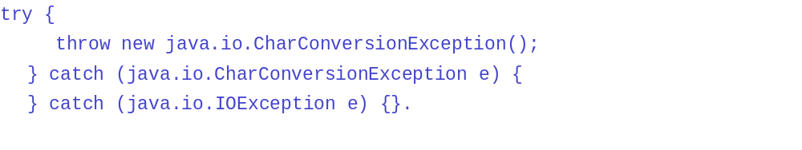When enabling this option, the compiler will issue an error or a warning for hidden catch blocks corresponding to checked exceptions. | ERROR
 | WARNING
 | INFO
 | IGNORE
Reporting Null related problems as a consequnce of assert statements (COMPILER_PB_INCLUDE_ASSERTS_IN_NULL_ANALYSIS)
When enabled, the compiler will raise null related errors or warnings for a variable that got marked as potentially or definitely null or not nullinside an assert statement, and whose null state has not been modified by any other statement following the assert.  This option has an effect only when the compiler compliance is 1.4 or greater.  Note that this option is only relevant in the context of the warnings raised by the options COMPILER_PB_REDUNDANT_NULL_CHECK, COMPILER_PB_NULL_REFERENCE, and COMPILER_PB_POTENTIAL_NULL_REFERENCE as a consequence of an assert statement. | ENABLED
 | DISABLED
Reporting Interface Method not Compatible with non-Inherited Methods (COMPILER_PB_INCOMPATIBLE_NON_INHERITED_INTERFACE_METHOD)
When enabled, the compiler will issue an error or a warning whenever an interface defines a method incompatible with a non-inherited Object one. | ERROR
 | WARNING
 | INFO
 | IGNORE
Reporting Incomplete Enum Switch (COMPILER_PB_INCOMPLETE_ENUM_SWITCH)
When enabled, the compiler will issue an error or a warning whenever an enum switch statement lacks a default case. If no default case is given, additionally one error or warning is issued regarding each enum constant for which a corresponding case label is lacking. | ERROR
 | WARNING
 | INFO
 | IGNORE
Reporting Indirect Reference to a Static Member (COMPILER_PB_INDIRECT_STATIC_ACCESS)
When enabled, the compiler will issue an error or a warning whenever a static field or method is accessed in an indirect way. A reference to a static member should preferably be qualified with its declaring type name. | ERROR
 | WARNING
 | INFO
 | IGNORE
Reporting Invalid Javadoc Comment (COMPILER_PB_INVALID_JAVADOC)
This is the generic control for the severity of Javadoc problems. When enabled, the compiler will issue an error or a warning for a problem in Javadoc. | ERROR
 | WARNING
 | INFO
 | IGNORE
Reporting Invalid Javadoc Tags (COMPILER_PB_INVALID_JAVADOC_TAGS)
When enabled, the compiler will signal unbound or unexpected reference tags in Javadoc. A 'throws' tag referencing an undeclared exception would be considered as unexpected.  Note that this diagnosis can be enabled based on the visibility of the construct associated with the Javadoc;  see also COMPILER_PB_INVALID_JAVADOC_TAGS_VISIBILITY. | ENABLED
 | DISABLED
Reporting Javadoc Tags with Deprecated References (COMPILER_PB_INVALID_JAVADOC_TAGS__DEPRECATED_REF)
Specify whether the compiler will report deprecated references used in Javadoc tags.  Note that this diagnosis can be enabled based on the visibility of the construct associated with the Javadoc;  see also COMPILER_PB_INVALID_JAVADOC_TAGS_VISIBILITY. | ENABLED
 | DISABLED
Reporting Javadoc Tags with Not Visible References (COMPILER_PB_INVALID_JAVADOC_TAGS__NOT_VISIBLE_REF)
Specify whether the compiler will report non-visible references used in Javadoc tags.  Note that this diagnosis can be enabled based on the visibility of the construct associated with the Javadoc;  see also COMPILER_PB_INVALID_JAVADOC_TAGS_VISIBILITY. | ENABLED
 | DISABLED
Visibility Level For Invalid Javadoc Tags (COMPILER_PB_INVALID_JAVADOC_TAGS_VISIBILITY)
Set the minimum visibility level for Javadoc tag problems. Below this level problems will be ignored. | PUBLIC
 | PROTECTED
 | DEFAULT
 | PRIVATE
Reporting Local Variable Declaration Hiding another Variable (COMPILER_PB_LOCAL_VARIABLE_HIDING)
When enabled, the compiler will issue an error or a warning whenever a local variable declaration is hiding some field or local variable (either locally, inherited or defined in enclosing type). | ERROR
 | WARNING
 | INFO
 | IGNORE
Maximum number of problems reported per compilation unit (COMPILER_PB_MAX_PER_UNIT)
Specify the maximum number of problems reported on each compilation unit (if the maximum is zero then all problems are reported). | A positive or null integer.  Default value is 100.
Reporting a method that qualifies as static, but not declared static (COMPILER_PB_MISSING_STATIC_ON_METHOD)
When enabled, the compiler will issue an error or a warning if a method has not been declared as static, even though it qualifies as one. | ERROR
 | WARNING
 | INFO
 | IGNORE
Reporting a method that may qualify as static, but not declared static (COMPILER_PB_POTENTIALLY_MISSING_STATIC_ON_METHOD)
When enabled, the compiler will issue an error or a warning if a method has not been declared as static, even though it may qualify as one, when another method doesn't override it. | ERROR
 | WARNING
 | INFO
 | IGNORE
Reporting Method With Constructor Name (COMPILER_PB_METHOD_WITH_CONSTRUCTOR_NAME)
Naming a method with a constructor name is generally considered poor style programming. When enabling this option, the compiler will signal such scenarios either as an error or a warning. | ERROR
 | WARNING
 | INFO
 | IGNORE
Reporting Missing @Deprecated Annotation (COMPILER_PB_MISSING_DEPRECATED_ANNOTATION)
When enabled, the compiler will issue an error or a warning whenever encountering a declaration carrying a @deprecated doc tag but having no corresponding @Deprecated annotation. | ERROR
 | WARNING
 | INFO
 | IGNORE
Reporting Missing Javadoc Comments (COMPILER_PB_MISSING_JAVADOC_COMMENTS)
This is the generic control for the severity of missing Javadoc comment problems. When enabled, the compiler will issue an error or a warning when Javadoc comments are missing.  Note that this diagnosis can be enabled based on the visibility of the construct associated with the expected Javadoc. | ERROR
 | WARNING
 | INFO
 | IGNORE
Reporting Missing Javadoc Comments on Overriding Methods (COMPILER_PB_MISSING_JAVADOC_COMMENTS_OVERRIDING)
Specify whether the compiler will verify overriding methods in order to report missing Javadoc comment problems. | ENABLED
 | DISABLED
Visibility Level For Missing Javadoc Comments (COMPILER_PB_MISSING_JAVADOC_COMMENTS_VISIBILITY)
Set the minimum visibility level for missing Javadoc problems. Below this level problems will be ignored. | PUBLIC
 | PROTECTED
 | DEFAULT
 | PRIVATE
Reporting missing tag description (COMPILER_PB_MISSING_JAVADOC_TAG_DESCRIPTION)
When enabled, the compiler will report a warning or an error for any Javadoc tag missing a required description.  The severity of the problem is controlled with option COMPILER_PB_INVALID_JAVADOC. It does not depend on option COMPILER_PB_INVALID_JAVADOC_TAGS.  When this option is valued to COMPILER_PB_MISSING_ JAVADOC_TAG_DESCRIPTION_ ALL_STANDARD_TAGS, a subset of the standard Javadoc tags that have a description, text or label are checked. While this set may grow in the future, note that user-defined tags are not and will not be checked. | COMPILER_PB_MISSING_  JAVADOC_TAG_DESCRIPTION_RETURN_TAG
COMPILER_PB_MISSING_
JAVADOC_TAG_DESCRIPTION_ALL_STANDARD_TAGS
COMPILER_PB_MISSING_
JAVADOC_TAG_DESCRIPTION_NO_TAG
 | Reporting Missing Javadoc Tags(COMPILER_PB_MISSING_JAVADOC_TAGS)
This is the generic control for the severity of Javadoc missing tag problems. When enabled, the compiler will issue an error or a warning when tags are missing in Javadoc comments.  Note that this diagnosis can be enabled based on the visibility of the construct associated with the Javadoc. | ERROR
 | WARNING
 | INFO
 | IGNORE
Reporting Missing Javadoc Tags on Overriding Methods (COMPILER_PB_MISSING_JAVADOC_TAGS_OVERRIDING)
Specify whether the compiler will verify overriding methods in order to report Javadoc missing tag problems. | ENABLED
 | DISABLED
Reporting Missing Javadoc Tags for Method Type Parameters (COMPILER_PB_MISSING_JAVADOC_TAGS_METHOD_TYPE_PARAMETERS)
Specify whether a missing @param for a type parameter in a method declaration should be reported. When enabled, the compiler will issue a missing Javadoc tag error or warning for a type parameter without a corresponding @param tag.  This option only has an effect if the compiler compliance is 1.5 or greater. | ENABLED
 | DISABLED
Visibility Level For Missing Javadoc Tags (COMPILER_PB_MISSING_JAVADOC_TAGS_VISIBILITY)
Set the minimum visibility level for Javadoc missing tag problems. Below this level problems will be ignored. | PUBLIC
 | PROTECTED
 | DEFAULT
 | PRIVATE
Reporting Missing @Override Annotation (COMPILER_PB_MISSING_OVERRIDE_ANNOTATION)
When enabled, the compiler will issue an error or a warning whenever encountering a method declaration which overrides a superclass method but has no @Override annotation. | ERROR
 | WARNING
 | INFO
 | IGNORE
Reporting Missing @Override Annotation For Interface Method Implementation (COMPILER_PB_MISSING_OVERRIDE_ANNOTATION_FOR_INTERFACE_METHOD_IMPLEMENTATION)
When enabled, the compiler will issue an error or a warning whenever encountering a method declaration which overrides or implements a superinterface method but has no @Override annotation.  This option only has an effect if the compiler compliance is 1.6 or greater.  The severity of the problem is controlled with option COMPILER_PB_MISSING_OVERRIDE_ANNOTATION. | ENABLED
 | DISABLED
Reporting Missing Declaration of serialVersionUID Field on Serializable Class (COMPILER_PB_MISSING_SERIAL_VERSION)
When enabled, the compiler will issue an error or a warning whenever a serializable class is missing a local declaration of a serialVersionUID field. This field must be declared as static final and be of type long. | ERROR
 | WARNING
 | INFO
 | IGNORE
Reporting Assignment with No Effect (COMPILER_PB_NO_EFFECT_ASSIGNMENT)
When enabled, the compiler will issue an error or a warning whenever an assignment has no effect (e.g. 'x = x'). | ERROR
 | WARNING
 | INFO
 | IGNORE
Reporting Non-Externalized String Literal (COMPILER_PB_NON_NLS_STRING_LITERAL)
When enabled, the compiler will issue an error or a warning for non externalized String literal (i.e. non tagged with //$NON-NLS-<n>$). | ERROR
 | WARNING
 | INFO
 | IGNORE
Reporting Dropped Nonnull Parameter Annotations (COMPILER_PB_NONNULL_PARAMETER_ANNOTATION_DROPPED)
When enabled, the compiler will issue an error or a warning against a parameter of a method that overrides an inherited method if all of the following hold:  - The overridden method declares the corresponding parameter as non-null (see COMPILER_NONNULL_ANNOTATION_NAME).  - The parameter in the overriding method has no null annotation.  - The overriding method is not affected by a nullness default (see COMPILER_NONNULL_BY_DEFAULT_ANNOTATION_NAME).  - Inheritance of null annotations is disabled (see COMPILER_INHERIT_NULL_ANNOTATIONS).  This particular situation bears the same inherent risk as any unannotated method parameter, because the compiler's null ananysis cannot decide wither null is or is not a legal value for this parameter. However, the annotation in the overridden method suggests that the parameter should also be annotated as non-null. If that is not intended or possible, it is recommended to annotate the parameter as nullable, in order to make this (legal) change of contract explicit. | ERROR
 | WARNING
 | INFO
 | IGNORE
Reporting Unsafe NonNull Interpretation Of Type Variables (COMPILER_PB_NONNULL_TYPEVAR_FROM_LEGACY_INVOCATION)
When enabled, the compiler will issue an error or a warning against a method call if all of the following hold:  - The method's declared return type is a type variable without any null annotation.  - For the given invocation this type variable is substituted with a nonnull type.  - The type declaring the method is provided by a third-party library.  - No null annotations exist for this library type, neither in its class file nor using external annotations.  This particular situation leverages the option to consistently substitute all occurrences of a type variable with a nonnull type, but it bears the risk that the library type may not be aware of null annotations thus lacking a necessary @Nullable annotation for a particular occurrence of a type variable.  This option only has an effect if the option COMPILER_ANNOTATION_NULL_ANALYSIS is enabled and when the configured set of null annotations declares the target TYPE_USE. | ERROR
 | WARNING
 | INFO
 | IGNORE
Reporting Null Dereference (COMPILER_PB_NULL_REFERENCE)
When enabled, the compiler will issue an error or a warning whenever a variable that is statically known to hold a null value is used to access a field or method.  Errors or warnings raised due to this option arising as a consequence of asserts can be controlled by COMPILER_PB_INCLUDE_ASSERTS_IN_NULL_ANALYSIS (java 1.4 and greater) | ERROR
 | WARNING
 | INFO
 | IGNORE
Reporting unchecked conversion from a type with unknown nullness to a null annotated type (COMPILER_PB_NULL_UNCHECKED_CONVERSION)
When enabled, the compiler will issue an error or a warning whenever one of the following situations is detected:  - A method declared with a nonnull annotation returns an expression for which insufficient nullness information is available for statically proving that no flow will pass a null value at runtime.  - An expression for which insufficient nullness information is available for statically proving that it will never evaluate to a null value at runtime is passed as an argument in a method call where the corresponding parameter of the called method is declared with a nonnull annotation.  - An expression for which insufficient nullness information is available for statically proving that it will never evaluate to a null value at runtime is assigned to a local variable that is declared with a nonnull annotation.  Unchecked null conversion is usually a consequence of using other unannotated variables or methods.  The compiler options COMPILER_NONNULL_ANNOTATION_NAME and COMPILER_NULLABLE_ANNOTATION_NAME control which annotations the compiler shall interpret as nonnull or nullable annotations, respectively.  This option only has an effect if the option COMPILER_ANNOTATION_NULL_ANALYSIS is enabled. | ERROR
 | WARNING
 | INFO
 | IGNORE
Reporting problems detected by pessimistic null analysis for free type variables (COMPILER_PB_PESSIMISTIC_NULL_ANALYSIS_FOR_FREE_TYPE_VARIABLES)
Unless set to "ignore", type variables not affected by any explicit null annotation are pessimistically analyzed in two directions: When reading a value of this type, it is assumed to be nullable. When this type appears as the required type (i.e., at the left hand side of an assignment or variable initialization, or as the method return type against which a return statement is being checked) the type is considered to require the nonnull property.  Problems reported due to this pessimistic analysis are reported with the level given in this option. | ERROR
 | WARNING
 | INFO
 | IGNORE
Reporting Violations of Null Specifications (COMPILER_PB_NULL_SPECIFICATION_VIOLATION)
When enabled, the compiler will issue an error or a warning whenever one of the following situations is detected:  - A method declared with a nonnull annotation returns a nullable expression.  - A nullable expression is passed as an argument in a method call where the corresponding parameter of the called method is declared with a nonnull annotation.  - A nullable expression is assigned to a local variable that is declared with a nonnull annotation.  - A method that overrides an inherited method declared with a nonnull annotation tries to relax that contract by specifying a nullable annotation (prohibition of contravariant return).  - A method that overrides an inherited method which has a nullable declaration for at least one of its parameters, tries to tighten that null contract by specifying a nonnull annotation for its corresponding parameter (prohibition of covariant parameters).  In the above an expression is considered as nullable if either it is statically known to evaluate to the value null, or if it is declared with a nullable annotation.  The compiler options COMPILER_NONNULL_ANNOTATION_NAME and COMPILER_NULLABLE_ANNOTATION_NAME control which annotations the compiler shall interpret as nonnull or nullable annotations, respectively.  This option only has an effect if the option COMPILER_ANNOTATION_NULL_ANALYSIS is enabled. | ERROR
 | WARNING
Reporting Overriding Methods that do not call their super method invocation. (COMPILER_PB_OVERRIDING_METHOD_WITHOUT_SUPER_INVOCATION)
When enabled, the compiler will issue an error or a warning if a method is overriding another method without calling the super invocation. | ERROR
 | WARNING
 | INFO
 | IGNORE
Reporting Potential Null Dereference (COMPILER_PB_POTENTIAL_NULL_REFERENCE)
When enabled, the compiler will issue an error or a warning whenever a variable that has formerly been tested against null but is not (no more) statically known to hold a non-null value is used to access a field or method.  Errors or warnings raised due to this option arising as a consequence of asserts can be controlled by COMPILER_PB_INCLUDE_ASSERTS_IN_NULL_ANALYSIS (java 1.4 and greater) | ERROR
 | WARNING
 | INFO
 | IGNORE
Reporting conflicts between declared null annotation and inferred null value (COMPILER_PB_NULL_ANNOTATION_INFERENCE_CONFLICT)
When enabled, the compiler will issue an error or a warning whenever one of the following situations is detected:  - A method declared with a nonnull annotation returns an expression that is statically known to evaluate to a null value on some flow.  - An expression that is statically known to evaluate to a null value on some flow is passed as an argument in a method call where the corresponding parameter of the called method is declared with a nonnull annotation.  - An expression that is statically known to evaluate to a null value on some flow is assigned to a local variable that is declared with a nonnull annotation.  The compiler options COMPILER_NONNULL_ANNOTATION_NAME and COMPILER_NULLABLE_ANNOTATION_NAME control which annotations the compiler shall interpret as nonnull or nullable annotations, respectively.  This option only has an effect if the option COMPILER_ANNOTATION_NULL_ANALYSIS is enabled. | ERROR
 | WARNING
 | INFO
 | IGNORE
Reporting Redundant Null Check (COMPILER_PB_REDUNDANT_NULL_CHECK)
When enabled, the compiler will issue an error or a warning whenever a variable that is statically known to hold a null or a non-null value is tested against null.  Errors or warnings raised due to this option arising as a consequence of asserts can be controlled by COMPILER_PB_INCLUDE_ASSERTS_IN_NULL_ANALYSIS (java 1.4 and greater) | ERROR
 | WARNING
 | INFO
 | IGNORE
Reporting Redundant Null Annotations. (COMPILER_PB_REDUNDANT_NULL_ANNOTATION)
When enabled, the compiler will issue an error or a warning when a non-null annotation (see COMPILER_NONNULL_ANNOTATION_NAME) is applied although the same effect is already achieved by a default applicable at the current location. Such a default may be effective by using the annotation specified by the option COMPILER_NONNULL_BY_DEFAULT_ANNOTATION_NAME.  The compiler options COMPILER_NONNULL_ANNOTATION_NAME and COMPILER_NULLABLE_ANNOTATION_NAME control which annotations the compiler shall interpret as nonnull or nullable annotations, respectively.  This option only has an effect if the option COMPILER_ANNOTATION_NULL_ANALYSIS is enabled. | ERROR
 | WARNING
 | INFO
 | IGNORE
Reporting missing default nullness annotation (COMPILER_PB_MISSING_NONNULL_BY_DEFAULT_ANNOTATION)
When enabled, the compiler will issue an error or a warning in the following cases:  - When a package does not contain a default nullness annotation, as a result of missing package-info.java or missing default nullness annotation in package-info.java.  - When a type inside a default package does not contain a default nullness annotation.  This option only has an effect if the option COMPILER_ANNOTATION_NULL_ANALYSIS is enabled. | ERROR
 | WARNING
 | INFO
 | IGNORE
Reporting Redundant Specification of type arguments for generic class instance creation (COMPILER_PB_REDUNDANT_TYPE_ARGUMENTS)
When enabled, the compiler will issue an error or a warning whenever type arguments are specified in a generic instance creation expression, although the diamond operator '<>' could have been used instead.  (java 1.7 and greater) | ERROR
 | WARNING
 | INFO
 | IGNORE
Reporting Attempt to Override Package Visible Method (COMPILER_PB_OVERRIDING_PACKAGE_DEFAULT_METHOD)
A package visible method, which is any method that is not explicitly declared as public, protected or private, is not visible from other packages, and thus cannot be overridden from another package. Attempting to override a package visible method from another package introduces a new method that is unrelated to the original one. When enabling this option, the compiler will signal such situations as an error or a warning. | ERROR
 | WARNING
 | INFO
 | IGNORE
Reporting Parameter Assignment (COMPILER_PB_PARAMETER_ASSIGNMENT)
When enabled, the compiler will issue an error or a warning if a parameter is assigned to. | ERROR
 | WARNING
 | INFO
 | IGNORE
Reporting Possible Accidental Boolean Assignment (COMPILER_PB_POSSIBLE_ACCIDENTAL_BOOLEAN_ASSIGNMENT)
When enabled, the compiler will issue an error or a warning if a boolean assignment is acting as the condition of a control statement (where it probably was meant to be a boolean comparison). | ERROR
 | WARNING
 | INFO
 | IGNORE
Reporting Raw Type Reference (COMPILER_PB_RAW_TYPE_REFERENCE)
When enabled, the compiler will issue an error or a warning when detecting references to raw types. Raw types are discouraged, and are intended to help interfacing with legacy code. In the future, the language specification may reject raw references to generic types. | ERROR
 | WARNING
 | INFO
 | IGNORE
Reporting Redundant Superinterface (COMPILER_PB_REDUNDANT_SUPERINTERFACE)
When enabled, the compiler will issue an error or a warning if a type explicitly implements an interface that is already implemented by any of its supertypes. | ERROR
 | WARNING
 | INFO
 | IGNORE
Reporting Special Parameter Hiding another Field (COMPILER_PB_SPECIAL_PARAMETER_HIDING_FIELD)
When enabled, the compiler will signal cases where a constructor or setter method parameter declaration is hiding some field (either locally, inherited or defined in enclosing type). | ENABLED
 | DISABLED
Reporting Non-Static Reference to a Static Member (COMPILER_PB_STATIC_ACCESS_RECEIVER)
When enabled, the compiler will issue an error or a warning whenever a static field or method is accessed with an expression receiver. | ERROR
 | WARNING
 | INFO
 | IGNORE
Further Determining the Effect of @SuppressWarnings if also COMPILER_PB_SUPPRESS_WARNINGS is enabled. (COMPILER_PB_SUPPRESS_OPTIONAL_ERRORS)
When enabled, the @SuppressWarnings annotation can additionally be used to suppress optional compiler diagnostics that have been configured as ERROR.  When disabled, all @SuppressWarnings annotations only affects warnings. | ENABLED
 | DISABLED
Determining Effect of @SuppressWarnings (COMPILER_PB_SUPPRESS_WARNINGS)
When enabled, the @SuppressWarnings annotation can be used to suppress some compile warnings.  When disabled, all @SupressWarnings annotations are ignored; i.e., warnings are reported even when they occur in the scope of an entity that carries an @SuppressWarnings annotation. | ENABLED
 | DISABLED
Perform syntactic null analysis for fields (COMPILER_PB_SYNTACTIC_NULL_ANALYSIS_FOR_FIELDS)
When enabled, the compiler will detect certain syntactic constellations where a null related warning against a field reference would normally be raised but can be suppressed at low risk given that the same field reference was known to be non-null immediately before. | ENABLED
 | DISABLED
Reporting Synthetic Access Emulation (COMPILER_PB_SYNTHETIC_ACCESS_EMULATION)
When enabled, the compiler will issue an error or a warning whenever it emulates access to a non-accessible member of an enclosing type. Such access can have performance implications. | ERROR
 | WARNING
 | INFO
 | IGNORE
Reporting Type Parameter Declaration Hiding another Type (COMPILER_PB_TYPE_PARAMETER_HIDING)
When enabled, the compiler will issue an error or a warning whenever a type parameter declaration is hiding some type. | ERROR
 | WARNING
 | INFO
 | IGNORE
Reporting Unavoidable Generic Type Problems due to raw APIs (COMPILER_PB_UNAVOIDABLE_GENERIC_TYPE_PROBLEMS)
When enabled, the compiler will issue an error or warning even when it detects a generics-related type problem that could not have been avoided by the programmer, because a referenced API already contains raw types. As an example, a type may be forced to use raw types in its method signatures and return types because the methods it overrides from a super type are declared to use raw types in the first place. | ENABLED
 | DISABLED
Reporting Unchecked Type Operation (COMPILER_PB_UNCHECKED_TYPE_OPERATION)
When enabled, the compiler will issue an error or a warning whenever an operation involves generic types, and potentially invalidates type safety since involving raw types (e.g. invoking #foo(X<String>) with arguments (X)). | ERROR
 | WARNING
 | INFO
 | IGNORE
Reporting Unclosed Closeable (COMPILER_PB_UNCLOSED_CLOSEABLE)
When enabled, the compiler will issue an error or a warning if a local variable holds a value of type java.lang.AutoCloseable (compliance >= 1.7) or a value of type java.io.Closeable (compliance <= 1.6) and if flow analysis shows that the method close() is not invoked locally on that value. | ERROR
 | WARNING
 | INFO
 | IGNORE
Reporting Potentially Unclosed Closeable (COMPILER_PB_POTENTIALLY_UNCLOSED_CLOSEABLE)
When enabled, the compiler will issue an error or a warning if a local variable holds a value of type java.lang.AutoCloseable (compliance >= 1.7) or a value of type java.io.Closeable (compliance <= 1.6) and if flow analysis shows that the method close() is not invoked locally on that value for all execution paths. | ERROR
 | WARNING
 | INFO
 | IGNORE
Reporting Explicitly Closed Closeable (COMPILER_PB_EXPLICITLY_CLOSED_AUTOCLOSEABLE)
When enabled, the compiler will issue an error or a warning if a local variable holds a value of type java.lang.AutoCloseable, and if the method close() is explicitly invoked on that resource, but the resource is not managed by a try-with-resources block. | ERROR
 | WARNING
 | INFO
 | IGNORE
Reporting a method invocation providing an argument of an unlikely type (COMPILER_PB_UNLIKELY_COLLECTION_METHOD_ARGUMENT_TYPE)
When enabled, the compiler will issue an error or warning when certain well-known Collection methods that take an 'Object', like e.g. Map.get(Object), are used with an argument type that seems to be not related to the corresponding type argument of the Collection. | ERROR
 | WARNING
 | INFO
 | IGNORE
Perform strict analysis against the expected type of collection methods (COMPILER_PB_UNLIKELY_COLLECTION_METHOD_ARGUMENT_TYPE_STRICT)
This is a sub-option of COMPILER_PB_UNLIKELY_COLLECTION_METHOD_ARGUMENT_TYPE, which will replace the heuristics with strict compatibility checks, i.e., each argument that is not strictly compatible with the expected type will trigger an error or warning. | ENABLED
 | DISABLED
Reporting a method invocation providing an argument of an unlikely type to method 'equals' (COMPILER_PB_UNLIKELY_EQUALS_ARGUMENT_TYPE)
When enabled, the compiler will issue an error or warning when java.lang.Object.equals(Object) is used with an argument type that seems to be not related to the receiver's type, or correspondingly when the arguments of java.util.Objects.equals(Object, Object)have types that seem to be not related to each other. | ERROR
 | WARNING
 | INFO
 | IGNORE
Reporting when public API uses a non-API type (COMPILER_PB_API_LEAKS)
When enabled, the compiler will issue an error or warning when public API mentions a type that is not accessible to clients. | ERROR
 | WARNING
 | INFO
 | IGNORE
Reporting Undocumented Empty Block (COMPILER_PB_UNDOCUMENTED_EMPTY_BLOCK)
When enabled, the compiler will issue an error or a warning when an empty block is detected and it is not documented with any comment. | ERROR
 | WARNING
 | INFO
 | IGNORE
Reporting Unhandled Warning Token for @SuppressWarnings (COMPILER_PB_UNHANDLED_WARNING_TOKEN)
When enabled, the compiler will issue an error or a warning when encountering a token it cannot handle inside a @SuppressWarnings annotation. | ERROR
 | WARNING
 | INFO
 | IGNORE
Reporting Unnecessary Else (COMPILER_PB_UNNECESSARY_ELSE)
When enabled, the compiler will issue an error or a warning when a statement is unnecessarily nested within an else clause (in situation where then clause is not completing normally). | ERROR
 | WARNING
 | INFO
 | IGNORE
Reporting Unnecessary Type Check (COMPILER_PB_UNNECESSARY_TYPE_CHECK)
When enabled, the compiler will issue an error or a warning when a cast or an instanceof operation is unnecessary. | ERROR
 | WARNING
 | INFO
 | IGNORE
Reporting Unqualified Access to Field (COMPILER_PB_UNQUALIFIED_FIELD_ACCESS)
When enabled, the compiler will issue an error or a warning when a field is access without any qualification. In order to improve code readability, it should be qualified, e.g. 'x' should rather be written 'this.x'. | ERROR
 | WARNING
 | INFO
 | IGNORE
Reporting Unused Declared Thrown Exception (COMPILER_PB_UNUSED_DECLARED_THROWN_EXCEPTION)
When enabled, the compiler will issue an error or a warning when a method or a constructor is declaring a checked exception as thrown, but its body actually raises neither that exception, nor any other exception extending it.  This diagnostic is further tuned by options COMPILER_PB_ UNUSED_DECLARED_THROWN_EXCEPTION_EXEMPT_EXCEPTION_AND_THROWABLE, COMPILER_PB_ UNUSED_DECLARED_THROWN_EXCEPTION_INCLUDE_DOC_COMMENT_REFERENCE, and COMPILER_PB_ UNUSED_DECLARED_THROWN_EXCEPTION_ WHEN_OVERRIDING. | ERROR
 | WARNING
 | INFO
 | IGNORE
Reporting Unused Declared Thrown Exception Exempts Exception And Throwable(COMPILER_PB_UNUSED_DECLARED_THROWN_EXCEPTION_EXEMPT_EXCEPTION_AND_THROWABLE)
When enabled, the compiler will issue an error or a warning when a method or a constructor is declaring a checked exception else than java.lang.Throwable or java.lang.Exception as thrown, but its body actually raises neither that exception, nor any other exception extending it. When disabled, the compiler will issue an error or a warning when a method or a constructor is declaring a checked exception (including java.lang.Throwable and java.lang.Exception) as thrown, but its body actually raises neither that exception, nor any other exception extending it.  The severity of the unused declared thrown exception problem is controlled with option COMPILER_PB_ UNUSED_DECLARED_THROWN_EXCEPTION.  This diagnostic is further tuned by options COMPILER_PB_ UNUSED_DECLARED_THROWN_EXCEPTION_INCLUDE_DOC_COMMENT_REFERENCE and COMPILER_PB_ UNUSED_DECLARED_THROWN_EXCEPTION_ WHEN_OVERRIDING. | ENABLED
 | DISABLED
Consider Reference in Doc Comment for Unused Declared Thrown Exception Check(COMPILER_PB_UNUSED_DECLARED_THROWN_EXCEPTION_INCLUDE_DOC_COMMENT_REFERENCE)
When enabled, the compiler will consider doc comment references to exceptions (i.e. @throws clauses) for the unused declared thrown exception check. Thus, documented exceptions will be considered as mandated as per doc contract.  The severity of the unused declared thrown exception problem is controlled with option COMPILER_PB_ UNUSED_DECLARED_THROWN_EXCEPTION.  Note: this option has no effect until the doc comment support is enabled according to the option COMPILER_DOC_COMMENT_SUPPORT.  This diagnostic is further tuned by options COMPILER_PB_ UNUSED_DECLARED_THROWN_EXCEPTION_EXEMPT_EXCEPTION_AND_THROWABLE and COMPILER_PB_ UNUSED_DECLARED_THROWN_EXCEPTION_ WHEN_OVERRIDING. | ENABLED
 | DISABLED
Reporting Unused Declared Thrown Exception in Overriding Method (COMPILER_PB_UNUSED_DECLARED_THROWN_EXCEPTION_WHEN_OVERRIDING)
When disabled, the compiler will report unused declared thrown exceptions neither on overriding methods nor on implementing methods.  The severity of the unused declared thrown exception problem is controlled with option COMPILER_PB_ UNUSED_DECLARED_THROWN_EXCEPTION.  This diagnostic is further tuned by options COMPILER_PB_ UNUSED_DECLARED_THROWN_EXCEPTION_EXEMPT_EXCEPTION_AND_THROWABLE and COMPILER_PB_ UNUSED_DECLARED_THROWN_EXCEPTION_INCLUDE_DOC_COMMENT_REFERENCE. | ENABLED
 | DISABLED
Reporting Unreferenced Label (COMPILER_PB_UNUSED_LABEL)
When enabled, the compiler will issue an error or a warning when encountering a labeled statement which label is never explicitly referenced. A label is considered to be referenced if its name explicitly appears within a break or continue statement; for instance the following label would be considered unreferenced:  LABEL: { break; } | ERROR
 | WARNING
 | INFO
 | IGNORE
Reporting Unused Type Parameter (COMPILER_PB_UNUSED_TYPE_PARAMETER)
When enabled, the compiler will issue an error or a warning for unused type parameter. | ERROR
 | WARNING
 | INFO
 | IGNORE
Reporting Unused Import (COMPILER_PB_UNUSED_IMPORT)
When enabled, the compiler will issue an error or a warning for unused import reference. | ERROR
 | WARNING
 | INFO
 | IGNORE
Reporting Unused Local (COMPILER_PB_UNUSED_LOCAL)
When enabled, the compiler will issue an error or a warning for unused local variables (i.e. variables never read from). | ERROR
 | WARNING
 | INFO
 | IGNORE
Reporting Allocation of an Unused Object (COMPILER_PB_UNUSED_OBJECT_ALLOCATION)
When enabled, the compiler will issue an error or a warning if an object is allocated but never used, neither by holding a reference nor by invoking one of the object's methods. | ERROR
 | WARNING
 | INFO
 | IGNORE
Reporting Unused Parameter (COMPILER_PB_UNUSED_PARAMETER)
When enabled, the compiler will issue an error or a warning for unused method parameters (i.e. parameters never read from). | ERROR
 | WARNING
 | INFO
 | IGNORE
Reporting Unused Parameter if Implementing Abstract Method (COMPILER_PB_UNUSED_PARAMETER_WHEN_IMPLEMENTING_ABSTRACT)
When enabled, the compiler will signal unused parameters in abstract method implementations. | ENABLED
 | DISABLED
Reporting Unused Parameter if Overriding Concrete Method (COMPILER_PB_UNUSED_PARAMETER_WHEN_OVERRIDING_CONCRETE)
When enabled, the compiler will signal unused parameters in methods overriding concrete ones. | ENABLED
 | DISABLED
Consider Reference in Doc Comment for Unused Parameter Check (COMPILER_PB_UNUSED_PARAMETER_INCLUDE_DOC_COMMENT_REFERENCE)
When enabled, the compiler will consider doc comment references to parameters (i.e. @param clauses) for the unused parameter check. Thus, documented parameters will be considered as mandated as per doc contract.  The severity of the unused parameter problem is controlled with option "org.eclipse.jdt.core.compiler.problem.unusedParameter"  . Note: this option has no effect until the doc comment support is enabled according to the option "org.eclipse.jdt.core.compiler.doc.comment.support". | ENABLED
 | DISABLED
Reporting Unused Exception Parameter (COMPILER_PB_UNUSED_EXCEPTION_PARAMETER)
When enabled, the compiler will issue an error or a warning for unused exception parameters (that is, the thrown exception is never read from). | ERROR
 | WARNING
 | INFO
 | IGNORE
Reporting Unused Private Members (COMPILER_PB_UNUSED_PRIVATE_MEMBER)
When enabled, the compiler will issue an error or a warning whenever a private method or field is declared but never used within the same unit. | ERROR
 | WARNING
 | INFO
 | IGNORE
Reporting Presence of Type Arguments for a Non-Generic Method Invocation (COMPILER_PB_UNUSED_TYPE_ARGUMENTS_FOR_METHOD_INVOCATION)
When enabled, the compiler will issue an error or a warning whenever type arguments are encountered for a non-generic method invocation.  Note that prior to compliance level "1.7", this situation would automatically result into an error. From Java 7 on, unused type arguments are tolerated, and optionally warned against. | ERROR
 | WARNING
 | INFO
 | IGNORE
Reporting Unnecessary @SuppressWarnings (COMPILER_PB_UNUSED_WARNING_TOKEN)
When enabled, the compiler will issue an error or a warning when encountering a @SuppressWarnings annotation for which no corresponding warning got detected in the code. This diagnostic is provided to help developers to get rid of transient @SuppressWarnings that are no longer needed.  Note that @SuppressWarnings("all") is still silencing the warning for unnecessary @SuppressWarnings, as it is the master switch to silence all warnings. | ERROR
 | WARNING
 | INFO
 | IGNORE
Reporting Varargs Argument Needing a Cast in Method/Constructor Inv (COMPILER_PB_VARARGS_ARGUMENT_NEED_CAST)
When enabled, the compiler will issue an error or a warning whenever a varargs arguments should be cast when passed to a method/constructor invocation. (e.g. Class.getMethod(String name, Class ... args ) invoked with arguments ("foo", null)). | ERROR
 | WARNING
 | INFO
 | IGNORE
Setting Source Compatibility Mode (COMPILER_SOURCE)
Specify the compatibility level of the Java source code.  Source level "1.4" enables assertions. From "1.4" on, 'assert' is a reserved keyword.  Source level "1.5" enables generics, autoboxing, covariance, annotations, enumerations enhanced for loops, static imports and varargs. From "1.5" on, 'enum' is a reserved keyword.  The compliance, source and target levels must satisfy a set of constraints summarized in a compatibility table below. | VERSION_1_3
 | VERSION_1_4
 | VERSION_1_5
 | VERSION_1_6
 | VERSION_1_7
 | VERSION_1_8
Generating Source Debug Attribute (COMPILER_SOURCE_FILE_ATTR)
When generated, this attribute will enable the debugger to present the corresponding source code. | GENERATE
 | DO_NOT_GENERATE
Determine whether task tags are case-sensitive (COMPILER_TASK_CASE_SENSITIVE)
When enabled, task tags are considered in a case-sensitive way. | ENABLED
 | DISABLED
Define the Automatic Task Priorities (COMPILER_TASK_PRIORITIES)
In parallel with the Automatic Task Tags, this list defines the priorities (high, normal or low) of the task markers issued by the compiler.  Possible priorities are "HIGH", "NORMAL" or "LOW". | {<priority>[,<priority>]*}.  Default value is "NORMAL,HIGH,  NORMAL"
Define the Automatic Task Tags (COMPILER_TASK_TAGS)
When the tag list is not empty, the compiler will issue a task marker whenever it encounters one of the corresponding tags inside any comment in Java source code. Generated task messages will start with the tag, and range until the next line separator, comment ending, or tag.  When a given line of code bears multiple tags, each tag will be reported separately. Moreover, a tag immediately followed by another tag will be reported using the contents of the next non-empty tag of the line, if any.  Note that tasks messages are trimmed. If a tag is starting with a letter or digit, then it cannot be leaded by another letter or digit to be recognized ("fooToDo" will not be recognized as a task for tag "ToDo", but "foo#ToDo" will be detected for either tag "ToDo" or "#ToDo"). Respectively, a tag ending with a letter or digit cannot be followed by a letter or digit to be recognized ("ToDofoo" will not be recognized as a task for tag "ToDo", but "ToDo:foo" will be detected either for tag "ToDo" or "ToDo:"). | {<tag>[,<tag>]*}.  Default value is "TODO,FIXME,  XXX"
The following table summarizes the compatible combinations of Java compliance, target and source levels (bold values are the defaults for each compliance level).
Compliance | Target | Source
1.7 | 1.7 | 1.7, 1.6, 1.5, 1.4, 1.3
1.7 | 1.6 | 1.6, 1.5, 1.4, 1.3
1.7 | 1.5 | 1.5, 1.4, 1.3
1.7 | 1.4 | 1.4, 1.3
1.7 | 1.3, 1.2, 1.1 | 1.3
1.6 | 1.6 | 1.6, 1.5, 1.4, 1.3
1.6 | 1.5 | 1.5, 1.4, 1.3
1.6 | 1.4 | 1.4, 1.3
1.6 | 1.3, 1.2, 1.1 | 1.3
1.5 | 1.5 | 1.5, 1.4, 1.3
1.5 | 1.4 | 1.4, 1.3
1.5 | 1.3, 1.2, 1.1 | 1.3
1.4 | 1.4 | 1.4, 1.3
1.4 | 1.3, 1.2, 1.1, cldc1.1 | 1.3
1.3 | 1.3, 1.2, 1.1, cldc1.1 | 1.3

Builder options
Description | Values
Cleaning Output Folder(s) (CORE_JAVA_BUILD_CLEAN_OUTPUT_FOLDER)
Indicate whether the JavaBuilder is allowed to clean the output folders when performing full build operations. | CLEAN
 | IGNORE
Reporting Duplicate Resources (CORE_JAVA_BUILD_DUPLICATE_RESOURCE)
Indicate the severity of the problem reported when more than one occurrence of a given resource is to be copied to the output location. | ERROR
 | WARNING
Abort if Invalid Classpath (CORE_JAVA_BUILD_INVALID_CLASSPATH)
Instruct the builder to abort if the classpath is invalid. | ABORT
Instruct the builder to abort if the classpath is invalid. | IGNORE
Computing Project Build Order (CORE_JAVA_BUILD_ORDER)
Indicate whether JavaCore should enforce the project build order to be based on the classpath prerequisite chain. When requesting to compute, this takes over the platform default order (based on project references). | COMPUTE
 | IGNORE
Recreate Modified class files in Output Folder (CORE_JAVA_BUILD_RECREATE_MODIFIED_CLASS_FILES_IN_OUTPUT_FOLDER)
Indicate whether the JavaBuilder should check for any changes to .class files in the output folders while performing incremental build operations. If changes are detected to managed .class files, then a full build is performed, otherwise the changes are left as is. Tools further altering generated .class files, like optimizers, should ensure this option remains set to its default state of ignore. | ENABLE
 | IGNORE
Specifying Filters for Resource Copying Control (CORE_JAVA_BUILD_RESOURCE_COPY_FILTER)
Specify filters to control the resource copy process. (<name> is a file name pattern (only * wild-cards allowed) or the name of a folder which ends with '/'; any resource which name matches one or more of these patterns is not copied to the output folder.) | {<name>[,<name>]*}.  Default value is ""

JavaCore options
Description | Values
Reporting Classpath Cycle (CORE_CIRCULAR_CLASSPATH)
Indicate the severity of the problem reported when a project is involved in a cycle. | ERROR
 | WARNING
Enabling Usage of Classpath Exclusion Patterns (CORE_ENABLE_CLASSPATH_EXCLUSION_PATTERNS)
When set to "disabled", no entry on a project classpath can be associated with an exclusion or inclusion pattern. | ENABLED
 | DISABLED
Enabling Usage of Classpath Multiple Output Locations (CORE_ENABLE_CLASSPATH_MULTIPLE_OUTPUT_LOCATIONS)
When set to "disabled", no entry on a project classpath can be associated with a specific output location. In particular, this prevents the use of multiple output locations for a single project. | ENABLED
 | DISABLED
Reporting an output location overlapping another source location (CORE_OUTPUT_LOCATION_OVERLAPPING_ANOTHER_SOURCE)
Indicate the severity of the problem reported when a source entry's output location overlaps another source entry. | ERROR
 | WARNING
 | INFO
 | IGNORE
Default Source Encoding Format (CORE_ENCODING)
Get the default encoding format of source files. This value is immutable and preset to the result of ResourcesPlugin.getEncoding().  It is offered as a convenience shortcut only. | Immutable, preset to the platform default.
Reporting Incompatible JDK Level for Required Binaries (CORE_INCOMPATIBLE_JDK_LEVEL)
Indicate the severity of the problem reported when a project prerequisites another project or library with an incompatible target JDK level (e.g. project targeting 1.1 vm, but compiled against 1.4 libraries). | ERROR
 | WARNING
 | INFO
 | IGNORE
Reporting Incomplete Classpath (CORE_INCOMPLETE_CLASSPATH)
Indicate the severity of the problem reported when an entry on the classpath doesn't exist, is not legitimate, or is not visible (e.g. a referenced project is closed). | ERROR
 | WARNING
Set the timeout value for retrieving a method's parameter names from javadoc (TIMEOUT_FOR_PARAMETER_NAME_FROM_ATTACHED_JAVADOC)
Timeout in milliseconds to retrieve a method's parameter names from javadoc.  If the value is 0, the parameter names are not fetched and the raw names are returned. | A positive or null integer.  Default is "50".
Set Java formatter name (JAVA_FORMATTER)
Name of the Java formatter to be used for formatting Java code. | A non-null, non-empty Sring value.  Default is "org.eclipse.jdt.core.defaultJavaFormatter".

Formatter options
Description | Values
Option to align type members of a type declaration on column (FORMATTER_ALIGN_TYPE_MEMBERS_ON_COLUMNS)
Possible values | TRUE
Possible values | FALSE
Option for alignment of arguments in allocation expression (FORMATTER_ALIGNMENT_FOR_ARGUMENTS_IN_ALLOCATION_EXPRESSION)
Possible value | values returned by createAlignmentValue(boolean, int, int) call
Default value | createAlignmentValue(false, WRAP_COMPACT, INDENT_DEFAULT)
Option for alignment of arguments in enum constant (FORMATTER_ALIGNMENT_FOR_ARGUMENTS_IN_ENUM_CONSTANT)
Possible value | values returned by createAlignmentValue(boolean, int, int) call
Default value | createAlignmentValue(false, WRAP_COMPACT, INDENT_DEFAULT)
Option for alignment of arguments in annotation (FORMATTER_ALIGNMENT_FOR_ARGUMENTS_IN_ANNOTATION)
Possible value | values returned by createAlignmentValue(boolean, int, int) call
Default value | createAlignmentValue(false, WRAP_NO_SPLIT, INDENT_DEFAULT)
Option for alignment of arguments in explicit constructor call (FORMATTER_ALIGNMENT_FOR_ARGUMENTS_IN_EXPLICIT_CONSTRUCTOR_CALL)
Possible value | values returned by createAlignmentValue(boolean, int, int) call
Default value | createAlignmentValue(false, WRAP_COMPACT, INDENT_DEFAULT)
Option for alignment of arguments in method invocation (FORMATTER_ALIGNMENT_FOR_ARGUMENTS_IN_METHOD_INVOCATION)
Possible value | values returned by createAlignmentValue(boolean, int, int) call
Default value | createAlignmentValue(false, WRAP_COMPACT, INDENT_DEFAULT)
Option for alignment of arguments in qualified allocation expression (FORMATTER_ALIGNMENT_FOR_ARGUMENTS_IN_QUALIFIED_ALLOCATION_EXPRESSION)
Possible value | values returned by createAlignmentValue(boolean, int, int) call
Default value | createAlignmentValue(false, WRAP_COMPACT, INDENT_DEFAULT)
Option for alignment of arguments in try with resources statement (FORMATTER_ALIGNMENT_FOR_RESOURCES_IN_TRY)
Possible value | values returned by createAlignmentValue(boolean, int, int) call
Default value | createAlignmentValue(false, WRAP_NEXT_PER_LINE, INDENT_DEFAULT)
Option for alignment of union type in multi-catch expression (FORMATTER_ALIGNMENT_FOR_UNION_TYPE_IN_MULTICATCH)
Possible value | values returned by createAlignmentValue(boolean, int, int) call
Default value | createAlignmentValue(false, WRAP_COMPACT, INDENT_DEFAULT)
Option for alignment of assignment (FORMATTER_ALIGNMENT_FOR_ASSIGNMENT)
Possible value | values returned by createAlignmentValue(boolean, int, int) call
Default value | createAlignmentValue(false, 0, INDENT_DEFAULT)
Option for alignment of binary expression (FORMATTER_ALIGNMENT_FOR_BINARY_EXPRESSION)
Possible value | values returned by createAlignmentValue(boolean, int, int) call
Default value | createAlignmentValue(false, WRAP_COMPACT, INDENT_DEFAULT)
Option for alignment of compact if (FORMATTER_ALIGNMENT_FOR_COMPACT_IF)
Possible value | values returned by createAlignmentValue(boolean, int, int) call
Default value | createAlignmentValue(false, WRAP_ONE_PER_LINE, INDENT_BY_ONE)
Option for alignment of conditional expression (FORMATTER_ALIGNMENT_FOR_CONDITIONAL_EXPRESSION)
Possible value | values returned by createAlignmentValue(boolean, int, int) call
Default value | createAlignmentValue(false, WRAP_ONE_PER_LINE, INDENT_DEFAULT)
Option for alignment of enum constants (FORMATTER_ALIGNMENT_FOR_ENUM_CONSTANTS)
Possible value | values returned by createAlignmentValue(boolean, int, int) call
Default value | createAlignmentValue(false, WRAP_NO_SPLIT, INDENT_DEFAULT)
Option for alignment of expressions in array initializer (FORMATTER_ALIGNMENT_FOR_EXPRESSIONS_IN_ARRAY_INITIALIZER)
Possible value | values returned by createAlignmentValue(boolean, int, int) call
Default value | createAlignmentValue(false, WRAP_COMPACT, INDENT_DEFAULT)
Option for alignment of method declaration (FORMATTER_ALIGNMENT_FOR_METHOD_DECLARATION)
Possible value | values returned by createAlignmentValue(boolean, int, int) call
Default value | createAlignmentValue(false, WRAP_COMPACT, INDENT_DEFAULT)
Option for alignment of multiple fields (FORMATTER_ALIGNMENT_FOR_MULTIPLE_FIELDS)
Possible value | values returned by createAlignmentValue(boolean, int, int) call
Default value | createAlignmentValue(false, WRAP_COMPACT, INDENT_DEFAULT)
Option for alignment of parameters in constructor declaration (FORMATTER_ALIGNMENT_FOR_PARAMETERS_IN_CONSTRUCTOR_DECLARATION)
Possible value | values returned by createAlignmentValue(boolean, int, int) call
Default value | createAlignmentValue(false, WRAP_COMPACT, INDENT_DEFAULT)
Option for alignment of parameters in method declaration (FORMATTER_ALIGNMENT_FOR_PARAMETERS_IN_METHOD_DECLARATION)
Possible value | values returned by createAlignmentValue(boolean, int, int) call
Default value | createAlignmentValue(false, WRAP_COMPACT, INDENT_DEFAULT)
Option for alignment of selector in method invocation (FORMATTER_ALIGNMENT_FOR_SELECTOR_IN_METHOD_INVOCATION)
Possible value | values returned by createAlignmentValue(boolean, int, int) call
Default value | createAlignmentValue(false, WRAP_COMPACT, INDENT_DEFAULT)
Option for alignment of superclass in type declaration (FORMATTER_ALIGNMENT_FOR_SUPERCLASS_IN_TYPE_DECLARATION)
Possible value | values returned by createAlignmentValue(boolean, int, int) call
Default value | createAlignmentValue(false, WRAP_NEXT_SHIFTED, INDENT_DEFAULT)
Option for alignment of superinterfaces in enum declaration (FORMATTER_ALIGNMENT_FOR_SUPERINTERFACES_IN_ENUM_DECLARATION)
Possible value | values returned by createAlignmentValue(boolean, int, int) call
Default value | createAlignmentValue(false, WRAP_COMPACT, INDENT_DEFAULT)
Option for alignment of superinterfaces in type declaration (FORMATTER_ALIGNMENT_FOR_SUPERINTERFACES_IN_TYPE_DECLARATION)
Possible value | values returned by createAlignmentValue(boolean, int, int) call
Default value | createAlignmentValue(false, WRAP_COMPACT, INDENT_DEFAULT)
Option for alignment of throws clause in constructor declaration (FORMATTER_ALIGNMENT_FOR_THROWS_CLAUSE_IN_CONSTRUCTOR_DECLARATION)
Possible value | values returned by createAlignmentValue(boolean, int, int) call
Default value | createAlignmentValue(false, WRAP_COMPACT, INDENT_DEFAULT)
Option for alignment of throws clause in method declaration (FORMATTER_ALIGNMENT_FOR_THROWS_CLAUSE_IN_METHOD_DECLARATION)
Possible value | values returned by createAlignmentValue(boolean, int, int) call
Default value | createAlignmentValue(false, WRAP_COMPACT, INDENT_DEFAULT)
Option to add blank lines after the imports declaration (FORMATTER_BLANK_LINES_AFTER_IMPORTS)
Possible value | "<n>", where n is zero or a positive integer
Default value | "0"
Option to add blank lines after the package declaration (FORMATTER_BLANK_LINES_AFTER_PACKAGE)
Possible value | "<n>", where n is zero or a positive integer
Default value | "0"
Option to add blank lines at the beginning of the method body (FORMATTER_BLANK_LINES_AT_BEGINNING_OF_METHOD_BODY)
Possible value | "<n>", where n is zero or a positive integer
Default value | "0"
Option to add blank lines before a field declaration (FORMATTER_BLANK_LINES_BEFORE_FIELD)
Possible value | "<n>", where n is zero or a positive integer
Default value | "0"
Option to add blank lines before the first class body declaration (FORMATTER_BLANK_LINES_BEFORE_FIRST_CLASS_BODY_DECLARATION)
Possible value | "<n>", where n is zero or a positive integer
Default value | "0"
Option to add blank lines before the imports declaration (FORMATTER_BLANK_LINES_BEFORE_IMPORTS)
Possible value | "<n>", where n is zero or a positive integer
Default value | "0"
Option to add blank lines before a member type declaration (FORMATTER_BLANK_LINES_BEFORE_MEMBER_TYPE)
Possible value | "<n>", where n is zero or a positive integer
Default value | "0"
Option to add blank lines before a method declaration (FORMATTER_BLANK_LINES_BEFORE_METHOD)
Possible value | "<n>", where n is zero or a positive integer
Default value | "0"
Option to add blank lines before a new chunk (FORMATTER_BLANK_LINES_BEFORE_NEW_CHUNK)
Possible value | "<n>", where n is zero or a positive integer
Default value | "0"
Option to add blank lines before the package declaration (FORMATTER_BLANK_LINES_BEFORE_PACKAGE)
Possible value | "<n>", where n is zero or a positive integer
Default value | "0"
Option to add blank lines between import groups (FORMATTER_BLANK_LINES_BETWEEN_IMPORT_GROUPS)
Possible value | "<n>", where n is zero or a positive integer
Default value | "1"
Option to add blank lines between type declarations (FORMATTER_BLANK_LINES_BETWEEN_TYPE_DECLARATIONS)
Possible value | "<n>", where n is zero or a positive integer
Default value | "0"
Option to position the braces of an annotation type declaration (FORMATTER_BRACE_POSITION_FOR_ANNOTATION_TYPE_DECLARATION)
Possible values | END_OF_LINE
Possible values | NEXT_LINE
Possible values | NEXT_LINE_SHIFTED
Possible values | NEXT_LINE_ON_WRAP
Option to position the braces of an anonymous type declaration (FORMATTER_BRACE_POSITION_FOR_ANONYMOUS_TYPE_DECLARATION)
Possible values | END_OF_LINE
Possible values | NEXT_LINE
Possible values | NEXT_LINE_SHIFTED
Possible values | NEXT_LINE_ON_WRAP
Option to position the braces of an array initializer (FORMATTER_BRACE_POSITION_FOR_ARRAY_INITIALIZER)
Possible values | END_OF_LINE
Possible values | NEXT_LINE
Possible values | NEXT_LINE_SHIFTED
Possible values | NEXT_LINE_ON_WRAP
Option to position the braces of a block (FORMATTER_BRACE_POSITION_FOR_BLOCK)
Possible values | END_OF_LINE
Possible values | NEXT_LINE
Possible values | NEXT_LINE_SHIFTED
Possible values | NEXT_LINE_ON_WRAP
Option to position the braces of a block in a case statement when the block is the first statement following (FORMATTER_BRACE_POSITION_FOR_BLOCK_IN_CASE)
Possible values | END_OF_LINE
Possible values | NEXT_LINE
Possible values | NEXT_LINE_SHIFTED
Possible values | NEXT_LINE_ON_WRAP
Option to position the braces of a constructor declaration (FORMATTER_BRACE_POSITION_FOR_CONSTRUCTOR_DECLARATION)
Possible values | END_OF_LINE
Possible values | NEXT_LINE
Possible values | NEXT_LINE_SHIFTED
Possible values | NEXT_LINE_ON_WRAP
Option to position the braces of an enum constant (FORMATTER_BRACE_POSITION_FOR_ENUM_CONSTANT)
Possible values | END_OF_LINE
Possible values | NEXT_LINE
Possible values | NEXT_LINE_SHIFTED
Possible values | NEXT_LINE_ON_WRAP
Option to position the braces of an enum declaration (FORMATTER_BRACE_POSITION_FOR_ENUM_DECLARATION)
Possible values | END_OF_LINE
Possible values | NEXT_LINE
Possible values | NEXT_LINE_SHIFTED
Possible values | NEXT_LINE_ON_WRAP
Option to position the braces of a method declaration (FORMATTER_BRACE_POSITION_FOR_METHOD_DECLARATION)
Possible values | END_OF_LINE
Possible values | NEXT_LINE
Possible values | NEXT_LINE_SHIFTED
Possible values | NEXT_LINE_ON_WRAP
Option to position the braces of a switch statement (FORMATTER_BRACE_POSITION_FOR_SWITCH)
Possible values | END_OF_LINE
Possible values | NEXT_LINE
Possible values | NEXT_LINE_SHIFTED
Possible values | NEXT_LINE_ON_WRAP
Option to position the braces of a type declaration (FORMATTER_BRACE_POSITION_FOR_TYPE_DECLARATION)
Possible values | END_OF_LINE
Possible values | NEXT_LINE
Possible values | NEXT_LINE_SHIFTED
Possible values | NEXT_LINE_ON_WRAP
Option to control whether blank lines are cleared inside block comments (FORMATTER_COMMENT_CLEAR_BLANK_LINES_IN_BLOCK_COMMENT)
Possible values | TRUE
Possible values | FALSE
Option to control whether blank lines are cleared inside javadoc comments (FORMATTER_COMMENT_CLEAR_BLANK_LINES_IN_JAVADOC_COMMENT)
Possible values | TRUE
Possible values | FALSE
Option to control whether multiple line comments are formatted (FORMATTER_COMMENT_FORMAT_BLOCK_COMMENT)
Possible values | TRUE
Possible values | FALSE
Option to control whether javadoc comments are formatted (FORMATTER_COMMENT_FORMAT_JAVADOC_COMMENT)
Possible values | TRUE
Possible values | FALSE
Option to control whether single line comments are formatted (FORMATTER_COMMENT_FORMAT_LINE_COMMENT)
Possible values | TRUE
Possible values | FALSE
Option to format line comments that start on the first column (FORMATTER_COMMENT_FORMAT_LINE_COMMENT_STARTING_ON_FIRST_COLUMN)
Possible values | TRUE
Possible values | FALSE
Option to control whether the header comment of a Java source file is formatted (FORMATTER_COMMENT_FORMAT_HEADER)
Possible values | TRUE
Possible values | FALSE
Option to control whether HTML tags are formatted. (FORMATTER_COMMENT_FORMAT_HTML)
Possible values | TRUE
Possible values | FALSE
Option to control whether code snippets are formatted in comments (FORMATTER_COMMENT_FORMAT_SOURCE)
Possible values | TRUE
Possible values | FALSE
Option to control whether description of Javadoc parameters are indented (FORMATTER_COMMENT_INDENT_PARAMETER_DESCRIPTION)
Possible values | TRUE
Possible values | FALSE
Option to control whether Javadoc root tags are indented. (FORMATTER_COMMENT_INDENT_ROOT_TAGS)
Possible values | TRUE
Possible values | FALSE
Option to insert an empty line before the Javadoc root tag block (FORMATTER_COMMENT_INSERT_EMPTY_LINE_BEFORE_ROOT_TAGS)
Possible values | INSERT
Possible values | DO_NOT_INSERT
Option to insert a new line after Javadoc root tag parameters (FORMATTER_COMMENT_INSERT_NEW_LINE_FOR_PARAMETER)
Possible values | INSERT
Possible values | DO_NOT_INSERT
Option to specify the line length for comments. (FORMATTER_COMMENT_LINE_LENGTH)
Possible value | "<n>", where n is zero or a positive integer
Default value | "80"
Option to control whether block comments will have new lines at boundaries (FORMATTER_COMMENT_NEW_LINES_AT_BLOCK_BOUNDARIES)
Possible values | TRUE
Possible values | FALSE
Option to control whether javadoc comments will have new lines at boundaries (FORMATTER_COMMENT_NEW_LINES_AT_JAVADOC_BOUNDARIES)
Possible values | TRUE
Possible values | FALSE
Option to preserve existing white space between code and line comments (FORMATTER_COMMENT_PRESERVE_WHITE_SPACE_BETWEEN_CODE_AND_LINE_COMMENT)
Possible values | TRUE
Possible values | FALSE
Option to compact else/if (FORMATTER_COMPACT_ELSE_IF)
Possible values | TRUE
Possible values | FALSE
Option to set the continuation indentation (FORMATTER_CONTINUATION_INDENTATION)
Possible value | "<n>", where n is zero or a positive integer
Default value | "2"
Option to set the continuation indentation inside array initializer (FORMATTER_CONTINUATION_INDENTATION_FOR_ARRAY_INITIALIZER)
Possible value | "<n>", where n is zero or a positive integer
Default value | "2"
Option to use the disabling and enabling tags (FORMATTER_USE_ON_OFF_TAGS)
Possible values | TRUE
Possible values | FALSE
Option to define the tag to put in a comment to disable the formatting (FORMATTER_DISABLING_TAG)
Possible values | String
Default value | "@format:off"
Option to define the tag to put in a comment to re-enable the formatting after it has been disabled (FORMATTER_ENABLING_TAG)
Possible values | String
Default value | "@format:on"
Option to indent body declarations compare to its enclosing annotation declaration header(FORMATTER_INDENT_BODY_DECLARATIONS_COMPARE_TO_ANNOTATION_DECLARATION_HEADER)
Possible values | TRUE
Possible values | FALSE
Option to indent body declarations compare to its enclosing enum constant header (FORMATTER_INDENT_BODY_DECLARATIONS_COMPARE_TO_ENUM_CONSTANT_HEADER)
Possible values | TRUE
Possible values | FALSE
Option to indent body declarations compare to its enclosing enum declaration header (FORMATTER_INDENT_BODY_DECLARATIONS_COMPARE_TO_ENUM_DECLARATION_HEADER)
Possible values | TRUE
Possible values | FALSE
Option to indent body declarations compare to its enclosing type header (FORMATTER_INDENT_BODY_DECLARATIONS_COMPARE_TO_TYPE_HEADER)
Possible values | TRUE
Possible values | FALSE
Option to indent breaks compare to cases (FORMATTER_INDENT_BREAKS_COMPARE_TO_CASES)
Possible values | TRUE
Possible values | FALSE
Option to indent empty lines (FORMATTER_INDENT_EMPTY_LINES)
Possible values | TRUE
Possible values | FALSE
Option to indent statements inside a block (FORMATTER_INDENT_STATEMENTS_COMPARE_TO_BLOCK)
Possible values | TRUE
Possible values | FALSE
Option to indent statements inside the body of a method or a constructor (FORMATTER_INDENT_STATEMENTS_COMPARE_TO_BODY)
Possible values | TRUE
Possible values | FALSE
Option to indent switch statements compare to cases (FORMATTER_INDENT_SWITCHSTATEMENTS_COMPARE_TO_CASES)
Possible values | TRUE
Possible values | FALSE
Option to indent switch statements compare to switch (FORMATTER_INDENT_SWITCHSTATEMENTS_COMPARE_TO_SWITCH)
Possible values | TRUE
Possible values | FALSE
Option to specify the equivalent number of spaces that represents one indentation (FORMATTER_INDENTATION_SIZE)
Possible value | "<n>", where n is zero or a positive integer
Default value | "4"
Option to insert a new line after an annotation on a parameter (FORMATTER_INSERT_NEW_LINE_AFTER_ANNOTATION_ON_PARAMETER)
Possible values | INSERT
Possible values | DO_NOT_INSERT
Option to insert a new line after an annotation on a field declaration (FORMATTER_INSERT_NEW_LINE_AFTER_ANNOTATION_ON_FIELD)
Possible values | INSERT
Possible values | DO_NOT_INSERT
Option to insert a new line after an annotation on a method declaration (FORMATTER_INSERT_NEW_LINE_AFTER_ANNOTATION_ON_METHOD)
Possible values | INSERT
Possible values | DO_NOT_INSERT
Option to insert a new line after an annotation on a package declaration (FORMATTER_INSERT_NEW_LINE_AFTER_ANNOTATION_ON_PACKAGE)
Possible values | INSERT
Possible values | DO_NOT_INSERT
Option to insert a new line after an annotation on a type declaration (FORMATTER_INSERT_NEW_LINE_AFTER_ANNOTATION_ON_TYPE)
Possible values | INSERT
Possible values | DO_NOT_INSERT
Option to insert a new line after an annotation on a local variable (FORMATTER_INSERT_NEW_LINE_AFTER_ANNOTATION_ON_LOCAL_VARIABLE)
Possible values | INSERT
Possible values | DO_NOT_INSERT
Option to insert a new line after a label (FORMATTER_INSERT_NEW_LINE_AFTER_LABEL)
Possible values | INSERT
Possible values | DO_NOT_INSERT
Option to insert a new line after the opening brace in an array initializer (FORMATTER_INSERT_NEW_LINE_AFTER_OPENING_BRACE_IN_ARRAY_INITIALIZER)
Possible values | INSERT
Possible values | DO_NOT_INSERT
Option to insert a new line at the end of the current file if missing (FORMATTER_INSERT_NEW_LINE_AT_END_OF_FILE_IF_MISSING)
Possible values | INSERT
Possible values | DO_NOT_INSERT
Option to insert a new line before the catch keyword in try statement (FORMATTER_INSERT_NEW_LINE_BEFORE_CATCH_IN_TRY_STATEMENT)
Possible values | INSERT
Possible values | DO_NOT_INSERT
Option to insert a new line before the closing brace in an array initializer (FORMATTER_INSERT_NEW_LINE_BEFORE_CLOSING_BRACE_IN_ARRAY_INITIALIZER)
Possible values | INSERT
Possible values | DO_NOT_INSERT
Option to insert a new line before the else keyword in if statement (FORMATTER_INSERT_NEW_LINE_BEFORE_ELSE_IN_IF_STATEMENT)
Possible values | INSERT
Possible values | DO_NOT_INSERT
Option to insert a new line before the finally keyword in try statement (FORMATTER_INSERT_NEW_LINE_BEFORE_FINALLY_IN_TRY_STATEMENT)
Possible values | INSERT
Possible values | DO_NOT_INSERT
Option to insert a new line before while in do statement (FORMATTER_INSERT_NEW_LINE_BEFORE_WHILE_IN_DO_STATEMENT)
Possible values | INSERT
Possible values | DO_NOT_INSERT
Option to insert a new line in an empty annotation declaration (FORMATTER_INSERT_NEW_LINE_IN_EMPTY_ANNOTATION_DECLARATION)
Possible values | INSERT
Possible values | DO_NOT_INSERT
Option to insert a new line in an empty anonymous type declaration (FORMATTER_INSERT_NEW_LINE_IN_EMPTY_ANONYMOUS_TYPE_DECLARATION)
Possible values | INSERT
Possible values | DO_NOT_INSERT
Option to insert a new line in an empty block (FORMATTER_INSERT_NEW_LINE_IN_EMPTY_BLOCK)
Possible values | INSERT
Possible values | DO_NOT_INSERT
Option to insert a new line in an empty enum constant (FORMATTER_INSERT_NEW_LINE_IN_EMPTY_ENUM_CONSTANT)
Possible values | INSERT
Possible values | DO_NOT_INSERT
Option to insert a new line in an empty enum declaration (FORMATTER_INSERT_NEW_LINE_IN_EMPTY_ENUM_DECLARATION)
Possible values | INSERT
Possible values | DO_NOT_INSERT
Option to insert a new line in an empty method body (FORMATTER_INSERT_NEW_LINE_IN_EMPTY_METHOD_BODY)
Possible values | INSERT
Possible values | DO_NOT_INSERT
Option to insert a new line in an empty type declaration (FORMATTER_INSERT_NEW_LINE_IN_EMPTY_TYPE_DECLARATION)
Possible values | INSERT
Possible values | DO_NOT_INSERT
Option to insert a space after and in wilcard (FORMATTER_INSERT_SPACE_AFTER_AND_IN_TYPE_PARAMETER)
Possible values | INSERT
Possible values | DO_NOT_INSERT
Option to insert a space after an assignment operator (FORMATTER_INSERT_SPACE_AFTER_ASSIGNMENT_OPERATOR)
Possible values | INSERT
Possible values | DO_NOT_INSERT
Option to insert a space after at in annotation (FORMATTER_INSERT_SPACE_AFTER_AT_IN_ANNOTATION)
Possible values | INSERT
Possible values | DO_NOT_INSERT
Option to insert a space after at in annotation type declaration (FORMATTER_INSERT_SPACE_AFTER_AT_IN_ANNOTATION_TYPE_DECLARATION)
Possible values | INSERT
Possible values | DO_NOT_INSERT
Option to insert a space after a binary operator (FORMATTER_INSERT_SPACE_AFTER_BINARY_OPERATOR)
Possible values | INSERT
Possible values | DO_NOT_INSERT
Option to insert a space after the closing angle bracket in type arguments (FORMATTER_INSERT_SPACE_AFTER_CLOSING_ANGLE_BRACKET_IN_TYPE_ARGUMENTS)
Possible values | INSERT
Possible values | DO_NOT_INSERT
Option to insert a space after the closing angle bracket in type parameters (FORMATTER_INSERT_SPACE_AFTER_CLOSING_ANGLE_BRACKET_IN_TYPE_PARAMETERS)
Possible values | INSERT
Possible values | DO_NOT_INSERT
Option to insert a space after the closing brace of a block (FORMATTER_INSERT_SPACE_AFTER_CLOSING_BRACE_IN_BLOCK)
Possible values | INSERT
Possible values | DO_NOT_INSERT
Option to insert a space after the closing parenthesis of a cast expression (FORMATTER_INSERT_SPACE_AFTER_CLOSING_PAREN_IN_CAST)
Possible values | INSERT
Possible values | DO_NOT_INSERT
Option to insert a space after the colon in an assert statement (FORMATTER_INSERT_SPACE_AFTER_COLON_IN_ASSERT)
Possible values | INSERT
Possible values | DO_NOT_INSERT
Option to insert a space after colon in a case statement when a opening brace follows the colon (FORMATTER_INSERT_SPACE_AFTER_COLON_IN_CASE)
Possible values | INSERT
Possible values | DO_NOT_INSERT
Option to insert a space after the colon in a conditional expression (FORMATTER_INSERT_SPACE_AFTER_COLON_IN_CONDITIONAL)
Possible values | INSERT
Possible values | DO_NOT_INSERT
Option to insert a space after colon in a for statement (FORMATTER_INSERT_SPACE_AFTER_COLON_IN_FOR)
Possible values | INSERT
Possible values | DO_NOT_INSERT
Option to insert a space after the colon in a labeled statement (FORMATTER_INSERT_SPACE_AFTER_COLON_IN_LABELED_STATEMENT)
Possible values | INSERT
Possible values | DO_NOT_INSERT
Option to insert a space after the comma in an allocation expression (FORMATTER_INSERT_SPACE_AFTER_COMMA_IN_ALLOCATION_EXPRESSION)
Possible values | INSERT
Possible values | DO_NOT_INSERT
Option to insert a space after the comma in annotation (FORMATTER_INSERT_SPACE_AFTER_COMMA_IN_ANNOTATION)
Possible values | INSERT
Possible values | DO_NOT_INSERT
Option to insert a space after the comma in an array initializer (FORMATTER_INSERT_SPACE_AFTER_COMMA_IN_ARRAY_INITIALIZER)
Possible values | INSERT
Possible values | DO_NOT_INSERT
Option to insert a space after the comma in the parameters of a constructor declaration(FORMATTER_INSERT_SPACE_AFTER_COMMA_IN_CONSTRUCTOR_DECLARATION_PARAMETERS)
Possible values | INSERT
Possible values | DO_NOT_INSERT
Option to insert a space after the comma in the exception names in a throws clause of a constructor declaration(FORMATTER_INSERT_SPACE_AFTER_COMMA_IN_CONSTRUCTOR_DECLARATION_THROWS)
Possible values | INSERT
Possible values | DO_NOT_INSERT
Option to insert a space after the comma in the arguments of an enum constant (FORMATTER_INSERT_SPACE_AFTER_COMMA_IN_ENUM_CONSTANT_ARGUMENTS)
Possible values | INSERT
Possible values | DO_NOT_INSERT
Option to insert a space after the comma in enum declarations (FORMATTER_INSERT_SPACE_AFTER_COMMA_IN_ENUM_DECLARATIONS)
Possible values | INSERT
Possible values | DO_NOT_INSERT
Option to insert a space after the comma in the arguments of an explicit constructor call(FORMATTER_INSERT_SPACE_AFTER_COMMA_IN_EXPLICIT_CONSTRUCTOR_CALL_ARGUMENTS)
Possible values | INSERT
Possible values | DO_NOT_INSERT
Option to insert a space after the comma in the increments of a for statement (FORMATTER_INSERT_SPACE_AFTER_COMMA_IN_FOR_INCREMENTS)
Possible values | INSERT
Possible values | DO_NOT_INSERT
Option to insert a space after the comma in the initializations of a for statement (FORMATTER_INSERT_SPACE_AFTER_COMMA_IN_FOR_INITS)
Possible values | INSERT
Possible values | DO_NOT_INSERT
Option to insert a space after the comma in the parameters of a method declaration (FORMATTER_INSERT_SPACE_AFTER_COMMA_IN_METHOD_DECLARATION_PARAMETERS)
Possible values | INSERT
Possible values | DO_NOT_INSERT
Option to insert a space after the comma in the exception names in a throws clause of a method declaration(FORMATTER_INSERT_SPACE_AFTER_COMMA_IN_METHOD_DECLARATION_THROWS)
Possible values | INSERT
Possible values | DO_NOT_INSERT
Option to insert a space after the comma in the arguments of a method invocation (FORMATTER_INSERT_SPACE_AFTER_COMMA_IN_METHOD_INVOCATION_ARGUMENTS)
Possible values | INSERT
Possible values | DO_NOT_INSERT
Option to insert a space after the comma in multiple field declaration (FORMATTER_INSERT_SPACE_AFTER_COMMA_IN_MULTIPLE_FIELD_DECLARATIONS)
Possible values | INSERT
Possible values | DO_NOT_INSERT
Option to insert a space after the comma in multiple local declaration (FORMATTER_INSERT_SPACE_AFTER_COMMA_IN_MULTIPLE_LOCAL_DECLARATIONS)
Possible values | INSERT
Possible values | DO_NOT_INSERT
Option to insert a space after the comma in parameterized type reference (FORMATTER_INSERT_SPACE_AFTER_COMMA_IN_PARAMETERIZED_TYPE_REFERENCE)
Possible values | INSERT
Possible values | DO_NOT_INSERT
Option to insert a space after the comma in superinterfaces names of a type header (FORMATTER_INSERT_SPACE_AFTER_COMMA_IN_SUPERINTERFACES)
Possible values | INSERT
Possible values | DO_NOT_INSERT
Option to insert a space after the comma in type arguments (FORMATTER_INSERT_SPACE_AFTER_COMMA_IN_TYPE_ARGUMENTS)
Possible values | INSERT
Possible values | DO_NOT_INSERT
Option to insert a space after the comma in type parameters (FORMATTER_INSERT_SPACE_AFTER_COMMA_IN_TYPE_PARAMETERS)
Possible values | INSERT
Possible values | DO_NOT_INSERT
Option to insert a space after ellipsis (FORMATTER_INSERT_SPACE_AFTER_ELLIPSIS)
Possible values | INSERT
Possible values | DO_NOT_INSERT
Option to insert a space after the opening angle bracket in parameterized type reference(FORMATTER_INSERT_SPACE_AFTER_OPENING_ANGLE_BRACKET_IN_PARAMETERIZED_TYPE_REFERENCE)
Possible values | INSERT
Possible values | DO_NOT_INSERT
Option to insert a space after the opening angle bracket in type arguments (FORMATTER_INSERT_SPACE_AFTER_OPENING_ANGLE_BRACKET_IN_TYPE_ARGUMENTS)
Possible values | INSERT
Possible values | DO_NOT_INSERT
Option to insert a space after the opening angle bracket in type parameters (FORMATTER_INSERT_SPACE_AFTER_OPENING_ANGLE_BRACKET_IN_TYPE_PARAMETERS)
Possible values | INSERT
Possible values | DO_NOT_INSERT
Option to insert a space after the opening brace in an array initializer (FORMATTER_INSERT_SPACE_AFTER_OPENING_BRACE_IN_ARRAY_INITIALIZER)
Possible values | INSERT
Possible values | DO_NOT_INSERT
Option to insert a space after the opening bracket inside an array allocation expression(FORMATTER_INSERT_SPACE_AFTER_OPENING_BRACKET_IN_ARRAY_ALLOCATION_EXPRESSION)
Possible values | INSERT
Possible values | DO_NOT_INSERT
Option to insert a space after the opening bracket inside an array reference (FORMATTER_INSERT_SPACE_AFTER_OPENING_BRACKET_IN_ARRAY_REFERENCE)
Possible values | INSERT
Possible values | DO_NOT_INSERT
Option to insert a space after the opening parenthesis in annotation (FORMATTER_INSERT_SPACE_AFTER_OPENING_PAREN_IN_ANNOTATION)
Possible values | INSERT
Possible values | DO_NOT_INSERT
Option to insert a space after the opening parenthesis in a cast expression (FORMATTER_INSERT_SPACE_AFTER_OPENING_PAREN_IN_CAST)
Possible values | INSERT
Possible values | DO_NOT_INSERT
Option to insert a space after the opening parenthesis in a catch (FORMATTER_INSERT_SPACE_AFTER_OPENING_PAREN_IN_CATCH)
Possible values | INSERT
Possible values | DO_NOT_INSERT
Option to insert a space after the opening parenthesis in a constructor declaration (FORMATTER_INSERT_SPACE_AFTER_OPENING_PAREN_IN_CONSTRUCTOR_DECLARATION)
Possible values | INSERT
Possible values | DO_NOT_INSERT
Option to insert a space after the opening parenthesis in enum constant (FORMATTER_INSERT_SPACE_AFTER_OPENING_PAREN_IN_ENUM_CONSTANT)
Possible values | INSERT
Possible values | DO_NOT_INSERT
Option to insert a space after the opening parenthesis in a for statement (FORMATTER_INSERT_SPACE_AFTER_OPENING_PAREN_IN_FOR)
Possible values | INSERT
Possible values | DO_NOT_INSERT
Option to insert a space after the opening parenthesis in an if statement (FORMATTER_INSERT_SPACE_AFTER_OPENING_PAREN_IN_IF)
Possible values | INSERT
Possible values | DO_NOT_INSERT
Option to insert a space after the opening parenthesis in a method declaration (FORMATTER_INSERT_SPACE_AFTER_OPENING_PAREN_IN_METHOD_DECLARATION)
Possible values | INSERT
Possible values | DO_NOT_INSERT
Option to insert a space after the opening parenthesis in a method invocation (FORMATTER_INSERT_SPACE_AFTER_OPENING_PAREN_IN_METHOD_INVOCATION)
Possible values | INSERT
Possible values | DO_NOT_INSERT
Option to insert a space after the opening parenthesis in a parenthesized expression (FORMATTER_INSERT_SPACE_AFTER_OPENING_PAREN_IN_PARENTHESIZED_EXPRESSION)
Possible values | INSERT
Possible values | DO_NOT_INSERT
Option to insert a space after the opening parenthesis in a switch statement (FORMATTER_INSERT_SPACE_AFTER_OPENING_PAREN_IN_SWITCH)
Possible values | INSERT
Possible values | DO_NOT_INSERT
Option to insert a space after the opening parenthesis in a synchronized statement (FORMATTER_INSERT_SPACE_AFTER_OPENING_PAREN_IN_SYNCHRONIZED)
Possible values | INSERT
Possible values | DO_NOT_INSERT
Option to insert a space after the opening parenthesis in a try with resources statement (FORMATTER_INSERT_SPACE_AFTER_OPENING_PAREN_IN_TRY)
Possible values | INSERT
Possible values | DO_NOT_INSERT
Option to insert a space after the opening parenthesis in a while statement (FORMATTER_INSERT_SPACE_AFTER_OPENING_PAREN_IN_WHILE)
Possible values | INSERT
Possible values | DO_NOT_INSERT
Option to insert a space after a postfix operator (FORMATTER_INSERT_SPACE_AFTER_POSTFIX_OPERATOR)
Possible values | INSERT
Possible values | DO_NOT_INSERT
Option to insert a space after a prefix operator (FORMATTER_INSERT_SPACE_AFTER_PREFIX_OPERATOR)
Possible values | INSERT
Possible values | DO_NOT_INSERT
Option to insert a space after question mark in a conditional expression (FORMATTER_INSERT_SPACE_AFTER_QUESTION_IN_CONDITIONAL)
Possible values | INSERT
Possible values | DO_NOT_INSERT
Option to insert a space after question mark in a wildcard (FORMATTER_INSERT_SPACE_AFTER_QUESTION_IN_WILDCARD)
Possible values | INSERT
Possible values | DO_NOT_INSERT
Option to insert a space after semicolon in a for statement (FORMATTER_INSERT_SPACE_AFTER_SEMICOLON_IN_FOR)
Possible values | INSERT
Possible values | DO_NOT_INSERT
Option to insert a space after each semicolon in a try with resources statement (FORMATTER_INSERT_SPACE_AFTER_SEMICOLON_IN_TRY_RESOURCES)
Possible values | INSERT
Possible values | DO_NOT_INSERT
Option to insert a space after an unary operator (FORMATTER_INSERT_SPACE_AFTER_UNARY_OPERATOR)
Possible values | INSERT
Possible values | DO_NOT_INSERT
Option to insert a space before and in wildcard (FORMATTER_INSERT_SPACE_BEFORE_AND_IN_TYPE_PARAMETER)
Possible values | INSERT
Possible values | DO_NOT_INSERT
Option to insert a space before an assignment operator (FORMATTER_INSERT_SPACE_BEFORE_ASSIGNMENT_OPERATOR)
Possible values | INSERT
Possible values | DO_NOT_INSERT
Option to insert a space before at in annotation type declaration (FORMATTER_INSERT_SPACE_BEFORE_AT_IN_ANNOTATION_TYPE_DECLARATION)
Possible values | INSERT
Possible values | DO_NOT_INSERT
Option to insert a space before an binary operator (FORMATTER_INSERT_SPACE_BEFORE_BINARY_OPERATOR)
Possible values | INSERT
Possible values | DO_NOT_INSERT
Option to insert a space before the closing angle bracket in parameterized type reference(FORMATTER_INSERT_SPACE_BEFORE_CLOSING_ANGLE_BRACKET_IN_PARAMETERIZED_TYPE_REFERENCE)
Possible values | INSERT
Possible values | DO_NOT_INSERT
Option to insert a space before the closing angle bracket in type arguments (FORMATTER_INSERT_SPACE_BEFORE_CLOSING_ANGLE_BRACKET_IN_TYPE_ARGUMENTS)
Possible values | INSERT
Possible values | DO_NOT_INSERT
Option to insert a space before the closing angle bracket in type parameters (FORMATTER_INSERT_SPACE_BEFORE_CLOSING_ANGLE_BRACKET_IN_TYPE_PARAMETERS)
Possible values | INSERT
Possible values | DO_NOT_INSERT
Option to insert a space before the closing brace in an array initializer (FORMATTER_INSERT_SPACE_BEFORE_CLOSING_BRACE_IN_ARRAY_INITIALIZER)
Possible values | INSERT
Possible values | DO_NOT_INSERT
Option to insert a space before the closing bracket in an array allocation expression(FORMATTER_INSERT_SPACE_BEFORE_CLOSING_BRACKET_IN_ARRAY_ALLOCATION_EXPRESSION)
Possible values | INSERT
Possible values | DO_NOT_INSERT
Option to insert a space before the closing bracket in an array reference (FORMATTER_INSERT_SPACE_BEFORE_CLOSING_BRACKET_IN_ARRAY_REFERENCE)
Possible values | INSERT
Possible values | DO_NOT_INSERT
Option to insert a space before the closing parenthesis in annotation (FORMATTER_INSERT_SPACE_BEFORE_CLOSING_PAREN_IN_ANNOTATION)
Possible values | INSERT
Possible values | DO_NOT_INSERT
Option to insert a space before the closing parenthesis in a cast expression (FORMATTER_INSERT_SPACE_BEFORE_CLOSING_PAREN_IN_CAST)
Possible values | INSERT
Possible values | DO_NOT_INSERT
Option to insert a space before the closing parenthesis in a catch (FORMATTER_INSERT_SPACE_BEFORE_CLOSING_PAREN_IN_CATCH)
Possible values | INSERT
Possible values | DO_NOT_INSERT
Option to insert a space before the closing parenthesis in a constructor declaration (FORMATTER_INSERT_SPACE_BEFORE_CLOSING_PAREN_IN_CONSTRUCTOR_DECLARATION)
Possible values | INSERT
Possible values | DO_NOT_INSERT
Option to insert a space before the closing parenthesis in enum constant (FORMATTER_INSERT_SPACE_BEFORE_CLOSING_PAREN_IN_ENUM_CONSTANT)
Possible values | INSERT
Possible values | DO_NOT_INSERT
Option to insert a space before the closing parenthesis in a for statement (FORMATTER_INSERT_SPACE_BEFORE_CLOSING_PAREN_IN_FOR)
Possible values | INSERT
Possible values | DO_NOT_INSERT
Option to insert a space before the closing parenthesis in an if statement (FORMATTER_INSERT_SPACE_BEFORE_CLOSING_PAREN_IN_IF)
Possible values | INSERT
Possible values | DO_NOT_INSERT
Option to insert a space before the closing parenthesis in a method declaration (FORMATTER_INSERT_SPACE_BEFORE_CLOSING_PAREN_IN_METHOD_DECLARATION)
Possible values | INSERT
Possible values | DO_NOT_INSERT
Option to insert a space before the closing parenthesis in a method invocation (FORMATTER_INSERT_SPACE_BEFORE_CLOSING_PAREN_IN_METHOD_INVOCATION)
Possible values | INSERT
Possible values | DO_NOT_INSERT
Option to insert a space before the closing parenthesis in a parenthesized expression (FORMATTER_INSERT_SPACE_BEFORE_CLOSING_PAREN_IN_PARENTHESIZED_EXPRESSION)
Possible values | INSERT
Possible values | DO_NOT_INSERT
Option to insert a space before the closing parenthesis in a switch statement (FORMATTER_INSERT_SPACE_BEFORE_CLOSING_PAREN_IN_SWITCH)
Possible values | INSERT
Possible values | DO_NOT_INSERT
Option to insert a space before the closing parenthesis in a synchronized statement (FORMATTER_INSERT_SPACE_BEFORE_CLOSING_PAREN_IN_SYNCHRONIZED)
Possible values | INSERT
Possible values | DO_NOT_INSERT
Option to insert a space before closing paranthesis in a try with resources statement (FORMATTER_INSERT_SPACE_BEFORE_CLOSING_PAREN_IN_TRY)
Possible values | INSERT
Possible values | DO_NOT_INSERT
Option to insert a space before the closing parenthesis in a while statement (FORMATTER_INSERT_SPACE_BEFORE_CLOSING_PAREN_IN_WHILE)
Possible values | INSERT
Possible values | DO_NOT_INSERT
Option to insert a space before colon in an assert statement (FORMATTER_INSERT_SPACE_BEFORE_COLON_IN_ASSERT)
Possible values | INSERT
Possible values | DO_NOT_INSERT
Option to insert a space before colon in a case statement (FORMATTER_INSERT_SPACE_BEFORE_COLON_IN_CASE)
Possible values | INSERT
Possible values | DO_NOT_INSERT
Option to insert a space before colon in a conditional expression (FORMATTER_INSERT_SPACE_BEFORE_COLON_IN_CONDITIONAL)
Possible values | INSERT
Possible values | DO_NOT_INSERT
Option to insert a space before colon in a default statement (FORMATTER_INSERT_SPACE_BEFORE_COLON_IN_DEFAULT)
Possible values | INSERT
Possible values | DO_NOT_INSERT
Option to insert a space before colon in a for statement (FORMATTER_INSERT_SPACE_BEFORE_COLON_IN_FOR)
Possible values | INSERT
Possible values | DO_NOT_INSERT
Option to insert a space before colon in a labeled statement (FORMATTER_INSERT_SPACE_BEFORE_COLON_IN_LABELED_STATEMENT)
Possible values | INSERT
Possible values | DO_NOT_INSERT
Option to insert a space before comma in an allocation expression (FORMATTER_INSERT_SPACE_BEFORE_COMMA_IN_ALLOCATION_EXPRESSION)
Possible values | INSERT
Possible values | DO_NOT_INSERT
Option to insert a space before comma in annotation (FORMATTER_INSERT_SPACE_BEFORE_COMMA_IN_ANNOTATION)
Possible values | INSERT
Possible values | DO_NOT_INSERT
Option to insert a space before comma in an array initializer (FORMATTER_INSERT_SPACE_BEFORE_COMMA_IN_ARRAY_INITIALIZER)
Possible values | INSERT
Possible values | DO_NOT_INSERT
Option to insert a space before comma in the parameters of a constructor declaration(FORMATTER_INSERT_SPACE_BEFORE_COMMA_IN_CONSTRUCTOR_DECLARATION_PARAMETERS)
Possible values | INSERT
Possible values | DO_NOT_INSERT
Option to insert a space before comma in the exception names of the throws clause of a constructor declaration(FORMATTER_INSERT_SPACE_BEFORE_COMMA_IN_CONSTRUCTOR_DECLARATION_THROWS)
Possible values | INSERT
Possible values | DO_NOT_INSERT
Option to insert a space before comma in the arguments of enum constant (FORMATTER_INSERT_SPACE_BEFORE_COMMA_IN_ENUM_CONSTANT_ARGUMENTS)
Possible values | INSERT
Possible values | DO_NOT_INSERT
Option to insert a space before comma in enum declarations (FORMATTER_INSERT_SPACE_BEFORE_COMMA_IN_ENUM_DECLARATIONS)
Possible values | INSERT
Possible values | DO_NOT_INSERT
Option to insert a space before comma in the arguments of an explicit constructor call(FORMATTER_INSERT_SPACE_BEFORE_COMMA_IN_EXPLICIT_CONSTRUCTOR_CALL_ARGUMENTS)
Possible values | INSERT
Possible values | DO_NOT_INSERT
Option to insert a space before comma in the increments of a for statement (FORMATTER_INSERT_SPACE_BEFORE_COMMA_IN_FOR_INCREMENTS)
Possible values | INSERT
Possible values | DO_NOT_INSERT
Option to insert a space before comma in the initializations of a for statement (FORMATTER_INSERT_SPACE_BEFORE_COMMA_IN_FOR_INITS)
Possible values | INSERT
Possible values | DO_NOT_INSERT
Option to insert a space before comma in the parameters of a method declaration (FORMATTER_INSERT_SPACE_BEFORE_COMMA_IN_METHOD_DECLARATION_PARAMETERS)
Possible values | INSERT
Possible values | DO_NOT_INSERT
Option to insert a space before comma in the exception names of the throws clause of a method declaration(FORMATTER_INSERT_SPACE_BEFORE_COMMA_IN_METHOD_DECLARATION_THROWS)
Possible values | INSERT
Possible values | DO_NOT_INSERT
Option to insert a space before comma in the arguments of a method invocation (FORMATTER_INSERT_SPACE_BEFORE_COMMA_IN_METHOD_INVOCATION_ARGUMENTS)
Possible values | INSERT
Possible values | DO_NOT_INSERT
Option to insert a space before comma in a multiple field declaration (FORMATTER_INSERT_SPACE_BEFORE_COMMA_IN_MULTIPLE_FIELD_DECLARATIONS)
Possible values | INSERT
Possible values | DO_NOT_INSERT
Option to insert a space before comma in a multiple local declaration (FORMATTER_INSERT_SPACE_BEFORE_COMMA_IN_MULTIPLE_LOCAL_DECLARATIONS)
Possible values | INSERT
Possible values | DO_NOT_INSERT
Option to insert a space before comma in parameterized type reference (FORMATTER_INSERT_SPACE_BEFORE_COMMA_IN_PARAMETERIZED_TYPE_REFERENCE)
Possible values | INSERT
Possible values | DO_NOT_INSERT
Option to insert a space before comma in the superinterfaces names in a type header (FORMATTER_INSERT_SPACE_BEFORE_COMMA_IN_SUPERINTERFACES)
Possible values | INSERT
Possible values | DO_NOT_INSERT
Option to insert a space before comma in type arguments (FORMATTER_INSERT_SPACE_BEFORE_COMMA_IN_TYPE_ARGUMENTS)
Possible values | INSERT
Possible values | DO_NOT_INSERT
Option to insert a space before comma in type parameters (FORMATTER_INSERT_SPACE_BEFORE_COMMA_IN_TYPE_PARAMETERS)
Possible values | INSERT
Possible values | DO_NOT_INSERT
Option to insert a space before ellipsis (FORMATTER_INSERT_SPACE_BEFORE_ELLIPSIS)
Possible values | INSERT
Possible values | DO_NOT_INSERT
Option to insert a space before the opening angle bracket in parameterized type reference(FORMATTER_INSERT_SPACE_BEFORE_OPENING_ANGLE_BRACKET_IN_PARAMETERIZED_TYPE_REFERENCE)
Possible values | INSERT
Possible values | DO_NOT_INSERT
Option to insert a space before the opening angle bracket in type arguments (FORMATTER_INSERT_SPACE_BEFORE_OPENING_ANGLE_BRACKET_IN_TYPE_ARGUMENTS)
Possible values | INSERT
Possible values | DO_NOT_INSERT
Option to insert a space before the opening angle bracket in type parameters (FORMATTER_INSERT_SPACE_BEFORE_OPENING_ANGLE_BRACKET_IN_TYPE_PARAMETERS)
Possible values | INSERT
Possible values | DO_NOT_INSERT
Option to insert a space before the opening brace in an annotation type declaration (FORMATTER_INSERT_SPACE_BEFORE_OPENING_BRACE_IN_ANNOTATION_TYPE_DECLARATION)
Possible values | INSERT
Possible values | DO_NOT_INSERT
Option to insert a space before the opening brace in an anonymous type declaration (FORMATTER_INSERT_SPACE_BEFORE_OPENING_BRACE_IN_ANONYMOUS_TYPE_DECLARATION)
Possible values | INSERT
Possible values | DO_NOT_INSERT
Option to insert a space before the opening brace in an array initializer (FORMATTER_INSERT_SPACE_BEFORE_OPENING_BRACE_IN_ARRAY_INITIALIZER)
Possible values | INSERT
Possible values | DO_NOT_INSERT
Option to insert a space before the opening brace in a block (FORMATTER_INSERT_SPACE_BEFORE_OPENING_BRACE_IN_BLOCK)
Possible values | INSERT
Possible values | DO_NOT_INSERT
Option to insert a space before the opening brace in a constructor declaration (FORMATTER_INSERT_SPACE_BEFORE_OPENING_BRACE_IN_CONSTRUCTOR_DECLARATION)
Possible values | INSERT
Possible values | DO_NOT_INSERT
Option to insert a space before the opening brace in an enum constant (FORMATTER_INSERT_SPACE_BEFORE_OPENING_BRACE_IN_ENUM_CONSTANT)
Possible values | INSERT
Possible values | DO_NOT_INSERT
Option to insert a space before the opening brace in an enum declaration (FORMATTER_INSERT_SPACE_BEFORE_OPENING_BRACE_IN_ENUM_DECLARATION)
Possible values | INSERT
Possible values | DO_NOT_INSERT
Option to insert a space before the opening brace in a method declaration (FORMATTER_INSERT_SPACE_BEFORE_OPENING_BRACE_IN_METHOD_DECLARATION)
Possible values | INSERT
Possible values | DO_NOT_INSERT
Option to insert a space before the opening brace in a switch statement (FORMATTER_INSERT_SPACE_BEFORE_OPENING_BRACE_IN_SWITCH)
Possible values | INSERT
Possible values | DO_NOT_INSERT
Option to insert a space before the opening brace in a type declaration (FORMATTER_INSERT_SPACE_BEFORE_OPENING_BRACE_IN_TYPE_DECLARATION)
Possible values | INSERT
Possible values | DO_NOT_INSERT
Option to insert a space before the opening bracket in an array allocation expression(FORMATTER_INSERT_SPACE_BEFORE_OPENING_BRACKET_IN_ARRAY_ALLOCATION_EXPRESSION)
Possible values | INSERT
Possible values | DO_NOT_INSERT
Option to insert a space before the opening bracket in an array reference (FORMATTER_INSERT_SPACE_BEFORE_OPENING_BRACKET_IN_ARRAY_REFERENCE)
Possible values | INSERT
Possible values | DO_NOT_INSERT
Option to insert a space before the opening bracket in an array type reference (FORMATTER_INSERT_SPACE_BEFORE_OPENING_BRACKET_IN_ARRAY_TYPE_REFERENCE)
Possible values | INSERT
Possible values | DO_NOT_INSERT
Option to insert a space before the opening parenthesis in annotation (FORMATTER_INSERT_SPACE_BEFORE_OPENING_PAREN_IN_ANNOTATION)
Possible values | INSERT
Possible values | DO_NOT_INSERT
Option to insert a space before the opening parenthesis in annotation type member declaration(FORMATTER_INSERT_SPACE_BEFORE_OPENING_PAREN_IN_ANNOTATION_TYPE_MEMBER_DECLARATION)
Possible values | INSERT
Possible values | DO_NOT_INSERT
Option to insert a space before the opening parenthesis in a catch (FORMATTER_INSERT_SPACE_BEFORE_OPENING_PAREN_IN_CATCH)
Possible values | INSERT
Possible values | DO_NOT_INSERT
Option to insert a space before the opening parenthesis in a constructor declaration (FORMATTER_INSERT_SPACE_BEFORE_OPENING_PAREN_IN_CONSTRUCTOR_DECLARATION)
Possible values | INSERT
Possible values | DO_NOT_INSERT
Option to insert a space before the opening parenthesis in enum constant (FORMATTER_INSERT_SPACE_BEFORE_OPENING_PAREN_IN_ENUM_CONSTANT)
Possible values | INSERT
Possible values | DO_NOT_INSERT
Option to insert a space before the opening parenthesis in a for statement (FORMATTER_INSERT_SPACE_BEFORE_OPENING_PAREN_IN_FOR)
Possible values | INSERT
Possible values | DO_NOT_INSERT
Option to insert a space before the opening parenthesis in an if statement (FORMATTER_INSERT_SPACE_BEFORE_OPENING_PAREN_IN_IF)
Possible values | INSERT
Possible values | DO_NOT_INSERT
Option to insert a space before the opening parenthesis in a method declaration (FORMATTER_INSERT_SPACE_BEFORE_OPENING_PAREN_IN_METHOD_DECLARATION)
Possible values | INSERT
Possible values | DO_NOT_INSERT
Option to insert a space before the opening parenthesis in a method invocation (FORMATTER_INSERT_SPACE_BEFORE_OPENING_PAREN_IN_METHOD_INVOCATION)
Possible values | INSERT
Possible values | DO_NOT_INSERT
Option to insert a space before the opening parenthesis in a parenthesized expression (FORMATTER_INSERT_SPACE_BEFORE_OPENING_PAREN_IN_PARENTHESIZED_EXPRESSION)
Possible values | INSERT
Possible values | DO_NOT_INSERT
Option to insert a space before the opening parenthesis in a switch statement (FORMATTER_INSERT_SPACE_BEFORE_OPENING_PAREN_IN_SWITCH)
Possible values | INSERT
Possible values | DO_NOT_INSERT
Option to insert a space before the opening parenthesis in a synchronized statement (FORMATTER_INSERT_SPACE_BEFORE_OPENING_PAREN_IN_SYNCHRONIZED)
Possible values | INSERT
Possible values | DO_NOT_INSERT
Option to insert a space before the opening parenthesis in a try with resources statement (FORMATTER_INSERT_SPACE_BEFORE_OPENING_PAREN_IN_TRY)
Possible values | INSERT
Possible values | DO_NOT_INSERT
Option to insert a space before the opening parenthesis in a while statement (FORMATTER_INSERT_SPACE_BEFORE_OPENING_PAREN_IN_WHILE)
Possible values | INSERT
Possible values | DO_NOT_INSERT
Option to insert a space before parenthesized expression in return statement (FORMATTER_INSERT_SPACE_BEFORE_PARENTHESIZED_EXPRESSION_IN_RETURN)
Possible values | INSERT
Possible values | DO_NOT_INSERT
Option to insert a space before parenthesized expression in throw statement (FORMATTER_INSERT_SPACE_BEFORE_PARENTHESIZED_EXPRESSION_IN_THROW)
Possible values | INSERT
Possible values | DO_NOT_INSERT
Option to insert a space before a postfix operator (FORMATTER_INSERT_SPACE_BEFORE_POSTFIX_OPERATOR)
Possible values | INSERT
Possible values | DO_NOT_INSERT
Option to insert a space before a prefix operator (FORMATTER_INSERT_SPACE_BEFORE_PREFIX_OPERATOR)
Possible values | INSERT
Possible values | DO_NOT_INSERT
Option to insert a space before question mark in a conditional expression (FORMATTER_INSERT_SPACE_BEFORE_QUESTION_IN_CONDITIONAL)
Possible values | INSERT
Possible values | DO_NOT_INSERT
Option to insert a space before question mark in a wildcard (FORMATTER_INSERT_SPACE_BEFORE_QUESTION_IN_WILDCARD)
Possible values | INSERT
Possible values | DO_NOT_INSERT
Option to insert a space before semicolon (FORMATTER_INSERT_SPACE_BEFORE_SEMICOLON)
Possible values | INSERT
Possible values | DO_NOT_INSERT
Option to insert a space before semicolon in for statement (FORMATTER_INSERT_SPACE_BEFORE_SEMICOLON_IN_FOR)
Possible values | INSERT
Possible values | DO_NOT_INSERT
Option to insert a space before each semicolon in try with resources statement (FORMATTER_INSERT_SPACE_BEFORE_SEMICOLON_IN_TRY_RESOURCES)
Possible values | INSERT
Possible values | DO_NOT_INSERT
Option to insert a space before unary operator (FORMATTER_INSERT_SPACE_BEFORE_UNARY_OPERATOR)
Possible values | INSERT
Possible values | DO_NOT_INSERT
Option to insert a space between brackets in an array type reference (FORMATTER_INSERT_SPACE_BETWEEN_BRACKETS_IN_ARRAY_TYPE_REFERENCE)
Possible values | INSERT
Possible values | DO_NOT_INSERT
Option to insert a space between empty braces in an array initializer (FORMATTER_INSERT_SPACE_BETWEEN_EMPTY_BRACES_IN_ARRAY_INITIALIZER)
Possible values | INSERT
Possible values | DO_NOT_INSERT
Option to insert a space between empty brackets in an array allocation expression (FORMATTER_INSERT_SPACE_BETWEEN_EMPTY_BRACKETS_IN_ARRAY_ALLOCATION_EXPRESSION)
Possible values | INSERT
Possible values | DO_NOT_INSERT
Option to insert a space between empty parenthesis in an annotation type member declaration(FORMATTER_INSERT_SPACE_BETWEEN_EMPTY_PARENS_IN_ANNOTATION_TYPE_MEMBER_DECLARATION)
Possible values | INSERT
Possible values | DO_NOT_INSERT
Option to insert a space between empty parenthesis in a constructor declaration (FORMATTER_INSERT_SPACE_BETWEEN_EMPTY_PARENS_IN_CONSTRUCTOR_DECLARATION)
Possible values | INSERT
Possible values | DO_NOT_INSERT
Option to insert a space between empty parenthesis in enum constant (FORMATTER_INSERT_SPACE_BETWEEN_EMPTY_PARENS_IN_ENUM_CONSTANT)
Possible values | INSERT
Possible values | DO_NOT_INSERT
Option to insert a space between empty parenthesis in a method declaration (FORMATTER_INSERT_SPACE_BETWEEN_EMPTY_PARENS_IN_METHOD_DECLARATION)
Possible values | INSERT
Possible values | DO_NOT_INSERT
Option to insert a space between empty parenthesis in a method invocation (FORMATTER_INSERT_SPACE_BETWEEN_EMPTY_PARENS_IN_METHOD_INVOCATION)
Possible values | INSERT
Possible values | DO_NOT_INSERT
Option to keep else statement on the same line (FORMATTER_KEEP_ELSE_STATEMENT_ON_SAME_LINE)
Possible values | TRUE
Possible values | FALSE
Option to keep empty array initializer one line (FORMATTER_KEEP_EMPTY_ARRAY_INITIALIZER_ON_ONE_LINE)
Possible values | TRUE
Possible values | FALSE
Option to keep guardian clause on one line (FORMATTER_KEEP_GUARDIAN_CLAUSE_ON_ONE_LINE)
Possible values | TRUE
Possible values | FALSE
Option to keep simple if statement on the one line (FORMATTER_KEEP_SIMPLE_IF_ON_ONE_LINE)
Possible values | TRUE
Possible values | FALSE
Option to keep then statement on the same line (FORMATTER_KEEP_THEN_STATEMENT_ON_SAME_LINE)
Possible values | TRUE
Possible values | FALSE
Option to specify the length of the page. Beyond this length, the formatter will try to split the code (FORMATTER_LINE_SPLIT)
Possible value | "<n>", where n is zero or a positive integer
Default value | "80"
Option to indent block comments that start on the first column (FORMATTER_NEVER_INDENT_BLOCK_COMMENTS_ON_FIRST_COLUMN)
Possible values | TRUE
Possible values | FALSE
Option to indent line comments that start on the first column (FORMATTER_NEVER_INDENT_LINE_COMMENTS_ON_FIRST_COLUMN)
Possible values | TRUE
Possible values | FALSE
Option to specify the number of empty lines to preserve (FORMATTER_NUMBER_OF_EMPTY_LINES_TO_PRESERVE)
Possible value | "<n>", where n is zero or a positive integer
Default value | "0"
Option to specify whether or not empty statement should be on a new line (FORMATTER_PUT_EMPTY_STATEMENT_ON_NEW_LINE)
Possible values | TRUE
Possible values | FALSE
Option to specify the tabulation size (FORMATTER_TAB_CHAR)
Possible values | TAB
Possible values | SPACE
Possible values | MIXED
Option to specify the equivalent number of spaces that represents one tabulation (FORMATTER_TAB_SIZE)
Possible value | "<n>", where n is zero or a positive integer
Default value | "4"
Option to use tabulations only for leading indentations (FORMATTER_USE_TABS_ONLY_FOR_LEADING_INDENTATIONS)
Possible values | TRUE
Possible values | FALSE
Option to wrap before the binary operator (FORMATTER_WRAP_BEFORE_BINARY_OPERATOR)
Possible values | TRUE
Possible values | FALSE
Option to wrap before OR operator in a multi-catch expression (FORMATTER_WRAP_BEFORE_OR_OPERATOR_MULTICATCH)
Possible values | TRUE
Possible values | FALSE
Option to wrap outer expressions in nested expressions (FORMATTER_WRAP_OUTER_EXPRESSIONS_WHEN_NESTED)
Possible values | TRUE
Possible values | FALSE

CodeAssist options
Description | Values
Define the Prefixes for Argument Name (CODEASSIST_ARGUMENT_PREFIXES)
When the prefixes is non empty, completion for argument name will begin with one of the proposed prefixes. | {<prefix>[,<prefix>]*}.  Default value is ""
Define the Suffixes for Argument Name (CODEASSIST_ARGUMENT_SUFFIXES)
When the suffixes is non empty, completion for argument name will end with one of the proposed suffixes. | {<suffix>[,<suffix>]*}.  Default value is ""
Activate Camel Case Sensitive Completion (CODEASSIST_CAMEL_CASE_MATCH)
When enabled, completion shows proposals whose name match the CamelCase pattern. | ENABLED
 | DISABLED
Activate Substring Code Completion (CODEASSIST_SUBSTRING_MATCH)
When enabled, completion shows proposals in which the pattern can be found as a substring in a case-insensitive way. | ENABLED
 | DISABLED
Activate Deprecation Sensitive Completion (CODEASSIST_DEPRECATION_CHECK)
When enabled, completion doesn't propose deprecated members and types. | ENABLED
 | DISABLED
Activate Discouraged Reference Sensitive Completion (CODEASSIST_DISCOURAGED_REFERENCE_CHECK)
When enabled, completion doesn't propose elements which match a discouraged reference rule. | ENABLED
 | DISABLED
Define the Prefixes for Field Name (CODEASSIST_FIELD_PREFIXES)
When the prefixes is non empty, completion for field name will begin with one of the proposed prefixes. | {<prefix>[,<prefix>]*}.  Default value is ""
Define the Suffixes for Field Name (CODEASSIST_FIELD_SUFFIXES)
When the suffixes is non empty, completion for field name will end with one of the proposed suffixes. | {<suffix>[,<suffix>]*}.  Default value is ""
Activate Forbidden Reference Sensitive Completion (CODEASSIST_FORBIDDEN_REFERENCE_CHECK)
When enabled, completion doesn't propose elements which match a forbidden reference rule. | ENABLED
 | DISABLED
Automatic Qualification of Implicit Members (CODEASSIST_IMPLICIT_QUALIFICATION)
When enabled, completion automatically qualifies completion on implicit field references and message expressions. | ENABLED
 | DISABLED
Define the Prefixes for Local Variable Name (CODEASSIST_LOCAL_PREFIXES)
When the prefixes is non empty, completion for local variable name will begin with one of the proposed prefixes. | {<prefix>[,<prefix>]*}.  Default value is ""
Define the Suffixes for Local Variable Name (CODEASSIST_LOCAL_SUFFIXES)
When the suffixes is non empty, completion for local variable name will end with one of the proposed suffixes. | {<suffix>[,<suffix>]*}.  Default value is ""
Define the Prefixes for Static Field Name (CODEASSIST_STATIC_FIELD_PREFIXES)
When the prefixes is non empty, completion for static field name will begin with one of the proposed prefixes. | {<prefix>[,<prefix>]*}.  Default value is ""
Define the Suffixes for Static Field Name (CODEASSIST_STATIC_FIELD_SUFFIXES)
When the suffixes is non empty, completion for static field name will end with one of the proposed suffixes. | {<suffix>[,<suffix>]*}.  Default value is ""
Activate Suggestion of Static Import (CODEASSIST_SUGGEST_STATIC_IMPORTS)
When enabled, completion proposals can contain static import pattern. | ENABLED
 | DISABLED
Activate Visibility Sensitive Completion (CODEASSIST_VISIBILITY_CHECK)
When enabled, completion doesn't propose elements that are not visible at the insertion point according to Java visibility rules (e.g. the private methods of a super class are not proposed). | ENABLED
 | DISABLED

Formatting Java code

Using the code formatter
The JDT API allows other plug-ins to use the default code formatter to format source code. The two methods to consider are:
- ToolFactory.createCodeFormatter(Map)
- ToolFactory.createCodeFormatter(Map, int)
Note: The CodeFormatter class is not intended to be subclassed by clients.

Getting a code formatter instance
The factory methods on ToolFactory can be invoked to create a new instance of the default code formatter. Before invoking one of those, you need to define a map that contains the code formatter options. In order to create such a map, you can use the methods defined in the class DefaultCodeFormatterConstants like DefaultCodeFormatterConstants.getEclipseDefaultSettings()
NOTE: These predefined maps contain only the code formatter specific options. In order to invoke the code formatter, you also need to specify what kind of source the code formatter will format. In order to do so, specify the three options:
- JavaCore.COMPILER_CODEGEN_TARGET_PLATFORM
- JavaCore.COMPILER_SOURCE
- JavaCore.COMPILER_COMPLIANCE
The possible values of these options are given by the constants:
- JavaCore.VERSION_1_1
- JavaCore.VERSION_1_2
- JavaCore.VERSION_1_3
- JavaCore.VERSION_1_4
- JavaCore.VERSION_1_5
- JavaCore.VERSION_1_6
- JavaCore.VERSION_1_7
- JavaCore.VERSION_1_8
- JavaCore.VERSION_9
If you want to modify the default maps, it is recommended that you use the methods defined on DefaultCodeFormatterConstants to create the values of the corresponding options. This is especially true for the options relative to code wrapping.

Invoking the code formatter
Use the newly created code formatter to format code snippets. The default code formatter allows you to format different kind of code snippets.
These kinds are specified in the documentation of the format method. The returned value of this method is a text edit. This text edit then needs to be applied to an IDocument instance in order to get the formatted result.

Example
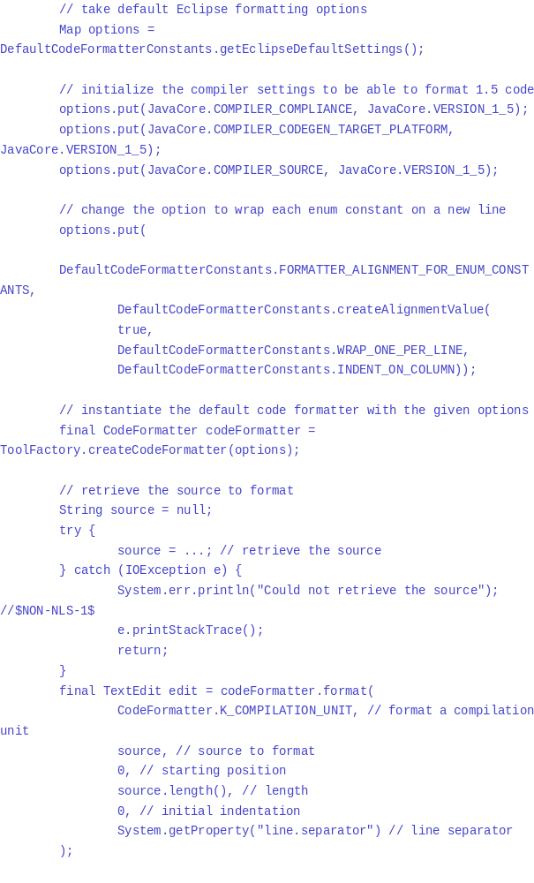On this example,
the result would be:
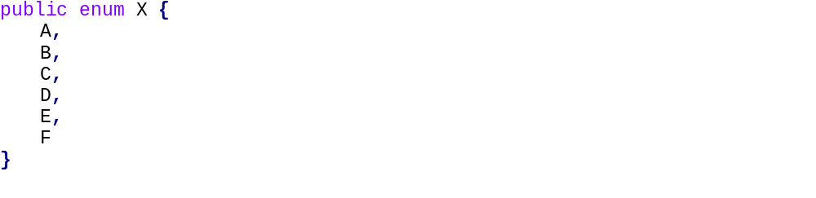

Formatting a set of regions
The default code formatter allows to format a set of regions of a given source file.
This can be achieved by calling the format(int, String, IRegion[], int, String) method of the code formatter, with a given source kind and an array of regions.
- Each of the region to format must be within source range and should not overlap with another region.
- The array of regions to format must contain at least one region. Regions should be sorted by their offsets, smaller offset first.

Comment Formatter API
The default code formatter API offers the possibility to format comments during the processing of the code snippet.
This can be achieved by combining the appropriate flag F_INCLUDE_COMMENTS with K_COMPILATION_UNIT and K_UNKNOWN flags.
This flag is effective only if the corresponding formatting option was enabled when calling format(int, String, int, int, int, String) or format(int, String, IRegion[], int, String) methods:
- FORMATTER_COMMENT_FORMAT_JAVADOC_COMMENT which controls the formatting of javadoc comments
- FORMATTER_COMMENT_FORMAT_BLOCK_COMMENT which controls the formatting of multiple lines comments
- FORMATTER_COMMENT_FORMAT_LINE_COMMENT which controls the formatting of single line comments

Comment formatter options
Various formatting options are available in order to format comments:
- General options to enable or disable the formatting of specific comments (javadoc, multi or single line comments), set maximum line width for comments.
- javadoc comments options to enable the formatting of code snippets or HTML sections inside javadoc comments, indent tag descriptions, etc.
- block comments option to keep or remove blanks lines within such comment
For detailed information about these settings, refer to the DefaultCodeFormatterConstants

Formatting comments with the stand-alone formatter
The default code formatter can be used to format comments (javadoc, multi or single line). In this case, the source passed to the format method should only contain a specific kind of comments, and corresponding kind K_JAVA_DOC, K_MULTI_LINE_COMMENT or K_SINGLE_LINE_COMMENT should be used.

Formatting javadoc comments
The following unformatted javadoc:
should be formatted as follows:
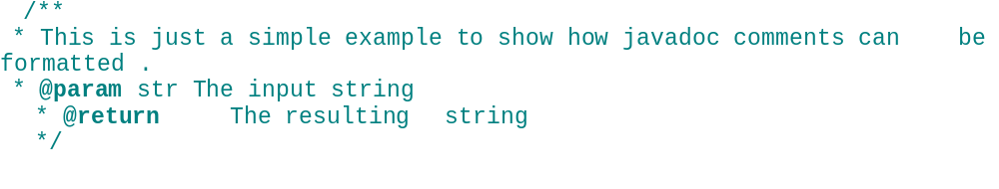using command:
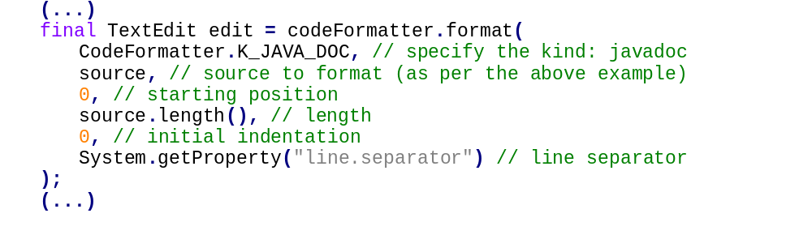

Formatting multi-line comments
The following unformatted multi-line comment: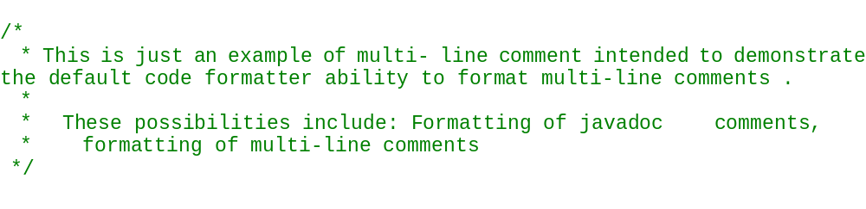
should be formatted as follows:
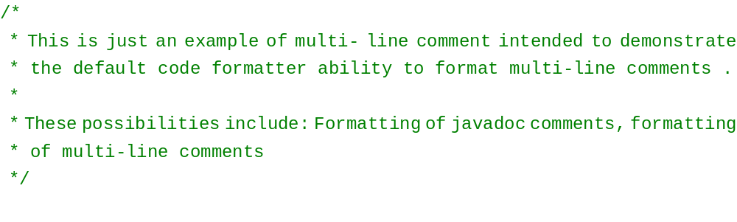using command: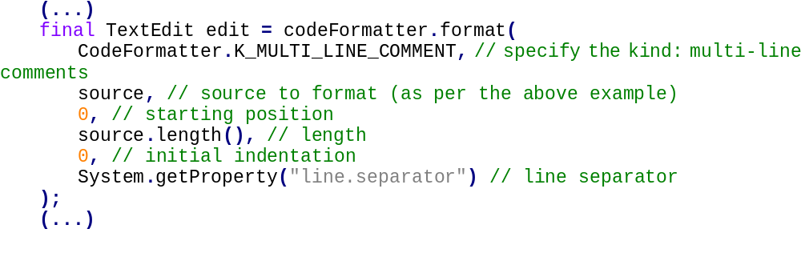

Formatting single line comments
The following unformatted single line comments:
should be formatted as follows:
// This is a long comment that should be split in multiple line comments in
// case the line comment formatting is enabled
using command:
